Fakultät Technik und Informatik  Department Fahrzeugtechnik und Flugzeugbau | Faculty of Engineering and Computer Science  Department of Automotive and  Aeronautical Engineering

Lukas Stichternath
Pilot Measures against Cabin Air Contamination
Bachelor thesis
Lukas Stichternath
Pilot Measures against Cabin Air Contamination
Bachelor thesis submitted as part of the bachelor examination
Degree program: Aeronautical Engineering
Department of Automotive and Aeronautical Engineering
Faculty of Engineering and Computer Science
Hamburg University of Applied Sciences

First examiner, supervisor: Prof. Dr.-Ing. Dieter Scholz, MSME
Second examiner: Prof. Dr. Rinie Akkermans

Submitted: 2021-02-03

DOI:
https://doi.org/10.15488/xxxxx

URN:
https://nbn-resolving.org/urn:nbn:de:gbv:18302-aero2021-02-03.012

Associated URLs:
https://nbn-resolving.org/html/urn:nbn:de:gbv:18302-aero2021-02-03.012

© This work is protected by copyright

The work is licensed under a Creative Commons Attribution-NonCommercial-ShareAlike 4.0
International License: CC BY-NC-SA
https://creativecommons.org/licenses/by-nc-sa/4.0

Any further request may be directed to:
Prof. Dr.-Ing. Dieter Scholz, MSME
E-Mail see: http://www.ProfScholz.de

This work is part of:
Digital Library - Projects & Theses - Prof. Dr. Scholz
http://library.ProfScholz.de

Published by
Aircraft Design and Systems Group (AERO)
Department of Automotive and Aeronautical Engineering
Hamburg University of Applied Science

This report is deposited and archived:
Deutsche Nationalbiliothek (https://www.dnb.de)
Repositorium der Leibniz Universität Hannover (https://www.repo.uni-hannover.de)
Internet Archive (https://archive.org)
Item: https://archive.org/details/TextStichternath.pdf

Abstract

Purpose – This thesis tries to improve the situation of pilots in a Cabin Air Contamination Event (CACE) by increasing awareness through added information. Pilot activities in a CACE center around getting information about the level of contamination, applying checklists, and troubleshooting procedures, and if necessary, descending to 10000 ft.
Methodology – Starting from the results of previous work at HAW Hamburg information available on the Internet was reviewed. Information from manuals available to pilots was added from own sources or also discovered on the Internet.
Findings – Sensors are necessary to help pilots to identify a CACE. Handheld sensors can be used without any delay today. Fixed sensors placed at various positions in the air conditioning system yield earlier warning and allow better trouble shooting. Suitable markers like formaldehyde have been identified. Suitable sensors are available. An electrical nose can recognize a pattern of substances and can distinguish e.g. engine oil from hydraulic fluid contamination. Although checklists dedicated to CACEs could guide pilots much better, if circumstances and the known smell already indicate a bleed air related problem, few airlines seem to use dedicated CACE related checklists. If a fire on board can be ruled out, descending to 10000 ft for direct cabin ventilation and cruise to the next alternate can prevent damage to passenger and crew health from otherwise continued flight at altitude with contaminated cabin air.
Research limitations – The investigation is based on a limited number of emergency checklists. Information is limited about sensors of marker substances for cabin air contamination.
Practical implications – Knowledge about CACEs can help pilots to make a better suited informed decision rather than following a smoke checklist blindly. Pilots are given hints what type of sensors to buy. A suitable sensor adds further to making an informed decision in a CACE.
Originality – This seems to be the first scientific discussion of pilot measures in a CACE.

Keywords

Aeronautics, Airplanes, Air-Pollution, Aircraft cabins, Smoke, Air conditioning, Air pilots, Detectors, Checklists, Fume, Emergency, Air traffic

Kurzreferat

Zweck – Diese Arbeit versucht, die Situation von Piloten bei einem Cabin Air Contamination Event (CACE) zu verbessern, indem das Verständnis für entsprechende Vorfälle durch zusätzliche Informationen erhöht wird. Bei den zu ergreifenden Maßnahmen der Piloten geht es darum, Informationen über den Verschmutzungsgrad zu erhalten, Checklisten anzuwenden und Verfahren zur Fehlerbehebung durchzuführen und gegebenenfalls auf 10000 Fuß abzusteigen.
Methodik – Ausgehend von den Ergebnissen früherer Arbeiten der HAW Hamburg wurden im Internet verfügbare Informationen recherchiert. Informationen aus Handbüchern, die Piloten zur Verfügung stehen, wurden aus eigenen Quellen hinzugefügt oder auch im Internet entdeckt.
Ergebnisse – Sensoren sind erforderlich, um Piloten bei der Identifizierung eines CACE zu helfen. Tragbare Sensoren können heute ohne Verzögerung eingesetzt werden. Feste Sensoren an verschiedenen Positionen in der Klimaanlage verbaut, geben eine frühere Warnung aus und ermöglichen eine bessere Fehlersuche. Geeignete Marker wie Formaldehyd wurden identifiziert. Geeignete Sensoren sind erhältlich. Eine elektrische Nase kann ein Geruchsmuster erkennen und kann z.B. Motoröl von einer Verschmutzung durch Hydraulikflüssigkeit unterscheiden. Obwohl Checklisten für CACEs die Piloten viel besser führen könnten, wenn die Umstände und der bekannte Geruch bereits auf ein Problem mit der Zapfluft hinweisen, scheinen nur wenige Fluggesellschaften spezielle Checklisten für CACE zu verwenden. Wenn ein Feuer an Bord ausgeschlossen werden kann, kann ein Abstieg auf 10000 Fuß in Erwägung gezogen werden. In dieser Flughöhe kann die Kabine direkt von außen belüftet werden und so der Flug zum nächsten Ausweichflughafen ohne weitere Kabinenluftkontamination erfolgen. Es kann so verhindert werden, dass die Gesundheit von Passagieren und Besatzungsmitgliedern beeinträchtigt wird.
Grenzen der Anwendbarkeit – Die Untersuchung basiert auf einer begrenzten Anzahl von Notfall-Checklisten. Informationen über Sensoren für Marker Substanzen zur Bestimmung der Luftverschmutzung in Flugzeugkabinen sind nur begrenzt vorhanden.
Bedeutung in der Praxis – Das Wissen über CACEs kann Piloten dabei helfen, angemessene und fundiertere Entscheidungen zu treffen, anstatt den Checklisten über Rauch im Flugzeug blind zu folgen. Piloten erhalten Hinweise, welche Art von Sensoren sie kaufen sollten. Ein geeigneter Sensor trägt zusätzlich dazu bei, eine fundierte Entscheidung im Fall eines CACEs zu treffen.
Originalität – Dies scheint die erste wissenschaftliche Diskussion zu sein über Maßnahmen, die Piloten im Fall eines CACE treffen können.

Stichworte

Luftfahrt, Luftfahrzeug, Passagierflugzeug, Flugzeugkabine, Luftverschmutzung, Flugbetrieb

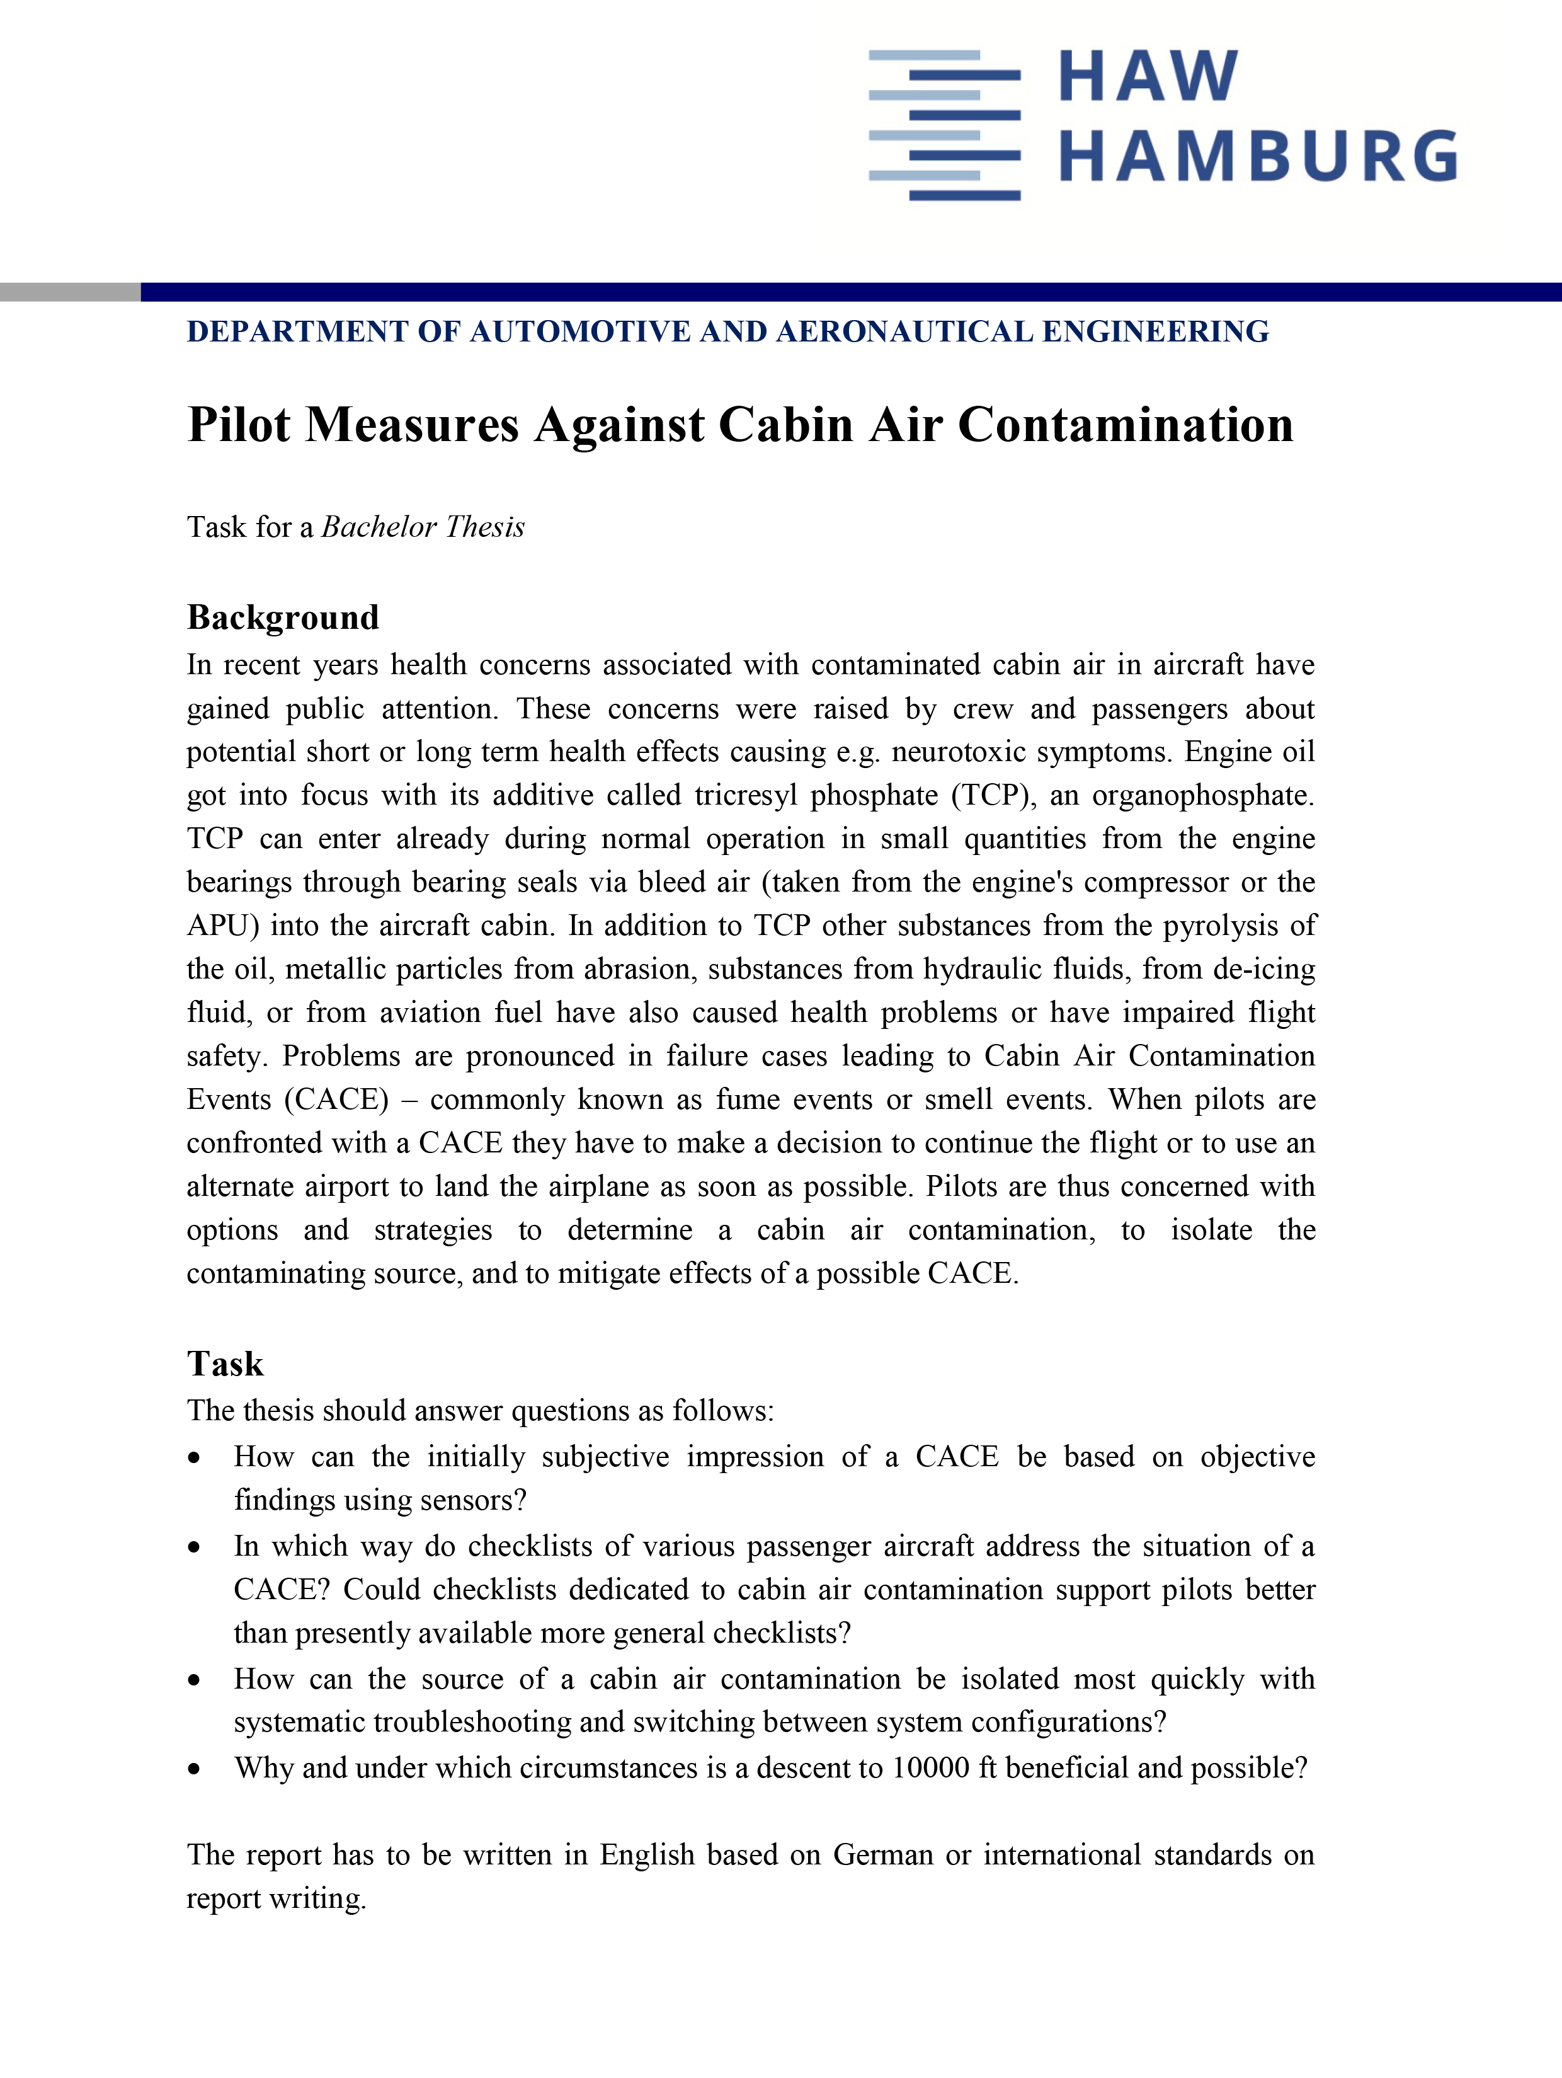

Table of Contents
Page
List of Figures 9
List of Tables 11
List of Symbols 12
List of Abbreviations 14
List of Definitions 15

1 Introduction 16
1.1 Motivation 16
1.2 Title Terminology 16
1.3 Objectives 17
1.4 Literature 17
1.5 Structure 18

2 State of the Art 19
2.1 Underlying Technical Problem 19
2.1.1 Operating Principle of the Pressurized Air-Conditioning System 19
2.1.2 Technical Problem of Air Contamination 20
2.2 Current Situation and Measures Already Taken against CACEs 21

3 Detection of a CACE 25
3.1 The Need for Sensor Data 25
3.2 Indicator Substances for CACEs 26
3.3 Measurement Approach 28
3.4 State of the Art Sensors 29
3.4.1 Hand-Held Devices 30
3.4.2 Fixed Devices 32
3.5 Concepts for Sensor Implementation and Placement 37
3.5.1 Hand-Held Devices 38
3.5.2 Fixed Devices 38

4 Suitable Checklists for a CACE 40
4.1 Airbus A320/A330/A340 40
4.2 Boeing B757/B767 50
4.3 McDonnell Douglas MD-11 53
4.4 EMC Checklists Provided by Airlines 59
4.5 Applicability and Potential Problems 63

5 Descending to FL100, Minimum Obstacle Clearance, MEA 72
5.1 Legal and Safety-Relevant Aviation Guidelines for the Cruising Altitude 73
5.2 Technical and Performance Relevant Aspects 74

6 Schedule to Determine the Reason for a CACE 91
6.1 Sensory Monitoring in Accordance with Section 3.5.2 91
6.2 Sensory Monitoring in Cabin and Cockpit / No Sensory Monitoring 91
6.3 Applicable Checklist for CACEs 93

7 Discussion 95

8 Summary 97

9 Recommendations 98

List of References 99

Appendix A American Airlines, AC Odor/Toxic Substances/Volatile Liquid 108
List of Figures

Figure 2.1 Classical mixed bleed and electrical architecture with pre-cooler in pylon,
Fehrm 2016 19
Figure 2.2 Schematic of the lubrication and sealing system of the shaft bearings,
Scholz 2019b 20
Figure 2.3 Filtration of cabin air option 1, Scholz 2018 21
Figure 2.4 Filtration of cabin air option 2, Scholz 2018 22
Figure 2.5 Filtration of cabin air option 3a, Scholz 2018 22
Figure 2.6 Filtration of cabin air option 3b, Scholz 2018 23
Figure 2.7 Filtration of cabin air option 4, Scholz 2018 23
Figure 3.1 DOCA Sensor, CORDIS 2016 34
Figure 3.2 Schematic structure of the PALL cabin air quality sensor, Mlcak 2019 35
Figure 3.3 Response spectrum Deicing Fluid, Mlcak 2019 36
Figure 3.4 Response spectrum Mobil Jet Oil, Mlcak 2019 36
Figure 3.5 Response spectrum Exxon Hijet, Mlcak 2019 36
Figure 4.1 EMC procedure smoke in cabin, Airbus A320, general instructions,
Smart Cockpit 2020a 41
Figure 4.2 EMC procedure smoke in cabin, Airbus A330/A340, Smart Cockpit 2020b 41
Figure 4.3 CAB FANS off, Airbus A320, Smart Cockpit 2021a 42
Figure 4.4 Avionics ventilation, normal operation, close-circuit config., Airbus A320,
Smart Cockpit 2021a 42
Figure 4.5 Avionics ventilation, normal operation, intermediate config., Airbus A320,
Smart Cockpit 2021 43
Figure 4.6 Avionics ventilation, smoke config., Airbus A320, Smart Cockpit 2021a 44
Figure 4.7 Overwrite Position BLOWER and EXTRACT Pushbutton, Overhead Panel,
Airbus A320, Smart Cockpit 2021a 44
Figure 4.8 Overwrite position VENT EXTRACT Pushbutton, Overhead Panel,
Airbus A340, Smart Cockpit 2021c 45
Figure 4.9 EMC procedure smoke in cabin, Airbus A320, air cond. smoke,
Smart Cockpit 2020a 46
Figure 4.10 Airbus A320, pneumatics, X-BLEED selector sw, Smart Cockpit 2021d 46
Figure 4.11 Airbus A320, pneumatics, pneumatic closure controls, Smart Cockpit 2021d 47
Figure 4.12 Airbus A340, pneumatics, pneumatic closure control, Smart Cockpit 2021e 48
Figure 4.13 Airbus A340, pneumatics, X-BLEED selector sw, Smart Cockpit 2021e 49
Figure 4.14 Airbus A340, air conditioning, CRG FWD ISOL VALVE,
Smart Cockpit 2021e 49
Figure 4.15 EMC procedure smoke in cabin, Airbus A320, source cannot be determined,
Smart Cockpit, 2020a 50
Figure 4.16 Emergency QRC, Boeing B757/B767, AAIB 2011 51
Figure 4.17 EMC checklist smoke/fire/fumes, Boeing B757/B767, AAIB 2011 52
Figure 4.18 EMC checklist air conditioning smoke, McDonnell Douglas MD-11,
Burian 2021 53
Figure 4.19 Air Control Panel, McDonnell Douglas (1993) MD-11 54
Figure 4.20 Air Control Panel, ECON P/B, McDonnell Douglas (1993) MD-11 54
Figure 4.21 Air Control Panel, Pack 1 sw, McDonnell Douglas (1993) MD-11 55
Figure 4.22 Engine 1 Bleed air and Pack 1 off, 1-3 ISOL valve open, McDonnell
Douglas MD-11, based on McDonnel Douglas 1993 55
Figure 4.23 Engine 3 Bleed air and Pack 3 off, 1-3 ISOL valve open, McDonnell
Douglas MD-11, based on McDonnel Douglas 1993 56
Figure 4.24 Engine 2 Bleed air and Pack 2 off, 1-2 ISOL valve open, McDonnell
Douglas MD-11, based on McDonnel Douglas 1993 57
Figure 4.25 EMC checklist smoke/fumes of unknown origin, McDonnell Douglas (Boeing) MD-11, Burian 2021 58
Figure 4.26 EMC Checklist ELIMINATION of ODOR in FLIGHT DECK/CABIN,
Scholz 2020c 59
Figure 4.27 Boeing 757 Air Conditioning System, Avsoft 2018a 60
Figure 4.28 Boeing 777 Air Conditioning System, Avsoft 2018b 60
Figure 4.29 EMC Checklist odors/toxic substances/volatile liquid, American Airlines, Boeing B737, based on Appendix A 62
Figure 4.30 Relative remaining concentration for a ventilation efficiency of η = 1 over relative time 64
Figure 4.31 TCP source strengths related to secondary event at S0, S1A and S1B,
Lakies 2019a 66
Figure 4.32 TCP concentration in the cabin at scenario S0 and variations S1A and S1B, Lakies 2019a 67
Figure 4.33 TCP concentration in the cabin 68
Figure 4.34 Relative concentration development for a ventilation efficiency of η = 1 over
relative time 70
Figure 5.1 Smoke/fumes removal, Airbus A320, Smart Cockpit 2020a 72
Figure 5.2 Smoke/fumes removal, Airbus A340, Smart Cockpit 2020b 72
Figure 5.3 Ratio of Cruise Speed, Mach Number and Range, Scholz 2017 77
Figure 5.4 Payload Range Diagram, A340-300, Airbus 2020 84
Figure 5.5 Payload Range Diagram, Lukaczyk 2016 85
Figure 5.6 Flight Route LAX – HNL, GCM 2021 87
Figure 5.7 Algebraic method for calculating Critical Point/Equal Tim Point,
SKYbrary 2017 88
Figure 5.8 US Airways Flight 432 Diversion Flight Route, GCM 2010 89

List of Tables

Table 3.1 Conclusions on Indicator Compounds, Jones 2019 27
Table 3.2 Handheld COTS measuring devices 31
Table 3.3 Stationary COTS sensors 32
Table 3.4 Integrated, low cost devices for air quality monitoring, FSS 2018 33
Table 4.1 Relative remaining concentration for a ventilation efficiency of η = 1
over relative time 64
Table 4.2 Variable TCP source strengths, release pattern used by Lakies (2019a) 66
Table 4.3 Variable TCP source strengths, simplified release pattern, based on
Lakies 2019a 67
Table 4.4 Relative concentration development for a ventilation efficiency of η = 1
over relative time 70
Table 5.1 Max. Cruise Thrust Limits, Airbus A330, Scholz 2020c 78
Table 5.2 Max. Cruise Thrust Limits, Airbus A340, Scholz 2020c 79
Table 5.3 Max. Cruise Thrust Limits, Airbus A350, Scholz 2020c 80
Table 5.4 NM per ton fuel, Airbus A330, based on Table 5.1 81
Table 5.5 NM per ton fuel, Airbus A340, based on Table 5.2 82
Table 5.6 NM per ton fuel, Airbus A350, based on Table 5.3 83
List of Symbols

a Speed of sound
B Breguet range factor
c Concentration of analyzed contaminant / Specific fuel consumption
C Constant of integration
E Lift-to-drag ratio
L Lift
m Mass
R Range
S Contamination source strength / Area
t Time
T Temperature
$v$ Air speed in the cabin
V Cruise speed

Greek Symbols

α Portion of the analyzed contaminant that passes a filter or duct section
ε Weakening coefficient for secondary CACE
θ Proportion of recirculated air
λ Air exchange rate
ρ Density
τ Absorption rate

List of Subscripts

0 Initial
10K 1000 feet
ca Conditioned air
cab Cabin
clean Cleanup
con Constant
cp Conditioning process
CR Cruise altitude
d Duct
e Effective
f Filter
i Internal
in Mixed air
lin Linear
ML Maximum Landing
MTO Maximum Takeoff
oa Outside air
out Outside
rec Recirculated air
rel Release
W Wing

List of Abbreviations

APU Auxiliary Power Unit
CAB Cabin
CACE Cabin Air Contamination Event
CAT Clean Air Technology
CKPT Cockpit
COTS Commercial off the-shelf
CP Critical Point
CRG Cargo
CSI Contaminant Sensing and Informing
DOCA Detection of Oil in Compressed Air
ECS Environmental Control System
EMC Emergency
FM Flight Manual
FSS Future Sky Safety
FTIR Fourier Transform Infrared
ETP Equal Time Point
IFCAS Industrial cabin air quality Framework based on Continuous Air quality Sensing
IFE Inflight Entertainment
IMS Ion Mobility Spectrometry
JRP Joint Research Program
MEA Minimum En Route Altitude
OEM Original Equipment Manufacturer
OVRD Override
PASOCA Photo-Acoustic Sensor for Oil detection in Compressed Air
QRC Quick Reference Checklist
SAR Specific Air Range
SW Switch
TAS True Air Speed
TCP Tricresyl phosphate
TOW Takeoff Weight
TVOC Total Volatile Organic Compounds
VOC Volatile Organic Compounds
List of Definitions

Cabin Air Contamination Event (CACE)
In a Cabin Air Contamination Event (CACE) the air in the cabin and/or cockpit of an
aircraft is contaminated. Sensation of the contamination can be from vison (fume/smoke),
olfaction (smell/odor), a combination of typical symptoms experienced by several
passengers and/or or crew or by related measurements of CO, CO2, ozone or other
"harmful or hazardous concentrations of gases or vapors" (CS-25.831). (Scholz 2019a)

Critical Point (CP) / Equal Time Point (ETP)
The Critical Point (CP), or Equal Time Point (ETP), is when an aircraft is the same flying time from 2 potential en-route diversions. Calculation of appropriate CPs aids decision making when deciding courses of action following a significant event such as an engine failure or on-board medical emergency. (SKYbrary 2017)

Fume Event
In a fume event, the cabin and/or cockpit of an aircraft is filled with fume. Air contamination is due to fluids such as engine oil, hydraulic fluid or anto-icing fluid. A fume event includes a smell event. (Scholz 2019b)

Minimum En Route Altitude (MEA)
The MEA is the lowest published altitude between radio fixes that assures acceptable navigational signal coverage and meets obstacle clearance requirements between those fixes. The MEA prescribed for a Federal Airway or segment, RNAV low or high route, or other direct route applies to the entire width of the airway, segment, or route between the radio fixes defining the airway, segment, or route. (FAA 2017)

Smell Event
A fume event without visible fume or smoke, but with a distinct smell usually described as ‘dirty socks’ from the butyric acid originating from a decomposition of the esters that are the base stock of the synthetic jet engine oil. (Scholz 2019b)

1 Introduction

1.1 Motivation

Due to the bleed air-based design of most aircraft air conditioning systems (see SKYbrary 2019a) and inappropriate timespans between seal replacements in the engines (see Scholz 2019a), critical cabin air contamination events keep occurring (e.g. B737 en-route, Glen Innes NSW Australia, 2007; A320, en-route, northeast of Granada Spain, 2017; B752, en-route, North Sea, 2006; E195, Exeter UK, 2019; A332, Karachi Pakistan, 2014; see SKYbrary 2019a). Though the technical reasons as well as the detrimental health effects are known (see Day 2015), some important measures are still unobserved. This thesis addresses the problem of a yet unobtained sensory determination of a CACE (see Jones 2019 and Mlcak 2019) and the inadequate guidelines for dealing with such an incident. Although there are several more reasons for cabin air contamination events, like deicing fluids and hydraulics (see Jones 2019 and Mlcak 2019), this thesis focuses on the cabin air contamination due to bleed air pollution. However, the results of this elaboration can also be applied to other reasons for cabin air contamination

1.2 Title Terminology

Pilot – An aircraft pilot or aviator is a person who controls the flight of an aircraft by operating its directional flight controls. (Wikipedia 2021a)

Measures – A way of achieving something, or a method for dealing with a situation
(Cambridge Dictionary 2021)

Aircraft Cabin Air – Aircraft cabin air is the air in the cabin of an aircraft. The air in the cockpit is included in this definition. In pressurized cabins it is the air inside the pressure seals. Pressure control is such that cabin pressure is reduced down to a pressure equivalent to 8000ft (referring to the ICAO Standard Atmosphere) as the aircraft climbs. In unpressurized aircraft cabins the air is at ambient pressure. Temperature control is done by heating or cooling as required. Venting ensures frequent exchange of cabin air with fresh air from outside. In addition, cabin air can be recirculated and filtered. When flying at high altitudes, cabin air is at similar low relative humidity as the air outside. (Scholz 2019a)

Contamination – The process of making a material unclean or unsuited for its intended purpose, usually by the addition or attachment of undesirable foreign substances.
(Scholz 2019a)

1.3 Objectives

The task sheet gives four research questions. Based on these questions, this thesis follows four main objectives: 1.) To give an overview of the possibilities to base the initially subjective impression of a CACE on objective findings using sensors. 2.) To show to what extend there are checklists on various passenger aircraft addressing a CACE. To show if other existing checklist could be applied, like the emergency checklist for “smoke in cabin”. 3.) To provide a suitable checklist to determine a systematic switching of bleed air sources in case of a CACE. 4.) To evaluate when a descent to 10000 ft is possible and beneficial.

1.4 Literature

This thesis is mainly based on the research done by Prof. Dr. Ing. Dieter Scholz, as well as the content and conclusions given by Prof. Byron Jones (2019) and Rick Mlcak (2019) at the Aircraft Cabin Air Conference in London, September 17th in 2019. Furthermore, the bachelor thesis written by Viola Voth (2018) and the project results elaborated by Marcel Lakies (2019a) are taken into account. In order to provide a well-founded evaluation of the Emergency (EMC) checklists, additional aircraft-specific documents from the smartcockpit.com website are being used and evaluated.

1.5 Structure

Chapter 2 Introduction into the topic of cabin air contamination to provide a basic understanding of the necessity for adequate measures to detect and react on CACEs.

Chapter 3 Analysis of technical solutions to base the impression of a cabin air contamination event on objective findings.

Chapter 4 View on the currently suitable checklists for a CACE on various passenger aircraft and consideration of applying other checklists like “Smoke in cabin”.

Chapter 5 Overview to when extend descending to 10000 feet is allowed and deem necessary.

Chapter 6 Elaboration of a schedule for determining the reason for a CACE based on systematic switching of the bleed air sources, considering the findings in Chapter 3 and 4 and elaboration of suitable emergency checklists for pilots in case of CACEs.

Chapter 7 Discussion of the thesis’ results.

Chapter 8 Summary of the thesis’ results.

Chapter 9 Recommendations for further investigations

2 State of the Art

2.1 Underlying Technical Problem

2.1.1 Operating Principle of the Pressurized Air-Conditioning System

Although there are plenty elaborations addressing the reason for cabin air contamination events this section serves to give a rough overview of the underlying technical problem that results from the use of bleed air from the aircraft engines.

According to EASA CS-25 certification rules for Large Aeroplanes, supplemental oxygen supply must be guaranteed from an altitude of 10000 feet and above, either by provision of oxygen masks or via a pressurized cabin. In commercial aviation, the second of the two variants is commonly applied. Apart from few exceptions like the Boeing 787, todays large passenger aircraft use air-conditioning systems based on bleed air supply, to provide fresh pressurized air for the cabin.

“A bleed air system uses a network of ducts, valves and regulators to conduct medium to high pressure air, "bled" from the compressor section of the engine(s) and APU, to various locations within the aircraft” (SKYbrary 2019a), as shown in Figure 2.1. Among other things, the bleed air is used for the air supply.

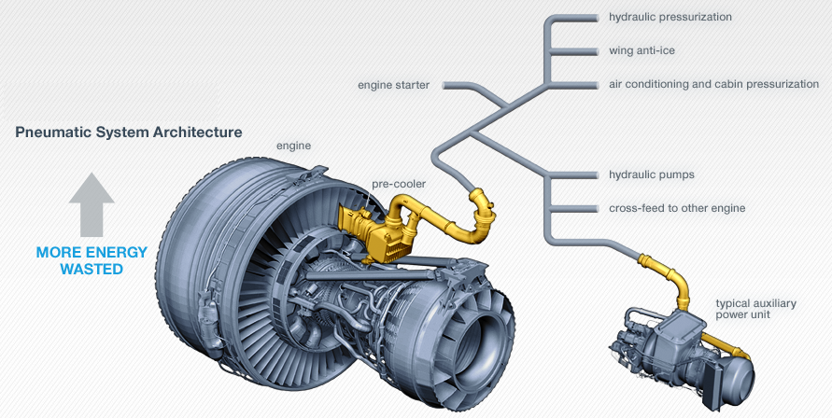
Figure 2.1 Classical mixed bleed and electrical architecture with pre-cooler in pylon, Fehrm 2016

2.1.2 Technical Problem of Air Contamination

Due to a variety of influences, the air drawn off at this point can already be contaminated. One of these contamination factors can be attributed to a design deficiency of the bleed air system itself. In her bachelor thesis Voth (2018) describes how oil particles get into the bleed air due to the sealing system of the shaft bearings, shown schematically in Figure 2.2.

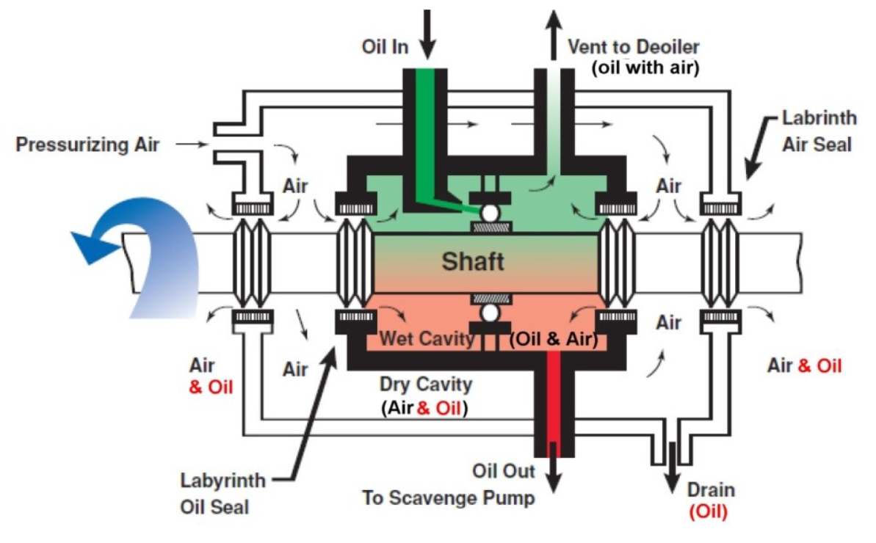
Figure 2.2 Schematic of the lubrication and sealing system of the shaft bearings, Scholz 2019b

Labyrinth seals in the engines do not actually seal but allow air to pass, containing toxic oil particles by design. The oil particles then directly enter the cabin with the bleed air. In his 2019 project report, Lakies (2019a) discusses further reasons for cabin air contamination, such as VOC, CO2, and others, in addition to engine oil leaks. His report includes equations to calculate the dynamics of the concentration of cabin air contaminants and concludes by saying that a reconstruction of the bleed air system and a purification of the cabin air deems necessary.

2.2 Current Situation and Measures Already Taken against
CACEs

Although the problem of air contamination has been known for years, hardly any noteworthy measures have been implemented to counteract the occurrence of CACEs on the one hand, and on the other hand to provide a schedule to adequately respond to such incidents.

The US company PALL has already developed and sold filter systems that are able to filter TCP and VOC out of the air. “The carbon adsorbent is effective at adsorbing volatile organic compounds (VOC). Test results have shown a removal efficiency of 65% ... 73% when challenged with TCPs in the gaseous phase” (PALL 2011 cited in Scholz 2018).

There are various concepts for air filtering. In his lecture for the German Aerospace Congress 2018 Scholz (2018) shows several variants where filters can be located efficiently as shown in Figures 2.3 to Figure 2.7.

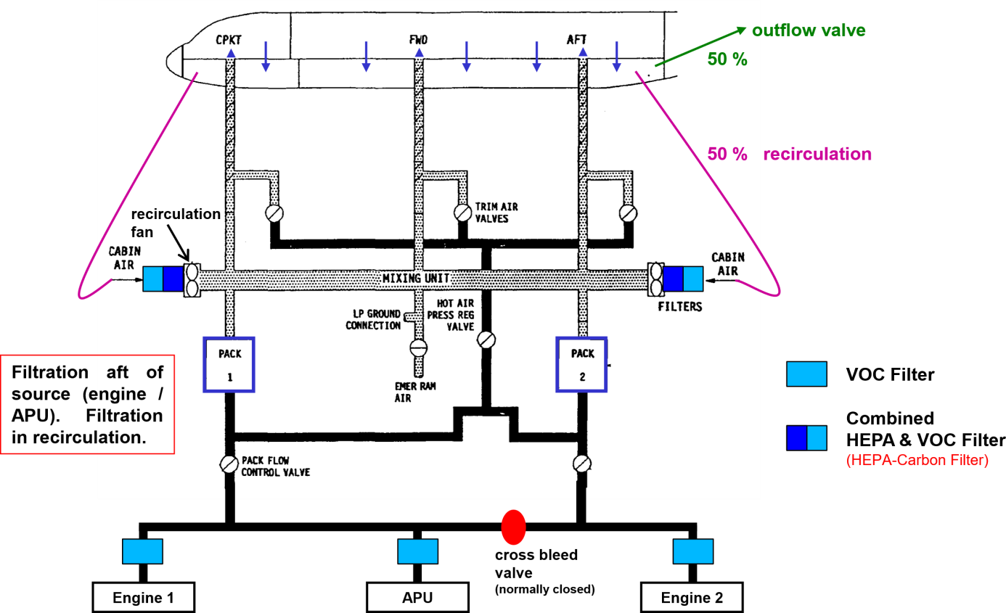
Figure 2.3 Filtration of cabin air option 1, Scholz 2018

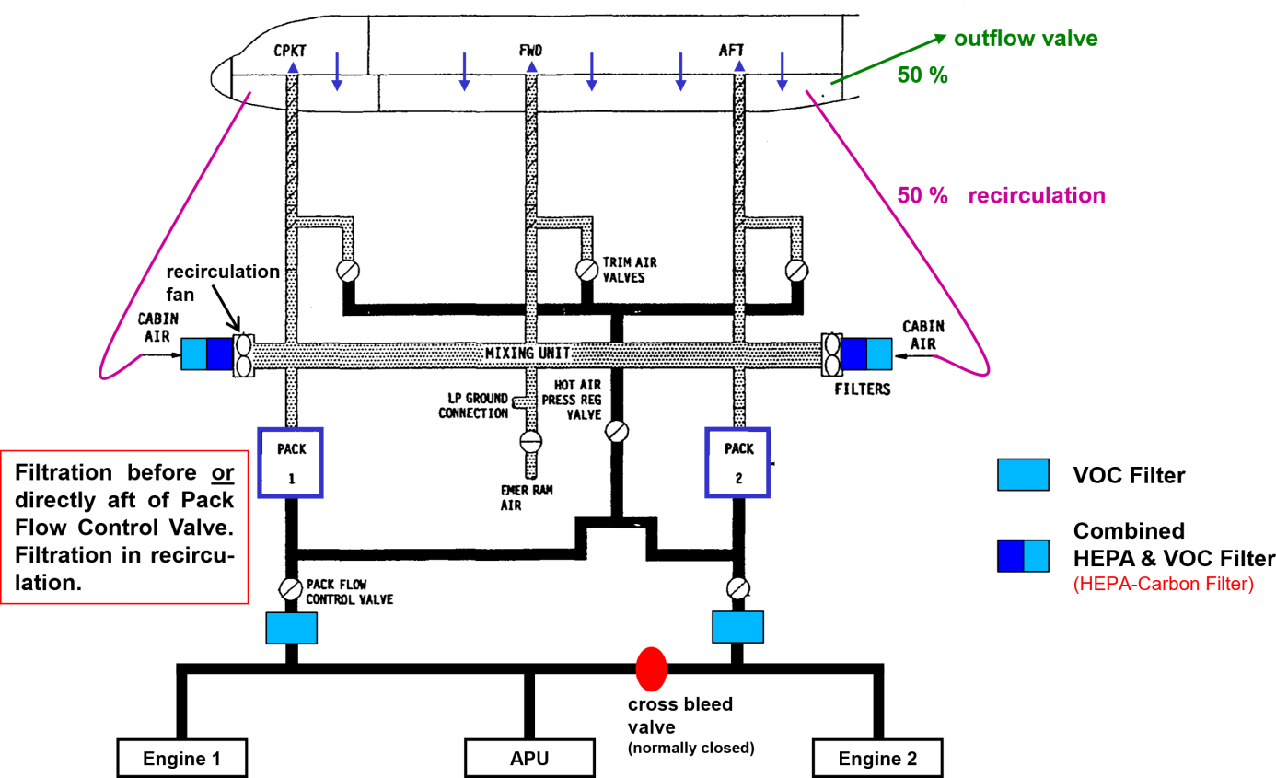
Figure 2.4 Filtration of cabin air option 2, Scholz 2018

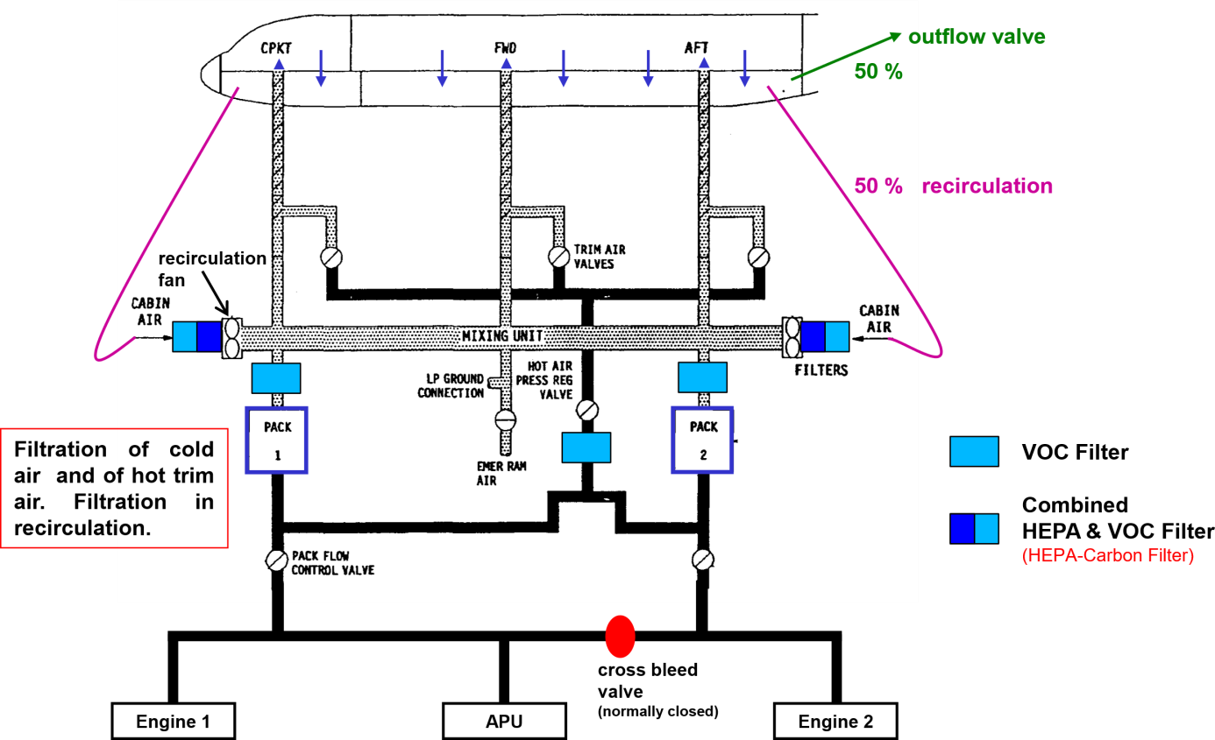
Figure 2.5 Filtration of cabin air option 3a, Scholz 2018

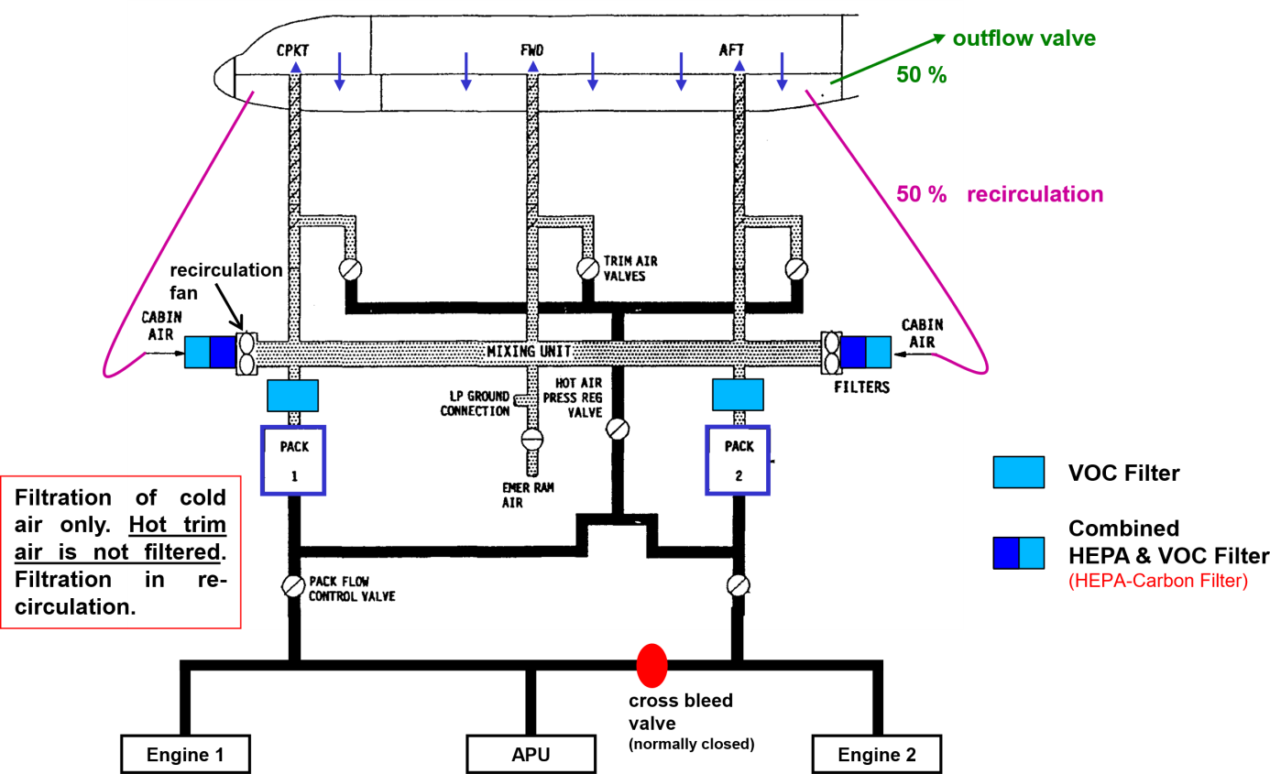
Figure 2.6 Filtration of cabin air option 3b, Scholz 2018

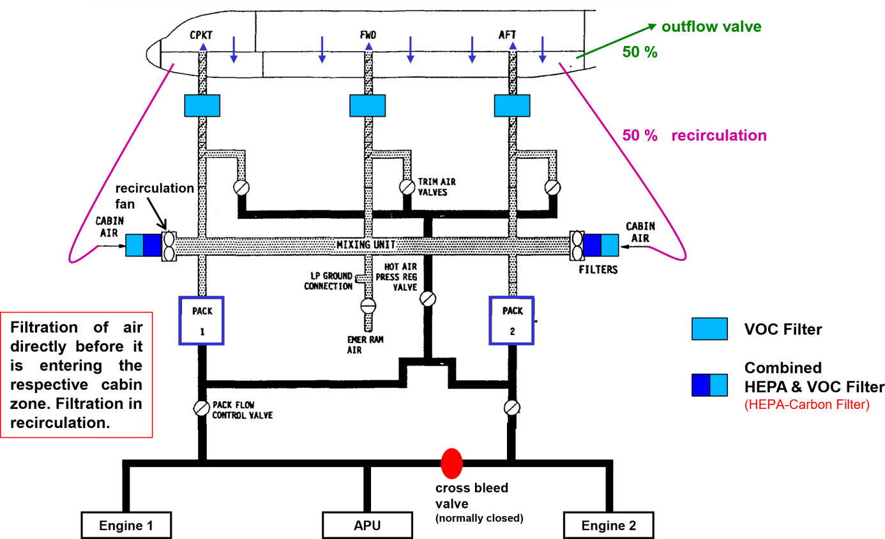
Figure 2.7 Filtration of cabin air option 4, Scholz 2018

Since in case 3b the hot trim air is not filtered a certain amount of bleed air from the engines can still enter the cabin directly, also allowing a certain amount of TCP and other components to enter. Although applicable, having filters located in hot areas is avoided due to a high risk of failure. As a result, the filtration concepts 3a and 4 are most likely to be applied in praxis.

In 2017 the British airline EasyJet announced to start testing a new air filtering system making them the first airline to act on the cabin air contamination problem (Haines 2017).

3 Detection of a CACE

3.1 The Need for Sensor Data

Besides the need for air purification and reconstruction of the air-conditioning system, pilots must be able to prove a CACE incident beyond any doubt in order to be able to react appropriately and quickly.

In case of air contamination due to oil in the cabin air a smell event occurs, commonly described as the smell of “dirty socks”. But the impression of a smell is highly subjective and volatile for humans due to the functioning principles of the human olfactory organ – the human nose.

“The human olfactory system uses a variety of chemical sensors known as olfactory receptors, combined with automated pattern recognition incorporated in the olfactory bulb and olfactory cortex in the brain. … The chemical reaction in the receptors produces an electrical stimulus. These electrical signals are then transported by the olfactory axons through the cribiform[sic] plate … to the olfactory bulb …. From the olfactory bulb, the receptor response information is transmitted to the limbic system. This gives rise to sub-conscious associations between odor and recalled memories.”
(Chen 2004, pp. 10-12)

Since the memories vary for each human, so do the individual associations between a specific smell and the recalled memories. Therefore, every pax in the aircraft cabin can have a different interpretation of a certain smell. Furthermore, humans do not smell all odors present but the change of the odors, making the recognition of a smell volatile. The duration of the smell impression also varies between every person. For example, if a person is used to the smell of dirty socks – maybe because of bad body hygiene – this person might not be sensible for the impression of a smell event. Besides the highly subjective impression of odors, there can also be contaminants in the air without an odor, and thereby not noticeable for the human nose at all.

Since the recognition of smell events is very subjective and the smell event itself not necessarily based on a system failure it is necessary to provide sensors to base the subjective impression of a smell event on objective findings. In case of a fume event it is obvious that a critical incident must have occurred so the probability for a false alert is low. Nevertheless, sensor data can provide essential information about the type of smoke development based on the detected compounds – The composition of smoke by fire is different from that of oil mists – so either way, providing sensors to which the pilots can refer is necessary and even prescribed in the EASA CS-25 guidelines for Large Aeroplanes. “CS 25.1309(c) requires that information concerning unsafe system operating conditions must be provided to the crew to enable them to take appropriate corrective action” (EASA 2012, p.591). Furthermore the CS-25 regulations state that “Even if operation or performance is unaffected or insignificantly affected at the time of failure, information to the crew is required if it is considered necessary for the crew to take any action or observe any precautions” (EASA 2012, p.592). It has been proven that cabin air pollution can lead to serious health problems (see Day 2015). In addition, numerous examples show that a CACE cannot be prevented with certainty (see SKYbrary 2019a), whereby the air conditioning system becomes a system in accordance with CS-25.1390, in which "unsafe system operating actions" (EASA 2012, p.591) can occur and as a result must be linked to an information system accordingly, which informs the crew about the malfunction.

3.2 Indicator Substances for CACEs

Sensors that can detect smell and fume events already exist but are currently not available as standard equipment on aircraft. Among others Scholz (2018) has already carried out research in this direction and addresses sensors in his lecture for the German Aerospace Congress 2018, which can be used as personal hand-held measuring devices for the pilots. In the lecture he uses a CO meter from Kkmoon for a test with exhaust gas on the ground but there are several possible sensors available on the marked since it’s a common technology which is not limited to the aircraft industry.

In his lecture at the Aircraft Cabin Air Conference 2019 in London, Byron W. Jones (Jones 2019) addresses the topic of bleed air contamination detection as well. Jones (2019) refers to the research project VIPR, where amongst other things they injected oil into the compressor of a C17 transport aircraft engine (the same engine is used in the Boeing 757) and measured the contamination in the cabin air. In the project 1200 g of oil per hour was injected for an air flow of approximately 20 kg per second (about 17 ppm by mass) which was being associated with acute events. The measuring results show a rise of approximately 500 ppb of carbonmonoxy (CO) in the cabin, leading to the conclusion that an appropriate sensor device should provide a measurement resolution of at least 100ppb in order to also detect low level events, below 17 ppm by mass. While these results do not change the conclusions by Prof. Scholz, it clearly states that sensors with industry standard are necessary, since common low-cost CO sensors do not provide such a high measurement resolution.

In addition to the possibility of using CO as an indicator for CACEs, Jones (2019) also discusses other possible substances as indicators. Due to the excessively high background level and various possible causes for an increase, CO2 as a standalone solution is out of the question as an effective indicator. According to Jones (2019), however, a promising approach is the use of VOCs as indicators. He starts with total VOC (TVOC) concentration measurements. During the tests, an increase of around 0.5 ppm by mass was measured for an acute event. From this, he concludes that TVOC can be used for acute events but could be problematic for low level events. In addition, the informative value on ground is questionable due to the high urban background levels.

The most promising VOC substance tend to be formaldehyde, with measured values of 300 ppb increase over 17 ppm by mass oil. Although it is not possible to say without a doubt whether the increased values are caused by exhaust gas from the environment or oil from the engines when just using formaldehyde sensors, this problem can be avoided by combining the formaldehyde sensors with CO₂ sensors, as a simultaneous increase in CO₂ values can be seen when the formaldehyde values are increased due to exhaust gases. According to Jones (2019), other VOCs can also provide usable information, but their efficiency and informative value tend to be below formaldehyde.

Another promising attempt appears to be the use of ultrafine particles as indicator for contamination events. Jones (2019) points out, that while the measurements of CO and VOC show measurable but just little increase in case of contamination events, ultrafine particles show four orders of magnitude increase between contaminated and clean air. Even if the engines are running a difference of two orders of magnitude increase can be measured, making ultrafine particles apparently the most suitable attempt for low level contamination events. The downside of ultrafine particles as indicators are the comparably expensive sensors, and it is still uncertain whether the efficiency is the same with other substances than oil, like hydraulics or anti-icing.

Even if it is still unclear which approach is the most effective to detect CACEs, Jones (2019) shows with his lecture that there are numerous possibilities to take a first step in the direction of a sensory monitoring of the cabin air and points out that a corresponding measurement does not need to be perfect in order to be useful. He concludes his lecture with the words "If you don't take the first step, you never get anywhere"(Jones 2019). The following Table 3.1 shows a summary of the indicator compounds considered by Jones (2019) and his conclusions as to whether these are suitable.

Table 3.1 Conclusions on Indicator Compounds, Jones 2019
Indicator compound |  | Unit | Measured  rise | Necessary  resolution | Conclusion
Carbon Dioxide | CO₂ | ppb | - | - | No
Carbon Monoxide | CO | ppb | ~500 | 100 | Maybe
Total Volatile  Organic Compounds | TVOC | ppb | ~500 | 100 | Maybe
Formaldehyde | HCHO | ppb | ~300 | 100 | Promising
Acetaldehyde | C₂H₄O | ppb | ~200 | 100 | Promising but Formaldehyde probably better
Tricresyl Phosphate | TCP | ppb | ~1 | 1 | No
Ultrafine Particles | UFP | $\frac{Particles}{{cm}^{3}}$ | 10² to 10⁴ | - | Very promising if suitable sensors become available

The ANSI / ASHRAE Standard 161-2013, published by the international organization ASHRAE, also deals with the issue of cabin air quality in commercial aircraft. The requirements for the indicator substances are formulated in that standard as follows:
“The indicator substance(s) shall (1) be shown to be associated with the presence of partly or fully pyrolized engine oil and hydraulic fluid; (2) have a sufficiently low background level that its presence can be reliably attributed to these contaminants; and (3) be measured with sufficient sensitivity to reliably detect the occurrence of these contamination events.” (ASHRAE 2013, p.6)

3.3 Measurement Approach

The question of the right indicator compounds is crucial, but not the only one. It is important to consider how a measurement of the cabin air quality (CAQ) can generally run and how it is structured. As part of the EASA (2020) Workshop on future Cabin Air Quality Research from January 30th to 31st, a “routine and dedicated CAQ monitoring methods” (Stranger 2020, p.146) are therefore defined consisting of four components.

- The first component are the indicator compounds “identified by means of chemical screening of CAQ” (Stranger 2020, p.146), as already examined in section 3.2.
- The second component sets the general conditions for the sensors in terms of shape and size. A "miniature-type sensor box"(Stranger 2020, p.146) is to be built into the air conditioning system as a kind of proxy in order to ensure a continuous assessment of the indicator compounds. Similar to a computer network, where the proxy server is between the sender and receiver and forwards and can filter the network traffic, a proxy configuration of the sensor box means that the fresh air is first passed through the sensor box before it enters the cabin.
- The third component is the sensor itself and thereby its operating principal. Several possibilities come into question, which will be discussed in more detail later. In the EASA (2020) workshop, the functional principle of an electrical nose is chosen, which is characterized by pattern recognition.
- Since for such a sensor system calibrations and validations need to be done, the last component is a “Gas generation system for complex gas mixtures in order to test, calibrate & validate” (Stranger 2020, p. 146) the sensor data under realistic conditions.

As already mentioned, there are different approaches for measuring cabin air pollution which can be mainly differentiated in two categories.

- The first and simplest variant is to measure the concentration of individual previously defined indicator compounds. This approach enables the detection of potentially undesirable and harmful substances, but the interpretation of the corresponding values is relatively imprecise. As Jones (2019) already pointed out, there are substances that indicate a problem with a relatively high degree of certainty, but individual components can be contained in a large number of substances, so that the cause cannot always be identified unequivocally.
- The second and more promising attempt is to take the odor as a sum of compounds and only look for patterns. This variant is not just used as basis of the routine described in the EASA (2020) Workshop, but also in several other research projects, like the EU-funded DOCA project as well as the “PUREcabin” technology (Mlcak 2019) developed by PALL Aerospace. In his lecture for the International Aircraft Cabin Air Conference in London Rick Mlcak (2019) explains the operational principal behind that method by using an apple as example, and the way human smell it. When humans smell an apple, they recognize that it is an apple not because the human nose senses the concentrations of the individual chemical compounds in it, but because of the sum of these compounds and their combination. Because of that basic functional principal humans are able to not only recognize one specific brand of apples with its exact chemical concentrations but apples as a hole category, since besides small variations in the exact chemical compound concentrations, apples always have a similar pattern of chemical components. The same goes for contaminants in the cabin air.

3.4 State of the Art Sensors

Having the measurement methods and indicator compounds examined in sections 3.2. and 3.3 the points that still remain from the “routine and dedicated CAQ monitoring methods” (Stranger 2020, p.146) in section 3.3 are the sensors themselves. The ASHRAE (2013) Standard states:

“The trigger point is defined as a concentration that may not be high enough to be associated with a negative health impact on its own but rather indicates the presence of partly or fully pyrolyzed oils or hydraulic fluids. The trigger point shall be high enough above background levels to indicate contamination but not so high above background levels to miss events.” (ASHRAE 2013, pp.6-7)

It must be noted that a "trigger point" should only be used as a support measure to indicate to the pilot by means of a signal that a critical level of an indicator substance has been reached. It is no substitute for the display of the specific value. CFR §91.3 in the FAAs General Operating and Flight Rules states:

(a) The pilot in command of an aircraft is directly responsible for, and is the final authority as to, the operation of that aircraft.
(b) In an in-flight emergency requiring immediate action, the pilot in command may deviate from any rule of this part to the extent required to meet that emergency.
(FAA 2021)

In order to be able to make a well-founded decision in an emergency and for efficient troubleshooting, it is necessary for the pilot to have a real-time display of the corresponding values. When in doubt, the decision to act lies with the pilot and not with a warning light.

By that means and considering the findings provided by Jones (2019) it is certain that sensors with a measurement resolution of industry grade are required to measure the selected indicator substances. The requirement for a correspondingly high resolution and a low sensor measuring range restricts the selection of suitable sensors and drives up the price, but some of the corresponding sensors are already available or in development.

In Mai 2018 the Joint Research Program (JRP) Future Sky Safety (FSS) released the “On-board air quality – Final report on the effect of new materials” (FSS 2018). In the study “the state of the art and developments, including related technologies, in cabin air quality, societal trends in air quality, and competitiveness for industry offered by cabin air quality” (FSS 2018, p.8) is being investigated. Among other things, the sensors for monitoring the cabin air quality are considered in terms of size, type and location. One of the study’s goals is the identification of the best monitoring equipment and methodology and their adaptation to aviation requirements. In order to do so the study takes various commercial off the-shelf sensor (COTS) into account, as well as new and more complex sensor concepts, which are “mainly focused on miniaturization of whole sensing technologies that are currently too large to be portable e.g. creation of handheld Ion Mobility Spectrometry (IMS), or manufacturing tailored sub-components to remove the limiting operational factors in current COTS sensors” (FSS 2018, p.36). Basically, the sensors that can be used for measurement can be divided into two categories. On the one hand, hand-held sensors, and fixed sensors, whereby the hand-held sensors are only of limited informative value due to their location in the cabin and the cockpit.

3.4.1 Hand-Held Devices

Air quality sensors are not only used in commercial aviation, but also in other industries. For this reason, there are already some COTS sensors that can be transferred to the requirements of commercial aviation. Many of these COTS sensors are hand-held sensor systems, some of which can measure individual indicator substances, but some of them are also able to detect several different substances. While being a good thing to begin with, hand-held measuring devices might not be sufficient for the pilots to be able to respond to cabin air contamination reliably and in adequate time. There are several reasons for this. First of all, the measurement would only take place in the cabin and the cockpit, resulting in an extensive and time-consuming troubleshooting process, since the origin is by then yet unclear. Another critical aspect when it comes to the troubleshooting process arises from the chemical nature of possible contaminants like an oil mist.

One substance for which a large number of hand-held sensors are available is CO. If these sensors are now used as an example, it should be noted that if an increased CO concentration is measured, and even if the origin is found, the reason for the increased measurement has not yet been determined. An increased proportion of CO in the cabin is not necessarily due to a leak in the bleed air supply. For example, it can also be caused by a fire. Surely that would be a critical event, but the necessary measures to be taken are not the same. Prof. Scholz also addressed these portable measuring devices in his letter to Ms. Dröge and Mr. Kindler from the German Bundestag fraction Bündnis 90 die Grünen from May 3, 2020, in which he demands “portable measuring devices for every pilot for use in the cockpit!” (Scholz 2020a, p.1). Prof. Scholz specifies this requirement by adding “Lufthansa procures (simple, portable) measuring devices (CO, CH₂O, UFP, or ...) in consultation with the findings from the working group FHE [of the German pilot union 'Vereinigung Cockpit' VC]” (Scholz 2020a, p.1). In order to make the use of hand-held sensors accordingly sensible, it is necessary to consider the simultaneous measurement of several indicator substances in order to be able to clearly assign the occurrence of increased measured values to a specific problem. Another reason for the insufficiency of handheld devices is that most of these measuring devices work battery operated, which greatly reduces reliability. The fact that such a device does not have a fixed position in the cockpit can also result in a critical measurement not being noticed at all or being noticed too late.

Despite all the potential insufficiencies, with the introduction of hand-held measuring devices for the detection of CO and other indicator compounds, the first step would be taken towards the detection of a CACE and thus an opportunity to react early and appropriate to possible malfunctions in the air supply, but the implementation of these requirements is still pending.

The following Table 3.2 provides a list of applicable sensors which could be used as hand-held devices for pilots. The sensors listed in the table have a high level of accuracy, but their efficiency still needs to be assessed, with regard to possibly too high background levels and reactions to fluctuating framework conditions such as ambient pressure, temperature, and others.

Table 3.2 Handheld COTS measuring devices
Model | Manufacturer | Range  (ppm) | Resolution  (ppm) | Indicator compound
testo 315-3 without Bluetooth (TESTO 2020a) | Testo | 0…100 | 0.5 | CO
CO probe (digital) - with Bluetooth ª (TESTO 2020b) | Testo | 0…100 | 0.1 | CO
HCHO / TVOC measuring device BQ16 (Trotec 2020) | Trotec | 0…5  0…9.99 | 0.01  0.01 | HCHO (Formaldehyde)  TVOC
Fluke 985 ^{b} (Fluke 2020) | Fluke | - | - | UFP
ª It is just a sensor, a measuring device like the “testo 440 – climate meter” (TESTO 2020b) is needed for evaluation
^{b} The resolution is not measured in ppm but the size of the particles – six channels
0.3 μm, 0.5 μm, 1.0 μm, 2.0 μm, 5.0 μm, 10.0 μm

With regard to the above-mentioned device for measuring UFPs (Fluke 2020), it is not only important to note that it may not be considered due to the unit price of just under 5000 €. It is also important here to examine the corresponding measuring range with the requirements for measuring accuracy, which has not yet been done at this point. Another problem is the individual and sometimes confusing display of the measurement results, which neither give concrete information about what the individual measurements mean, nor interact with measuring devices that may be used simultaneously for other indicator substances.

3.4.2 Fixed Devices

A sensor system integrated into the aircraft electronics, which gives the pilot a message on the screens located in the field of vision, is much more efficient and more fail-safe due to the onboard power supply. The FSS (2018) study explains that there are many systems for real-time analyzes using sampling tubes, which, like the hand-held devices mentioned above, measure individual indicator substances. However, these are not yet realistically usable at the moment, as the conclusion of the FSS (2018) study shows:

“It was noted that over time, some sensors could be subject to drift and that maintaining calibration could be a challenge e.g. pressure changes could affect the reading. As a methodology, a manifold of COTS sensors could conceivably be an option for cabin air monitoring however they would need further adaptation to the aircraft environment, in terms of size, cost and resilience to cabin air changes during the flight phases.” (FSS 2018, p.34)

This consideration took into account results from other studies, such as the "Aircraft Cabin Air Sampling Study" (Crump 2011). In this study, a photo-ionization detector (PID) was used to detect VOC and TVOC, as well as a gas monitor (electrochemical sensor) and P-Trak ultrafine particle counter to measure CO and UFP values (Crump 2011). The following Table 3.3 provides an overview of some stationary COTS Sensors available on the market, which could be integrated into the onboard systems.

Table 3.3 Stationary COTS sensors
Model | Manufacturer | Range  (ppm | μm) | Resolution  (ppm | μg/m³) | Indicator compound
SGX-4CO (SGX 2020a) | SGX Sensortech | 0…1000 | (Analog) | CO
SGX-4 DT (SGX 2020b) | SGX Sensortech | 0…500 | (Analog) | CO
DFRobot Air Quality Monitor PM 2.5 Formaldehyde  Temperature & Humidity  Sensor (DFROBOT 2020) | DFRobot | 0.3 - 1.0,  1.0 - 2.5,  2.5 - 10.0  0…2 | 1  0.01 | UFP  HCHO (Formaldehyde)

In addition to the possibility of using standalone COTS sensors for measuring individual indicator substances, the FSS (2018) study also points out that “Various small, integrated, low cost devices to monitor indoor and/or outdoor air quality are currently on the market, many being part of distributed reporting networks” (FSS 2018, p.35). The examples given in the study are outdoor and indoor solutions, some for private use but also for companies. All products presented and listed in the following Table 3.4 contain and combine the measurements of various indicator substances. Most products are also designed so that the sensor values are collected centrally and distributed among the entire population or all customers. This way everyone can see the air quality of the entire region.

Table 3.4 Integrated, low cost devices for air quality monitoring, FSS 2018
Model | Description | Indicator compounds
uHoo (UHOO 2021) | Cloud based indoor monitoring | CO₂; VOC; PM2.5; CO; O₃
Awair (AWAIR 2021) | Linked monitoring system for smart environment | CO₂; chemicals and particles  (not further specified in FSS 2018)
Airbeam and Aircasting (AIRBEAM 2021) | Linked monitoring system with network uplink (Aircasting Network) | CO; NO₂
Egg (EGG 2021) | Crowdsourced monitoring network | CO; VOC; CO₂; SO₂; particles
uRADMonitor (URADMONITOR 2021) | Global network of interconnected hardware devices | Paarticles; VOC

The indicator compounds listed in Table 3.4 are only those that were considered appropriate in the context of this thesis. The actual scope of the measurable components can exceed those listed. The listed products are also able to measure temperature and humidity, for example. The applicability of the products listed in Table 3.4, especially with regard to measurement resolution and measurement range, has not yet been checked at this point. Due to the basic design for operation on the ground, a one-to-one transfer to commercial aviation is not possible anyway. Nonetheless, the examples given show that a basic networking of individual COTS sensors is not only possible but is already available on a commercial scale and can also be applied to commercial aviation with additional research and development work.

There is also the possibility to test specifically for oil components in the air. As part of the EU-funded DOCA project (CORDIS 2016), which started in September 2012 and was completed in December 2014, a real time capable sensor system was developed with which it is possible to detect oil in compressed air, shown in Figure 3.1.

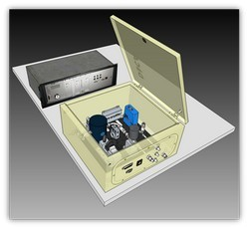
Figure 3.1 DOCA Sensor, CORDIS 2016

“In particular, the newly developed sensor system is capable of detecting contaminant concentrations of less than 1 ppb in all lubricants or mixed oils. The connection of the sensor to the compressed air system is achieved by a patented quick lock system”(CORDIS 2016). In 2016 a follow-up project was started by Eurostars with the title PASOCA (EUROSTARS 2016), in order to take the prototype to a certified commercial product. The system is based on the photoacoustic sensory technology. The sample (from the compressed air) is irradiated with nanosecond pulsed laser light. The contaminant particles absorb the light, causing local heating and thermo elastic expansion. Pressure or sound waves are emitted, which are detected by ultra-high frequency receiver. The detected frequency changes are amplified and can then be assigned to the components by their resonance frequencies.

A similar attempt is pursued by the Company PALL Aerospace with their pure cabin technology (Mlcak 2019) since it also relies on the measuring of resonant frequencies. The “PUREcabin” concept is divided in two parts, the “PALL Clean Air Technology” (PALL CAT) concentrating on the filtering of the cabin air, and the “Contaminant Sensing and Informing” (CSI). Since the filtering of the cabin air is already mentioned in Section 2.2 and is not subject of this thesis, the PALL CAT will not be further discussed at this point. The CSI is again split in three functions. Detecting contaminant events, determine whether the level of contaminants is stable, increasing or decreasing and finally identifying the contaminant source. The idea is to measure the “normal” operating condition in the aircraft and thereby being able to detect deviations from that normal state. This way the CSI works similar to the human nose, which as mentioned in Section 3.1, also recognizes an increasing concentration of a smell rather than the presence itself. The following Figure 3.2 shows the schematic structure of the Sensor technology developed by PALL Aerospace.

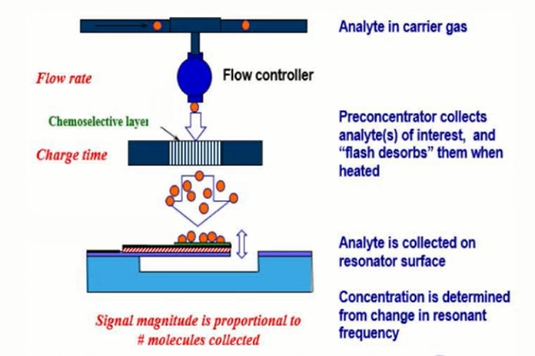
Figure 3.2 Schematic structure of the PALL cabin air quality sensor, Mlcak 2019

Based on the functionality of the human nose, the aim of the CSI is not just to detect the presence of components, but rather to clearly assign the odor (i.e. the combination of several components) to a source. As can be seen in Figure 3.2, in order to do so, a small amount of the cabin air is passed through a preconcentrator which collects and thereby isolates the analytes (chemicals) of interest. The Analytes captured are then heated up once a minute and flash desorb from the preconcentrator onto a resonator surface. When the analytes hit the resonator a change of mass occurs, causing a change of the resonant frequency. During the flash the resonant frequency is measured with a frequency of 100 Hz to measure the response spectra. The response spectra, which are exemplary shown in Figures 3.3 to 3.5 for Deicing fluid, Mobil jet oil and Exxon Hijet, are different for each chemical and can be assigned by running the response spectra through a pattern recognition algorithm. More precisely the change in the response spectra is analyzed by the pattern recognition algorithm.

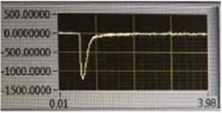  Figure 3.3 Response spectrum Deicing Fluid (Mlcak 2019) | 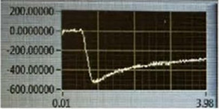  Figure 3.4 Response spectrum Mobil Jet Oil (Mlcak 2019)
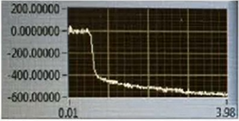
Figure 3.5 Response spectrum Exxon Hijet, Mlcak 2019

According to Mlcak (2019), when PALL Aerospace started their on-aircraft tests, they found themselves facing multiple difficulties, causing a delay of the product launch. The first problem arises from the condensed oil vapors and ultrafine particles, which can deposit on the surface of the sensor as well as on numerous others in the cabin. Such a coat on the sensor surface influences the accuracy of the measurement through the change in mass and also shortens the life span of the sensor through simultaneous partial oxidation. Since the use of filters in front of the sensor would make the measurement itself more or less obsolete, the problem can only be approached by adapting the sensor. PALL Aerospace therefore focused on finding materials that are compatible with the fluids used and with fouling mitigation features for the sensor. Another difficulty to deal with is the varying contaminant level depending on whether the ECS is on or off, causing false positives or negatives. When the ECS is turned off, the air in the cabin is stagnant, which causes a high contaminant level, since no fresh air can enter the cabin and the already present contaminants cannot exit the cabin. As a result, the measurements show high contaminant levels without having an external contamination source. By placing the sensor right in front of the ECS duct, the measurements just shows what the ECS is supplying. That way the problem of the fluctuating background level is avoided. Last but not least the on-aircraft tests show a dependence of the contamination level from the ECS state. When the ECS is set on cooling, the added contaminants are bound in the heat exchanger and therefore not detected at the ECS duct outlet. Only when the ECS is set to heat, the contaminants dissolve from the heat exchanger and get into the cabin. This discovery shows that cabin air pollution cannot be immediately and unequivocally associated with bleed air pollution. In order to do that PALL Aerospace aims to develop a bleed air sensor as soon as the cabin air quality sensor is in the field. That way the bleed air contaminants are measured before they reach the mixing chamber.

Independent of the PURECabin technology developed by PALL Aerospace, the FSS (2018) study defines the framework conditions for a corresponding sensor system as follows:

- Performance requirements suggest accuracy (±15%), sensitivity (low ambient levels), and sampling interval (≤60 s),
- Physical attributes suggest limitations on the size of sensor elements (≤ 3/8” in diameter), weight of sensor systems (≤1 kg), supply voltage (28 V),
- Cost motivated suggestions include frequency of maintenance (coincident with service schedules), required operator skill (minimal) and target cost for replaceable sensor elements (≤$100).
(FSS 2018, p.35)

Taking limiting factors like the inability of current sensors to tolerate ambient conditions into account, as well as too high costs and dimensions, “some research strategies have focused on miniaturization of whole sensing technologies that are currently too large to be portable” (FSS 2018, p.36) The technologies primarily aimed at are Ion Mobility Spectrometry (IMS), sub-components in current existing COTS sensors, and miniature Fourier Transform Infrared (FTIR) sensors like the one being developed by FrinGOe (2021). Considering two sensor types, COTS gas sensors and sensors based on “Thermal desorption – gas chromatography – mass spectroscopy” (FSS 2018, p.42), the FSS (2018) study proposes a concept for continuous air quality sensing called “Industrial cabin air quality Framework based on Continuous Air quality Sensing” (IFCAS). “The core of IFCAS is a network of distributed low power, low weight sensors that is distributed across the cabin” (FSS 2018, p.48), based on the operating principle of an electric nose like other solutions already assessed in this section.

3.5 Concepts for Sensor Implementation and Placement

In order to detect the presence of contaminants effectively and also being able to locate the source efficiently in adequate response time, it is important to distinguish the most suitable position for the sensors in the aircraft. Since the above-mentioned sensors operate with varying principles the suitable locations vary as well.

3.5.1 Hand-Held Devices

The placement of the handheld devices is largely determined by their definition, insofar as they have to be used in the cockpit or the passenger cabin. Nevertheless, it should be noted that these sensors, due to their generally limited efficiency in locating the source of the contamination, should definitely be positioned in a clearly visible location. Ideally, these sensors should be in the pilots' field of vision so that they are able to react to contamination as quickly as possible. If this is not the case, there is a risk that critical high measurements will be realized too late or not at all.

3.5.2 Fixed Devices

Since the monitoring of the fixed sensor devices does not necessarily dependent on the placement of the sensor itself, the sensors cannot just be placed in the passenger cabin or the cockpit, but also in the air conditioning ducts and other positions in the aircraft, depending on the sensors themselves.

There are several options for the placement of the sensors, which differ significantly in terms of costs, installation effort, precision, and scope of measurement. If you decide on the more extensive variant of optical acoustic spectroscopy, or if you follow the approach of PALL Aerospace with your cabin air quality sensor, it makes the most sense to place them at the ECS duct outlet, as these sensors are designed to measure several different contaminants. In this way, a large number of possible contaminations can be measured with just a few sensors and traced back to their cause. While a wide range of possible contaminations is covered, it is difficult and, in some cases, not even possible to determine the exact cause of specific contamination events of the cabin air, as shown by the on-aircraft tests by PALL Aerospace. In order to be able to trace every contamination event down to its specific source, the use of multiple sensors is necessary, making it very expensive to just use these kinds of sensors.

Another less expensive solution would be the use of fixed COTS sensors combined in an onboard air quality monitoring network. If placed at the outlet of the ECS ducts or other places in the cabin, the possibility to trace the cause for a positive measurement is very low. In order to obtain meaningful measurement results, it is necessary to position the sensors at significant points in the aircraft. In the event of a CACE due to contamination of the bleed air, the most sensible solution would be to place a CO sensor, or a sensor for other adequate indicator compounds on the bleed air line of each individual engine, even before the packs. In this scenario, it would be possible to immediately assign the corresponding problem to its cause, but at the same time numerous other reasons for contamination of the cabin air are not recognized or taken into account. If such simple sensors are used exclusively, this inadequacy can only be covered by a high number and placement in numerous other locations, which also leads to increasing costs.

The most reasonable attempt appears to be the one already exemplary pursued by PALL Aerospace with their CSI concept of the “PUREcabin” technology (Mlcak 2019). Their goal is the detection of a variety of different contamination events and the tracing of their causes. In order to do so, they place their cabin air quality sensor in front of the ECS duct outlets in the cabin, as described in Section 3.2.2, to magnify the number of detectable contamination events, and plan to place further bleed air sensors in the bleed air lines at positions where the bleed air has not yet entered the packs and the mixing chamber.

If stationary installed sensors are used, the question arises as to how an evaluation and a central evaluation can be achieved. Again, there are two basic principles. On the one hand, a conventional wired network of the sensors or a wireless network. In both cases, a centralized consolidation of the sensor values would be possible and thus centralized monitoring of the air conditioning system. In his 2012 Progress Report, Byron Jones (2012) already states:

Wireless sensor networks can provide the necessary coverage and cooperation to effectively monitor air quality sensor systems in aircraft bleed air supplies and airliner cabins. A prototype of such a system has been successfully tested in a Boeing 767 mock-up cabin. The wireless sensor network was shown capable of monitoring multiple environmental variables, and providing real-time, correlated data and represents a new tool that will improve our ability to characterize highly dynamic environmental control systems on aircraft. (Jones 2012, p.40)

4 Suitable Checklists for a CACE

When going through currently available emergency checklists one finds that there are already checklists addressing the event of smoke and fumes in the cabin which is suspected to come from the air conditioning. Even if the presence of these checklists is promising, it is important to check whether they adequately consider a CACE due to bleed air pollution and allow an appropriate reaction by the pilots. To check this, different emergency checklists for "Smoke and Fumes in Cabin" are compared, checked for similarities and differences, and then analyzed for applicability. The Airbus models A320/A330/A340, the Boeing B757/B767 and the McDonnell Douglas (Boeing) MD-11 serve as examples for EMC checklists provided by Original Equipment Manufacturers (OEM). In addition, some EMC Checklists from individual airlines are provided, directly addressing the presence of odors in the cabin.

4.1 Airbus A320/A330/A340

The Procedures for smoke, fumes and avionics smoke provided by Airbus is basically divided into two main blocks. First the "Immediate Actions", defining basic steps in order to protect the crew. These steps are reversable and designed to not worsen the situation. The second block is the diversion part. The diversion block is again split into sections, the first one being the "at any time" procedures, followed by the steps for the "Source determination". Starting with the “Immediate Action” block the checklists of the Airbus models begin with LAND ASAP, i.e. the request to land as soon as possible, as shown in Figures 4.1 and 4.2.

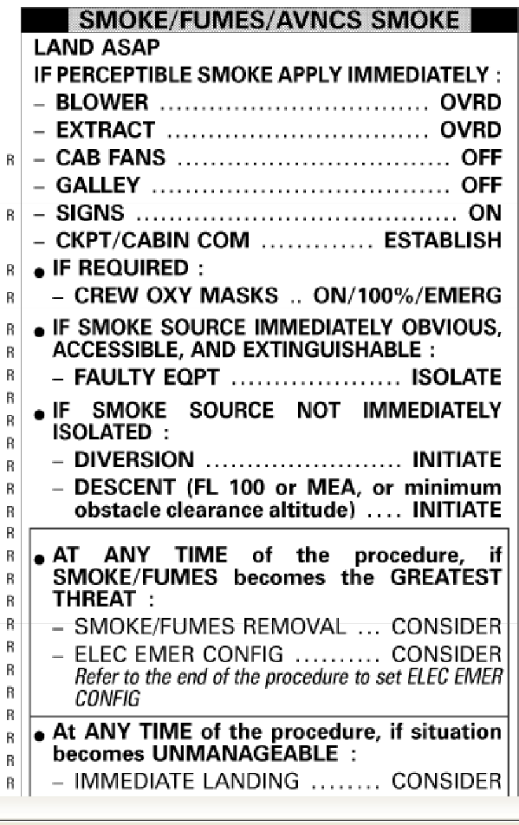
Figure 4.1 EMC procedure smoke in cabin, Airbus A320, general instructions,
Smart Cockpit 2020a

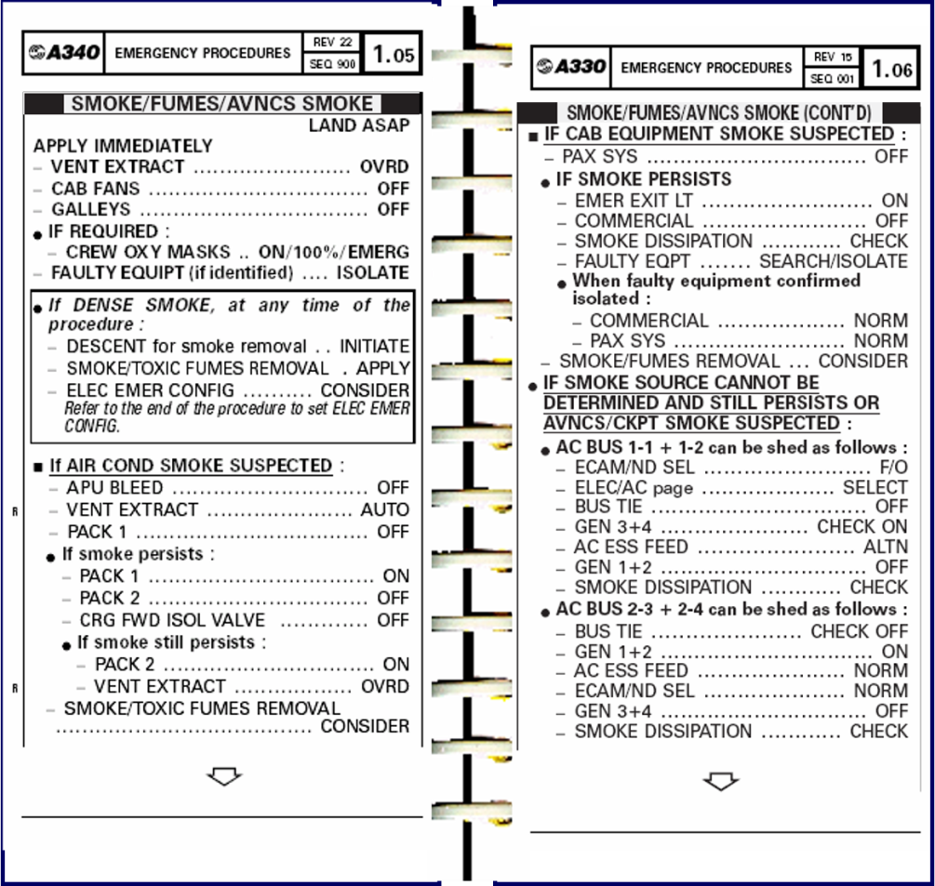
Figure 4.2 EMC procedure smoke in cabin, Airbus A330/A340,
Smart Cockpit 2020b
Even if landing as soon as possible is necessary or recommended in some cases, this does not have to apply to all cases of smoke or fumes in the cabin. If the cause can be determined quickly and the smoke and / or odor development can be stopped, it is not necessary to deviate from the destination airport. For the A320 the first instructions, beside LAND ASAP, are BLOWER OVRD, EXTRACT OVRD, CAB FANS OFF, and GALLEYS OFF, as can be seen in Figure 4.1. They are intended to disrupt the air recirculation in the cabin in order to prevent persistent contamination. As the marked area in Figure 4.3 shows, by switching the CAB FANS switch to off, the cabin fans, leading to the mixing chamber, are turned off. This way the used air from the cabin does not reenter the mixing chamber, which means that there is no more recirculation of the cabin air.

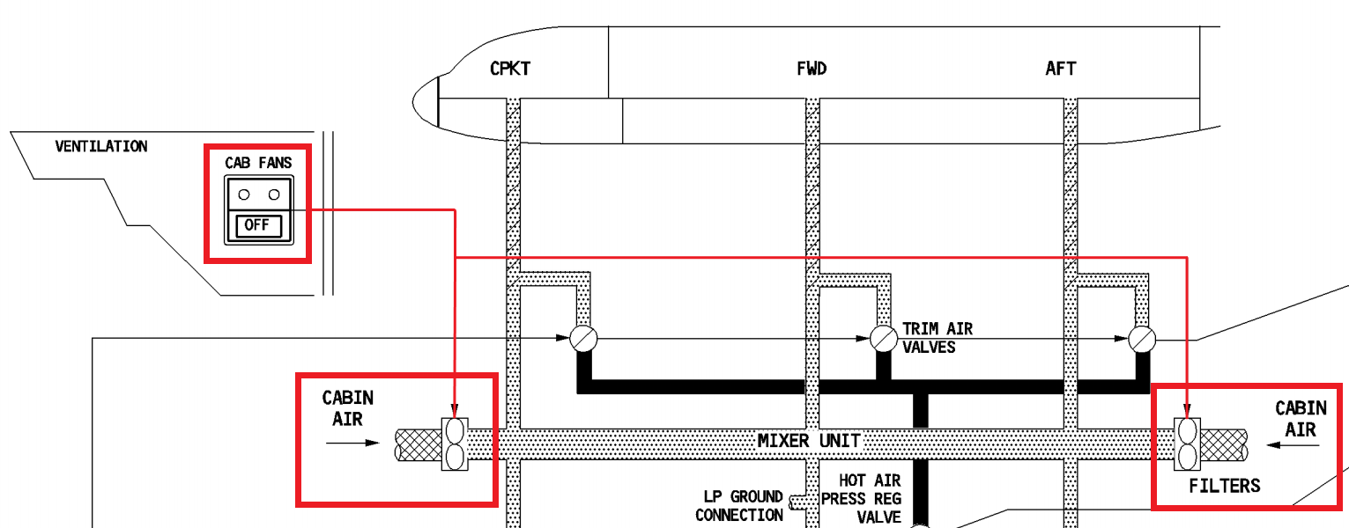
Figure 4.3 CAB FANS off, Airbus A320, Smart Cockpit 2021a

Both, the BLOWER, and the EXTRACT pushbutton are part of the avionics ventilation system. The BLOWER pushbutton is connected to the blower fan and the EXTRACT pushbutton controls the extract fan, as can be seen in Figures 4.4 to 4.6.

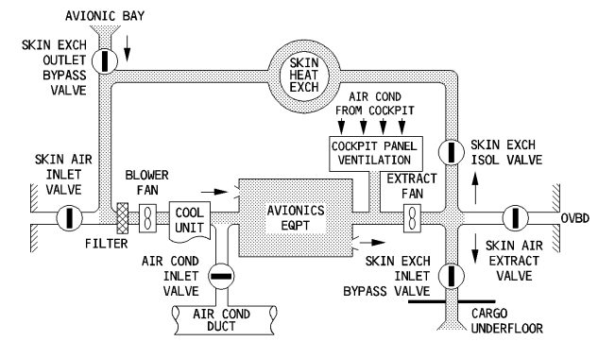
Figure 4.4 Avionics ventilation, normal operation, close-circuit config., Airbus A320, Smart Cockpit 2021a

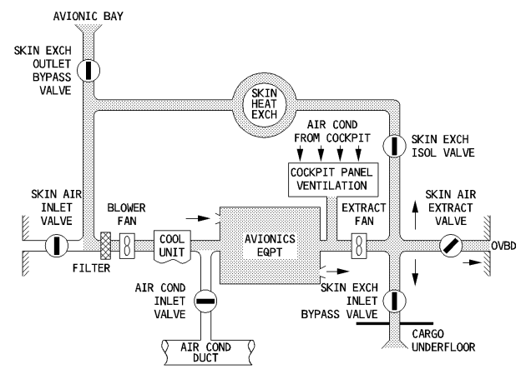
Figure 4.5 Avionics ventilation, normal operation, intermediate config., Airbus A320, Smart Cockpit 2021a

In normal inflight operation mode, the avionics ventilation is either in closed-circuit configuration (Figure 4.4), which means that the air used for the cooling circulates between the avionics compartment and the underfloor cargo compartment, or in intermediate configuration (Figure 4.5). In intermediate configuration the air still circulates between the underfloor cargo compartment and the avionics compartment but is partially extracted overboard. The operation mode depends on the skin temperature, i.e. the temperature in the cabin. If the skin temperature is above the inflight threshold the avionics ventilation operates in intermediate configuration. Otherwise the ventilation operates in closed-circuit configuration. By switching both, the BLOWER switch as well as the EXTRACT switch, to overwrite (OVRD) the avionics compartment is supplied with fresh air from the air conditioning system instead of recirculated air from the underfloor cargo compartment. The fresh air from the air conditioning system then passed through the avionics compartment and directly extracted overboard as shown in Figures 4.6 and 4.7.

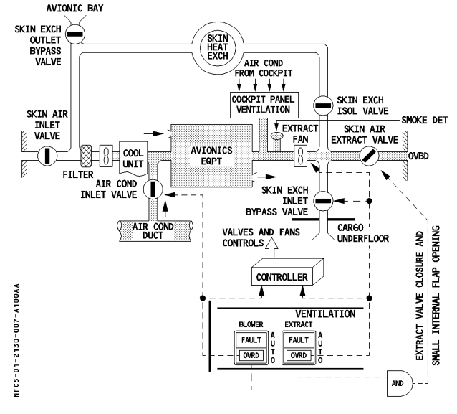
Figure 4.6 Avionics ventilation, smoke config., Airbus A320, Smart Cockpit 2021a

Having both the BLOWER and EXTRACT switch on OVRD, as well as the CAB FANS switch turned off, and thereby the air recirculation in the cabin and the avionics compartment stopped, the contamination level can go down as fast as possible, provided that the source of the contamination has been isolated.

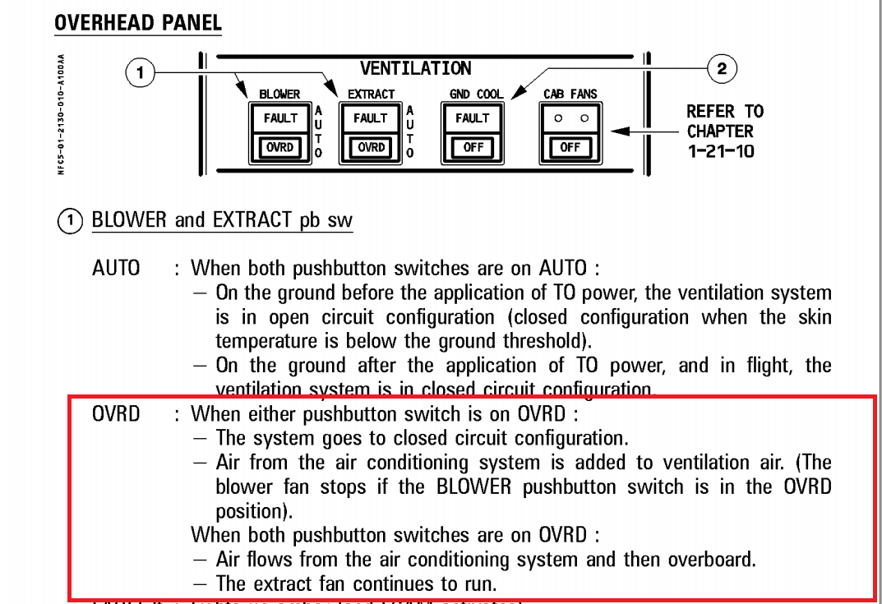
Figure 4.7 Overwrite Position BLOWER and EXTRACT Pushbutton, Overhead Panel, Airbus A320, Smart Cockpit 2021a

Since the on-board electronics cannot be excluded as a source of smoke or odor development at this point, the power supply to the primary and secondary galley is interrupted by switching the GALLEY pushbutton to Off, thus avoiding further damage from a possible short circuit or other electronic damage (see Smart Cockpit 2021b, p.48). Depending on the aircraft variant, there may also be a GALY & CAB pushbutton on the overhead panel instead of the GALLEY pushbutton. In this case, the power supply of the in-flight entertainment system (IFE) is also deactivated when it is switched off (see Smart Cockpit 2021b, p.50-52).

In the case of the A330 and A340, the same goal is pursued, here too the next instructions are CAB FANS OFF, GALLEYS OFF and VENT EXTRACT OVRD. Although the formulation differs from the A320 with the BLOWER and EXTRACT OVRD, its aim is identical as can be inferred from Figure 4.8 .

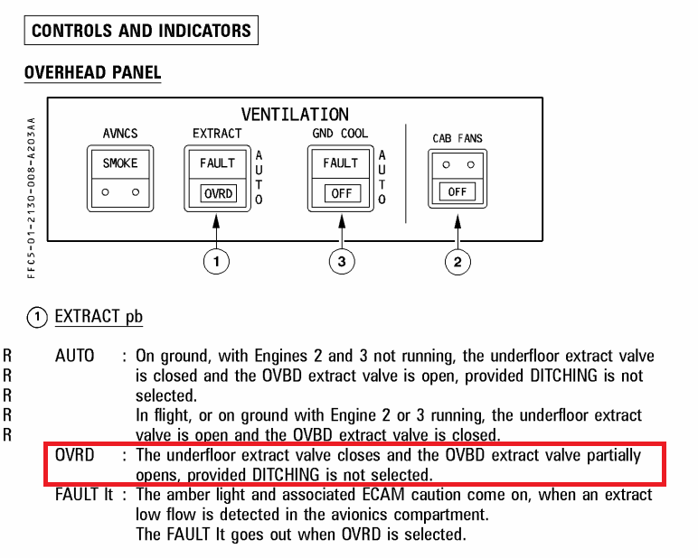
Figure 4.8 Overwrite position VENT EXTRACT Pushbutton, Overhead Panel, Airbus A340, Smart Cockpit 2021c

When the VENT ETRACT pushbutton is set to override, the overboard extract valve opens partially and the underfloor extract valve is closed. This way the potentially contaminated air from the avionics compartment is not circulated further through the underfloor cargo compartment, but directly extracted overboard (see Smart Cockpit 2021c, p.42). After the air recirculation is stopped, the oxygen supply of the crew masks is switched to ON, 100%, or EMERG according to both checklists, if it deems necessary.

Following the “Immediate Actions” the diversion steps are applied next starting with the check whether the faulty equipment can be identified immediately, and thereby be isolated. If not the case, the “at any time” steps are listed, which are meant to be applied whenever the smoke or fumes become the greatest risk. The A320 checklist stipulates that if the faulty equipment cannot be identified immediately, diversion and a descend to FL100 or minimum obstacle clearance altitude must be initiated. According to the A330/A340 checklist, a descent must only be initiated with dense smoke, for smoke and toxic fumes removal. In addition, it must be considered whether the on-board electronics should be switched to emergency configuration. The same procedure is also described in the A320 checklist in the event that smoke, or fumes are found to be the greatest danger.

The “at any time” steps are then followed by the main diversion procedure for the source identification. If smoke from the air conditioning system is suspected, i.e. also in the case of oil mist development due to bleed air pollution, the bleed air supply of the APU is first stopped for the A330 and A340, the extraction ventilation is switched to automatic and Pack 1 is switched off according to Figure 4.2. If the smoke still persists, Pack 1 is switched on again and Pack 2 is switched off, as well as the CRG FWD ISOL VALVE switch. If there is still no improvement, Pack 2 is switched on again and steps for smoke and toxic fumes removal should be considered. The equivalent procedure for the A320 can be seen in Figure 4.9.

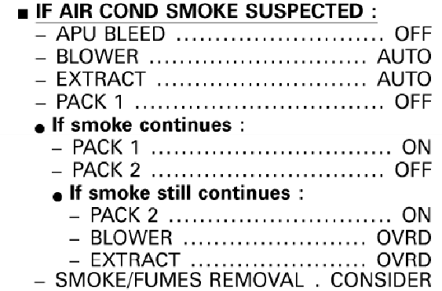
Figure 4.9 EMC procedure smoke in cabin, Airbus A320, air cond. smoke,
Smart Cockpit 2020a

As one will recognize the procedure is nearly the same in both checklists, apart from the checkpoint for the forward cargo isolation valve and a slight formal deviation, which has already been mentioned earlier. The checkpoints for the BLOWER and EXTRACT switch for the A320 are replaced by VENT EXTRACT switch for the A330 and A340. According to the pneumatics system instructions for the Airbus A320 (Smart Cockpit 2021d), when the APU bleed valve is closed, the cross-bleed valve is closed as well (see Figure 4.10).

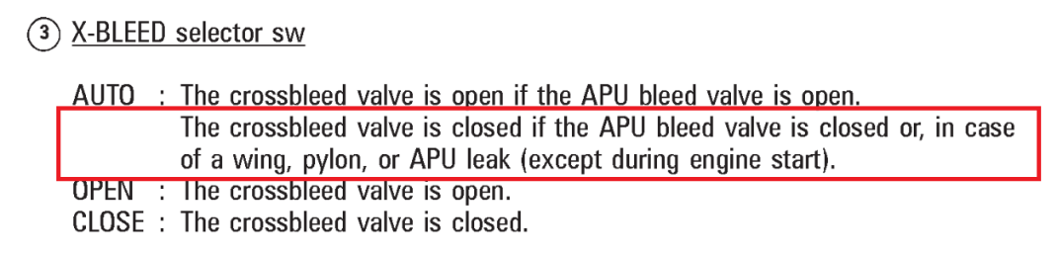
Figure 4.10 Airbus A320, pneumatics, X-BLEED selector sw, Smart Cockpit 2021d

As a result, after the APU BLEED Switch is switched off, each Pack is only fed through the bleed air supply line of one engine, as can be concluded from Figure 4.11.

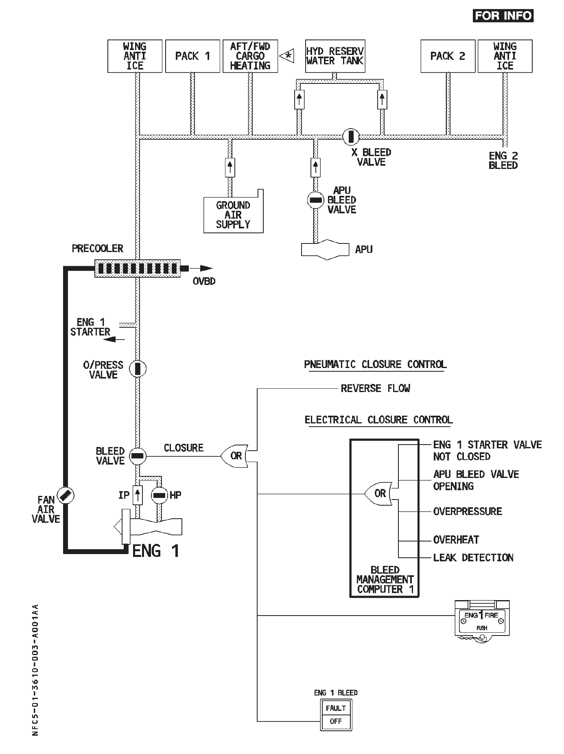
Figure 4.11 Airbus A320, pneumatics, pneumatic closure controls, Smart Cockpit 2021d

In case of a bleed air pollution the continuance of the cabin air contamination should be stopped when switching of the packs one by one, as long as the X-BLEED VALVE switch is set to AUTO or OFF. In case of the Airbus A330, which as well as the Airbus A320 is a twin turbine aircraft, the pneumatics system for the APU bleed vale and the cross-bleed valve works the same way, as evidenced by the pneumatics system instructions for the Airbus A330 (see Smart Cockpit 2021f). Although the Airbus A340 is powered by four turbines, the pneumatic system for the bleed air supply works very similar to the Airbus A320 and A330 systems. When the cross-bleed valve is closed, Pack 1 is fed with bleed air from engines 1 and 2. Pack 2 is supplied accordingly by Engines 3 and 4. The operating principle and connection between the APU bleed valve and the cross bleed valve are the same, as can be seen in the following Figures 4.12 and 4.13.

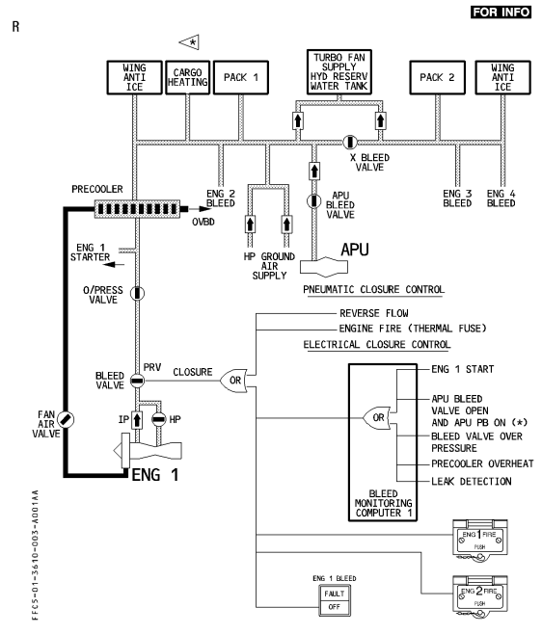
Figure 4.12 Airbus A340, pneumatics, pneumatic closure control, Smart Cockpit 2021e

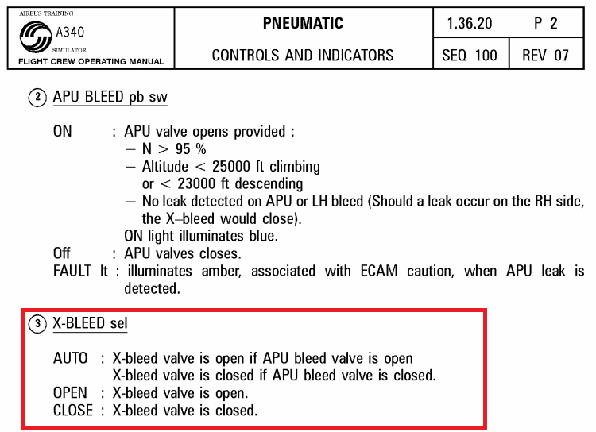
Figure 4.13 Airbus A340, pneumatics, X-BLEED selector sw, Smart Cockpit 2021e

In case of the Airbus A330 and A340, when Pack 2 is switched off, the CRG FWD ISOL VALVE switch is switched off as well, i.e. the cargo forward inlet and outlet isolation valves are switched off (see Smart Cockpit 2021c, page 58). As can be seen in Figure 4.14, by switching of the cargo forward isolation valves the extract fan is also stopped.

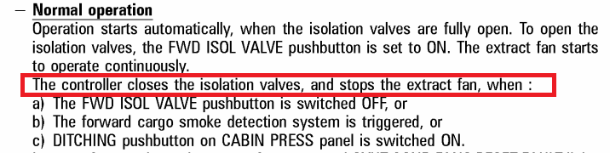
Figure 4.14 Airbus A340, air conditioning, CRG FWD ISOL VALVE, Smart Cockpit 2021e

“Due to extract fan suction, the cabin air flows through the inlet isolation valves into the forward cargo compartment via the sidewall and ceiling inlets. Air is extracted through outlets, on the opposite sidewall, and goes via the extract fan and outlet isolation valve to the underfloor bilge area near the forward outflow valve. To decrease compartment temperature, the inlet ventilation air is mixed with cold air from Pack 2”(Smart Cockpit 2021c, page 56, ll. 3-8).

When the cargo forward isolation valves are switched off, the cold air supply from Pack 2 is cut of as well, which can also be found on page 58 of Smart Cockpit 2021c. Since the cold air is gained from Pack 2, the isolation of the forward cargo compartment is necessary if the smokes source is suspected to be Pack 2.

If the source is different from the one considered in this case and the smoke production does not subside even after switching off the two packs, or the X-BLEED VALE switch is set to ON, i.e. the cross bleed valve is open, the checklist "If smoke source cannot be determined and still persists" will be applied. For the A330 and A340 this can already be seen in Figure 4.2, the corresponding process for the A320 is shown in the following Figure 4.15.

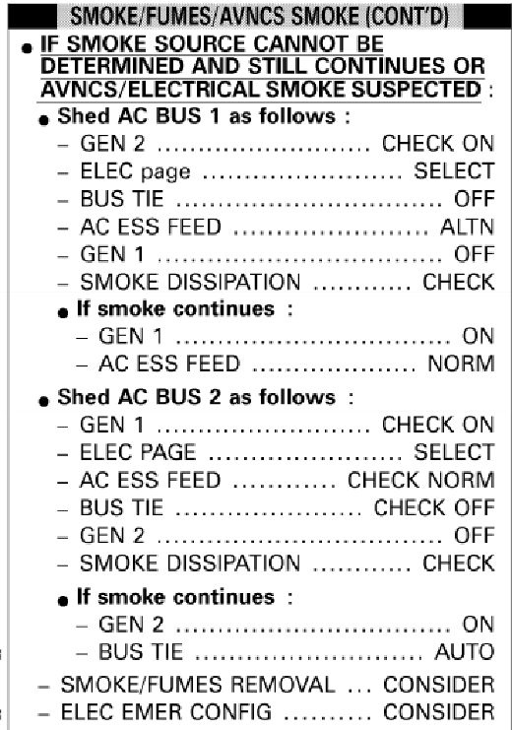
Figure 4.15 EMC procedure smoke in cabin, Airbus A320, source cannot be determined,
Smart Cockpit, 2020a

As Figures 4.2 and 4.15 show, if the cause for the smoke or fumes cannot be determined in the air conditioning system, the further procedure is primarily based on the assumption that the electronics have malfunction. For this reason, the A320 as well as the A330 and A340 are switched to AC Essential and generator 1 and 2 are switched on and off one after the other to exclude them as possible source. Since there is no fault in the electronics in the case of a CACE due to bleed air contamination, these efforts would have no effect.

4.2 Boeing B757/B767

Following the Airbus EMC checklists, the EMC checklists of the B757 and B767, which are exemplary for Boeing, are now evaluated to the same extent. The following Figures 4.16 and 4.17 show the Emergency Quick Reference Checklist (QRC) and the Emergency Checklist for smoke, fire, and fumes for the Boeing B757 and B767.

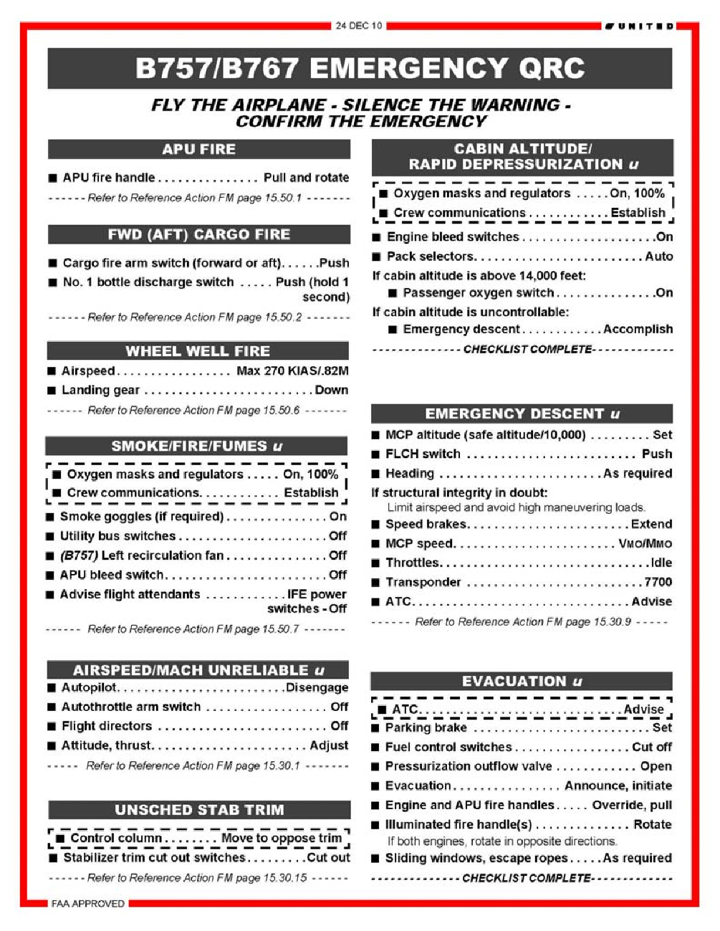
Figure 4.16 Emergency QRC, Boeing B757/B767, AAIB 2011

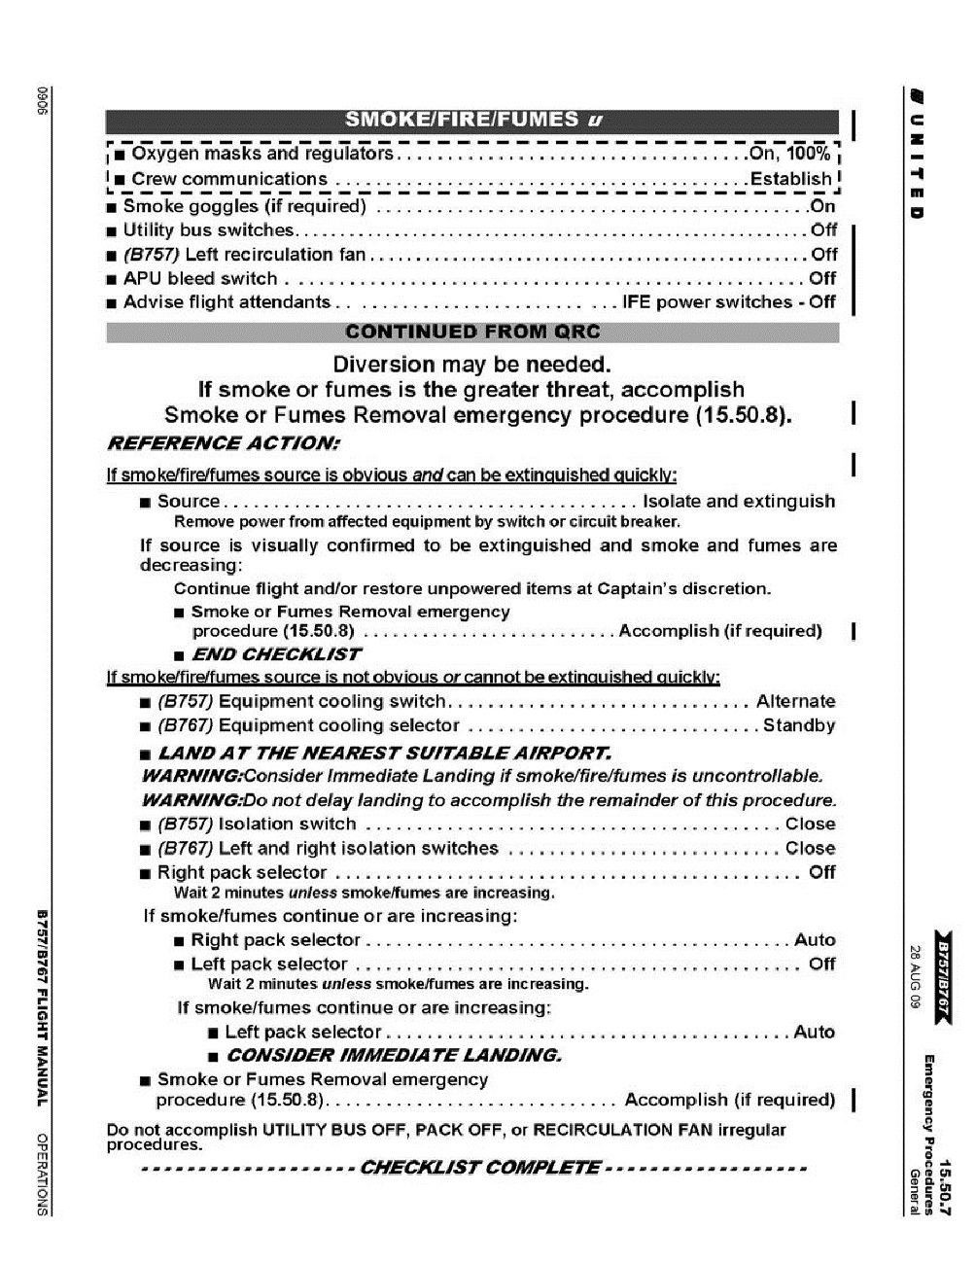
Figure 4.17 EMC checklist smoke/fire/fumes, Boeing B757/B767, AAIB 2011

As with the emergency checklists of the Airbus aircraft, the first steps in the QRC of the Boeing B757 and B767 (Figure 4.15) are switching on the oxygen masks and switching to 100% oxygen supply, followed by establishing crew communication. Then the utility bus switches, and the Inflight Entertainment (IFE) power switches are switched off. In addition to the electronics, the air recirculation is interrupted, and the APU bleed air supply is stopped. The Quick Reference Checklist QRC ends with the reference to the detailed, subsequent reference action Flight Manual (FM) page 15.50.7, which is shown in Figure 4.16. Like the EMC checklist for Airbus aircraft, this begins with the case that the source of the smoke/fire/fume is obvious and quickly extinguishable. In this case, the source must also be isolated for Boeing aircraft and extinguished in the event of a fire. In addition, the appropriate steps for smoke and fumes removal must be taken, if necessary. In the event that the source cannot be determined immediately, the equipment cooling is switched to alternate (B757) or standby (B767) and the isolation switches are set to close. Then, likewise the Airbus EMC checklists, the two packs are switched on and off one after the other in order to check them as a possible source. If these measures do not have any effect, according to the EMC checklist of the Boeing B757 and B767, only the fastest possible landing and measures for smoke or fumes removal remain an option.

4.3 McDonnell Douglas MD-11

Another example is the McDonnell Douglas (Boeing) MD-11. Here, there is an EMC checklist for the event that smoke is suspected from the air conditioning system as well, which is shown in Figure 4.18.

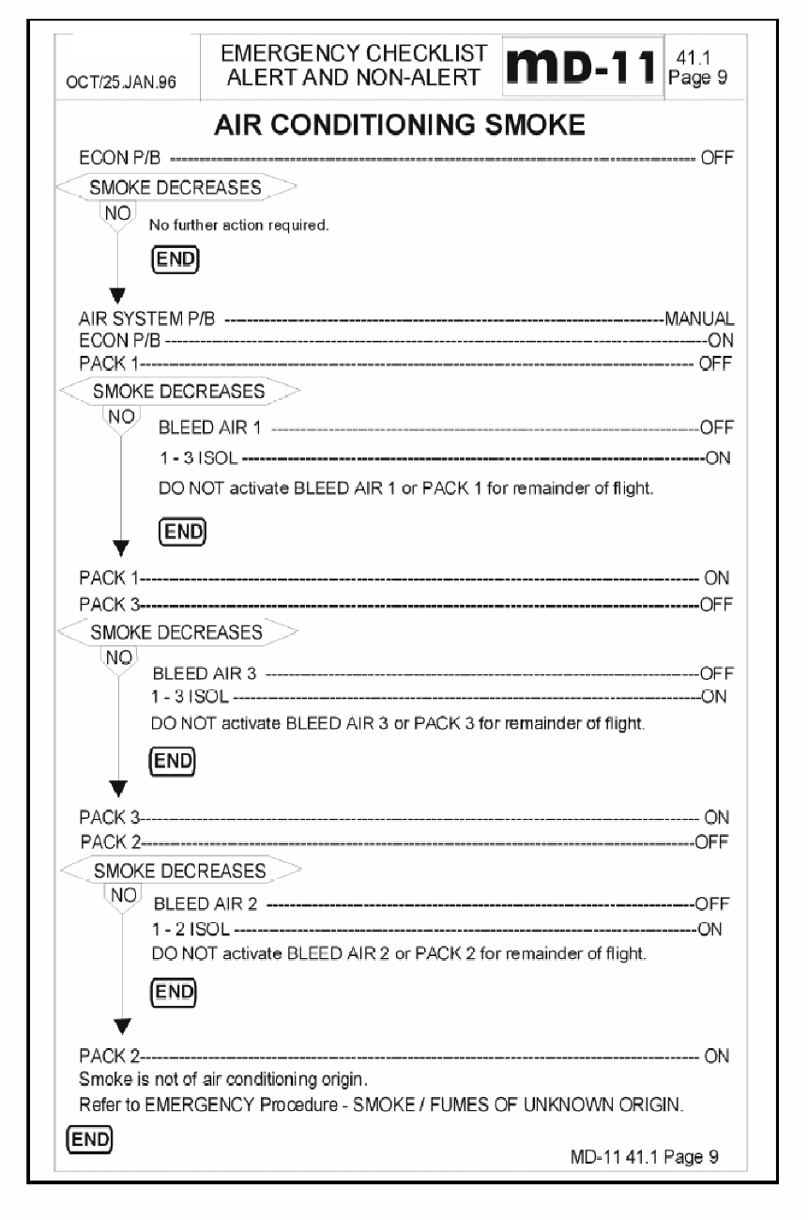
Figure 4.18 EMC checklist air conditioning smoke, McDonnell Douglas MD-11, Burian 2021

Unlike the Airbus and Boeing aircraft considered so far, the MD-11 does not have two but three Packs. When smoke is suspected from the air conditioning system, first the ECON P/B switch is switched to Off. As can be seen in Figures 4.19 and 4.20, switching the ECON push button to OFF the Packs operate under normal condition and the recirculation fans are turned off.

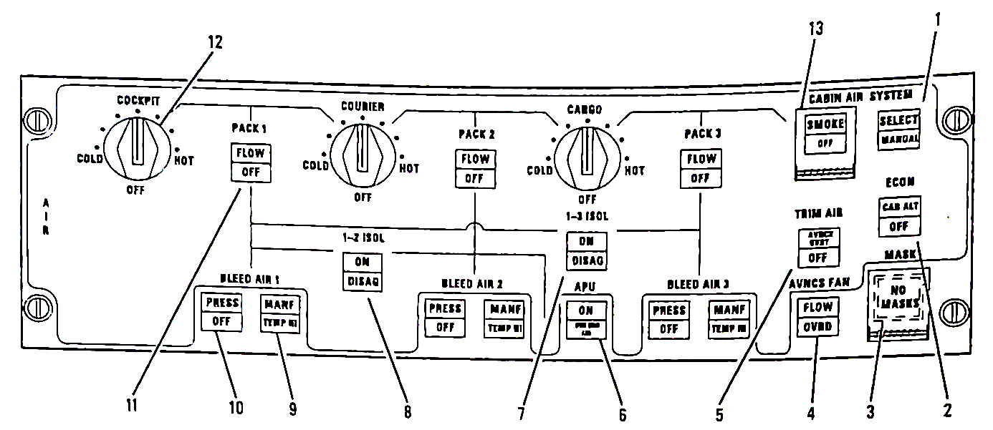
Figure 4.19 Air Control Panel, McDonnell Douglas (1993) MD-11

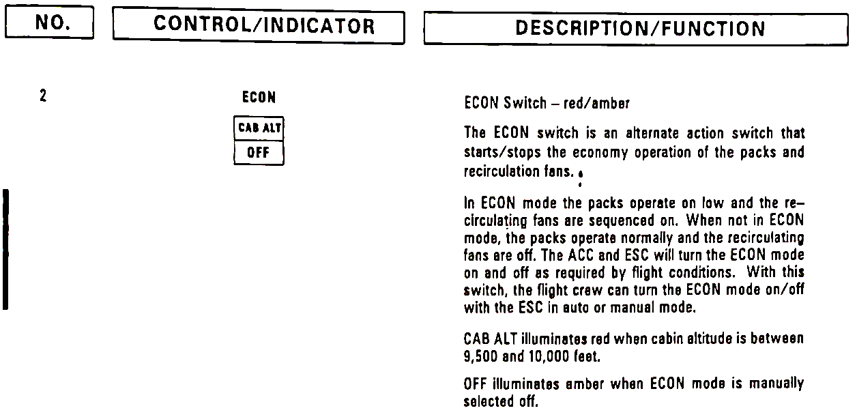
Figure 4.20 Air Control Panel, ECON P/B, McDonnell Douglas (1993) MD-11

The goal in doing so is to determine whether there is a problem in the recirculation system. If the smoke does not decrease, a problem in the fresh air supply is most likely, so the AIR SYSTEM P/B switch is set to manual, the ECON P/B switched back on and Pack 1 is turned off. With the ECON P/B switch set to ON the recirculation of the cabin air operates normally and the Packs work on low condition. As Figure 4.21 shows, when the air system is in manual mode, setting the Pack 1 switch to OFF will close the associated pack flow control valve and the ram air door.

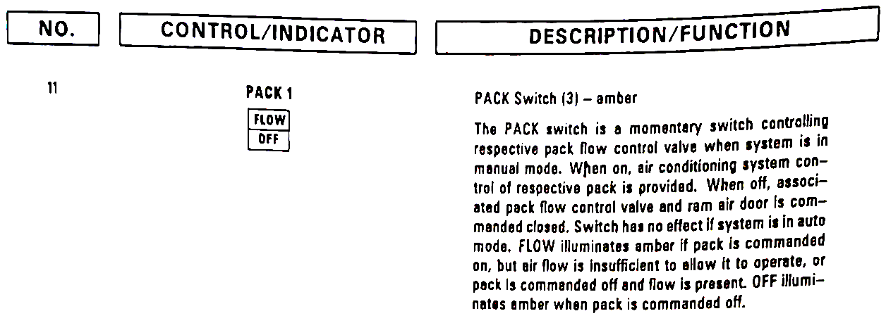
Figure 4.21 Air Control Panel, Pack 1 sw, McDonnell Douglas (1993) MD-11

If the smoke decreases a malfunctioning in either Pack 1 or Engine 1 can be concluded, the bleed air supply from engine 1 is then stopped, Pack 1 deactivated and the isolation valve 1-3 ISOL opened. The resulting air supply to the cabin can be seen in Figure 4.22.

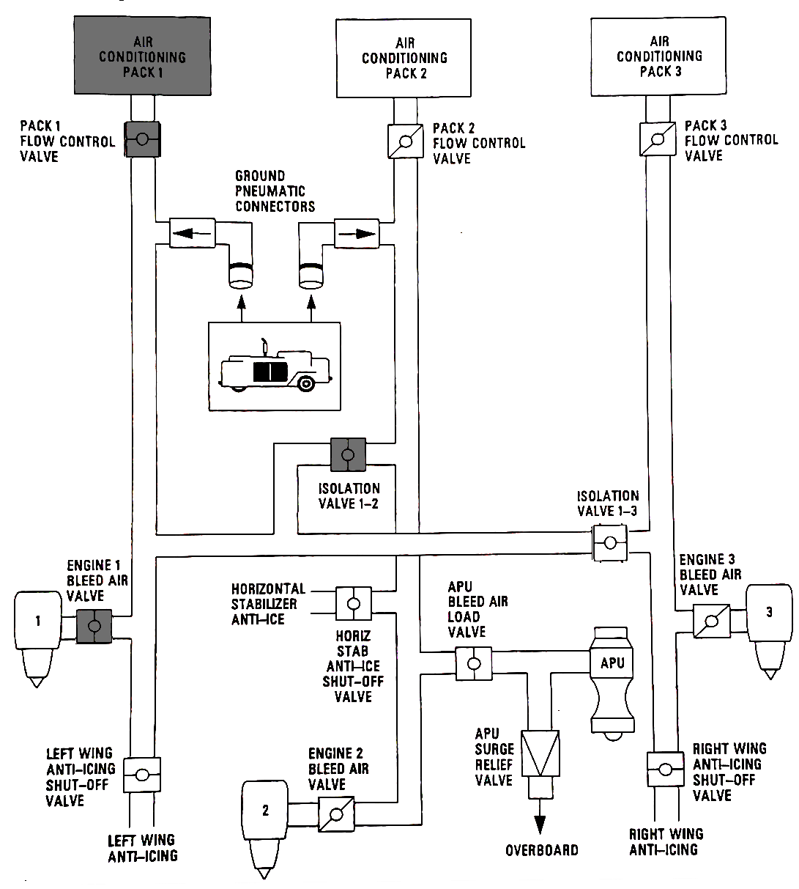
Figure 4.22 Engine 1 Bleed air and Pack 1 off, 1-3 ISOL valve open, McDonnell Douglas MD-11, based on McDonnel Douglas 1993

If this setting is used, only Packs 2 and 3 are used, Pack 2 is fed exclusively from Engine 2 and Pack 3 exclusively from Engine 3. By opening the isolation valve 1-3, a bleed air supply for the Anti-icing for the left wing is still provided, despite the deactivation of the bleed air supply by Engine 1. If the smoke level remains the same, Pack 1 is switched on again and Pack 3 is switched off. In case of a decreasing smoke level isolation valve 1-3 ISOL is opened like before and the bleed air supply from Engine 3 is stopped, resulting in the air supply configuration presented in Figure 4.23. This time the open valve 1-3 provides the continuance of the bleed air supply for the Anti-icing of the right wing.

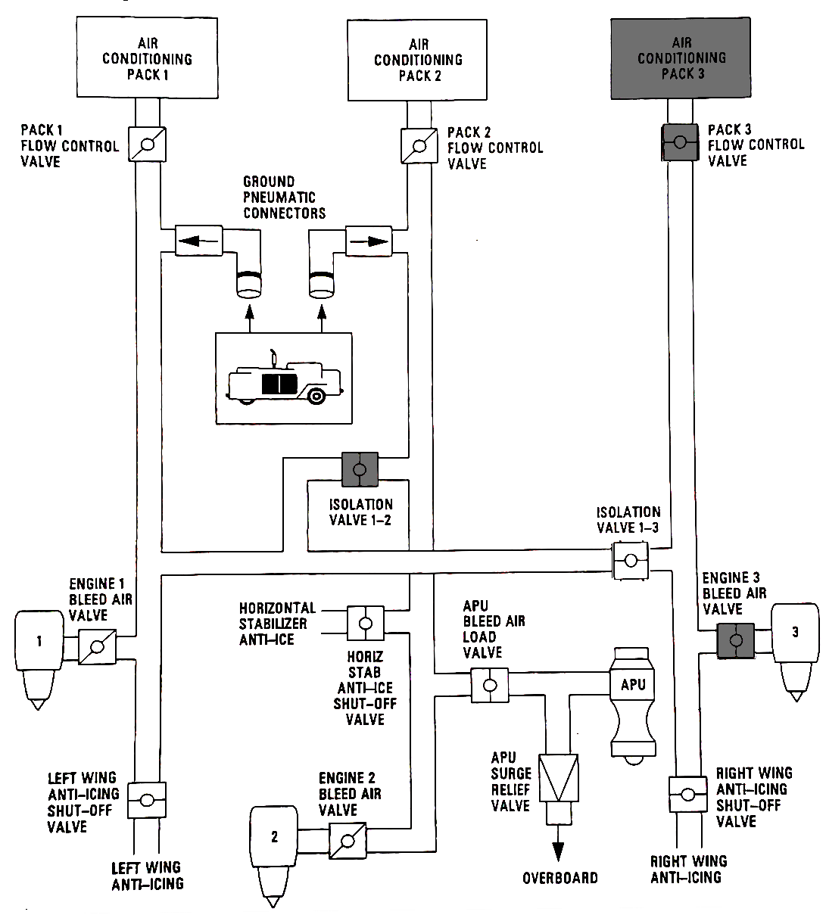
Figure 4.23 Engine 3 Bleed air and Pack 3 off, 1-3 ISOL valve open, McDonnell Douglas MD-11, based on McDonnel Douglas 1993)

The same goes for Pack 2 if the smoke still persists after switching off Pack 3 and the resulting air supply configuration shown in Figure 4.24. If the smoke decreases when Pack 2 is turned off, isolation valve 1-2 ISOL is opened to provide bleed air to the necessary systems usually supplied by Engine 2 and the bleed air supply from Engine 2 is stopped. Like before the air supply to the cabin is then provided by the two remaining Packs.

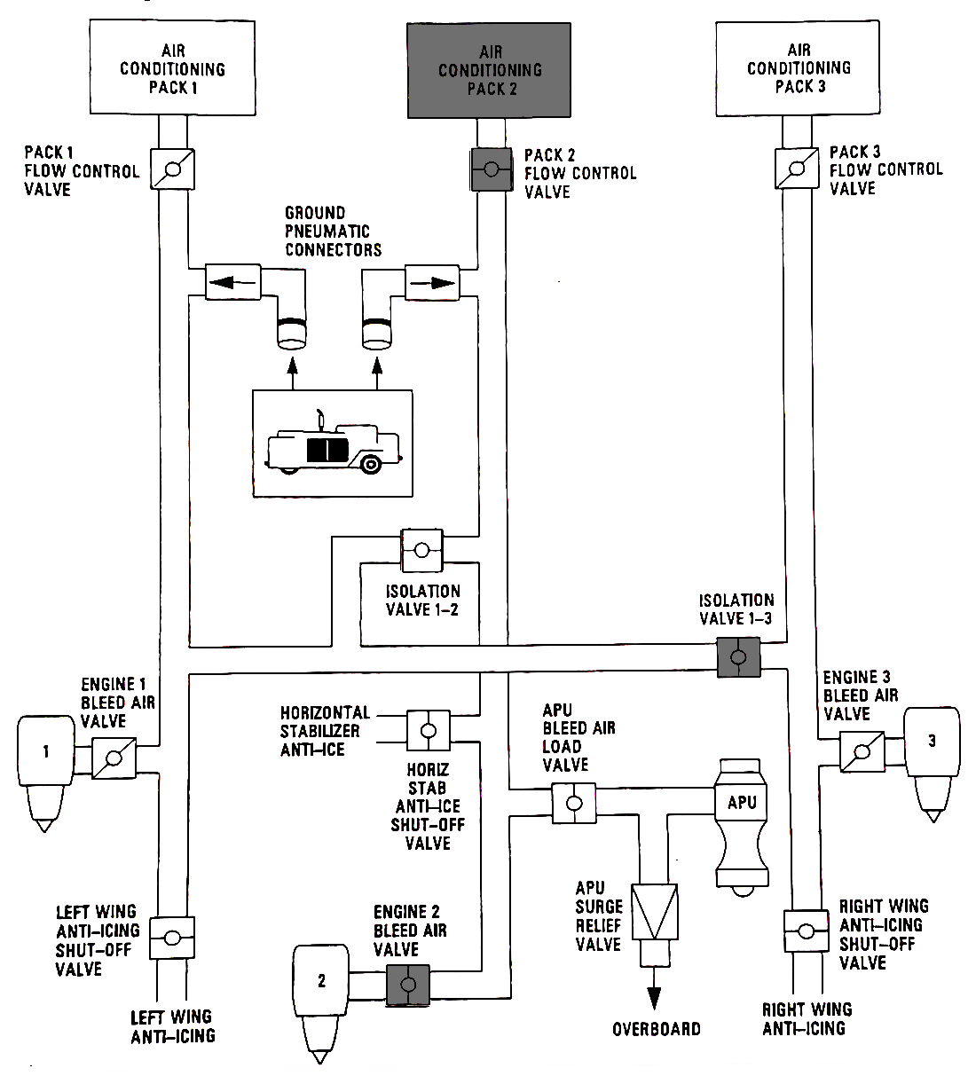
Figure 4.24 Engine 2 Bleed air and Pack 2 off, 1-2 ISOL valve open, McDonnell Douglas MD-11, based on McDonnel Douglas 1993

If these efforts show no effect, all packs remain set to on. The smoke is no longer considered to come from the air conditioning and the EMC CHECKLIST SMOKE/FUMES OF UNKNOWN ORIGIN is applied. As Figure 4.25 shows, when the EMC Checklist for smoke or fumes of unknown origin is applied, the first step is to switch off the CAB BUS switch in order to check the cabin bus system as the smoke origin.

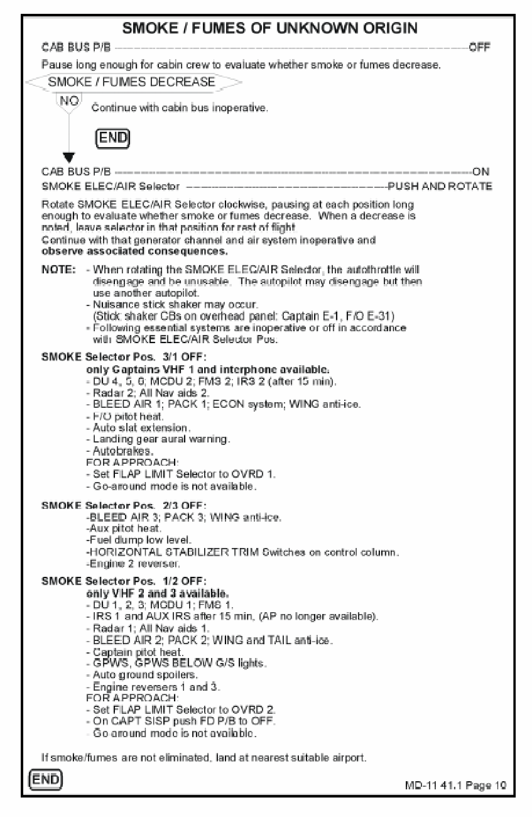
Figure 4.25 EMC checklist smoke/fumes of unknown origin, McDonnell Douglas (Boeing) MD-11, Burian 2021

If the smoke does not decrease the CAB BUS switch is turned back on and the SMOKE ELEC/AIR selector is applied. The SMOKE ELEC/AIR selector has three selectable positions. Along with other systems in selector position 3/1 OFF, BLEED AIR 1 and Pack 1 are set inoperative. In position 2/3 OFF BLEED AIR 3 and Pack 3 are inoperative and BLEED AIR 2 and Pack 2 in selector position 1/2 OFF. As a result, bleed air contaminations can be determined as the smoke source, even if not using the EMC checklist for AIR CONDITIONING SMOKE. Even though the checklist does not allow a differentiation between a male function of a pack or a bleed air contamination, the contamination of the cabin air can be stopped.

4.4 EMC Checklists provided by airlines

In addition to the EMC checklists provided by the OEMs there are several checklists provided by individual airlines directly addressing the event of odors in the cabin. The following figure 4.26 shows a checklist from the US American airline Frontier.

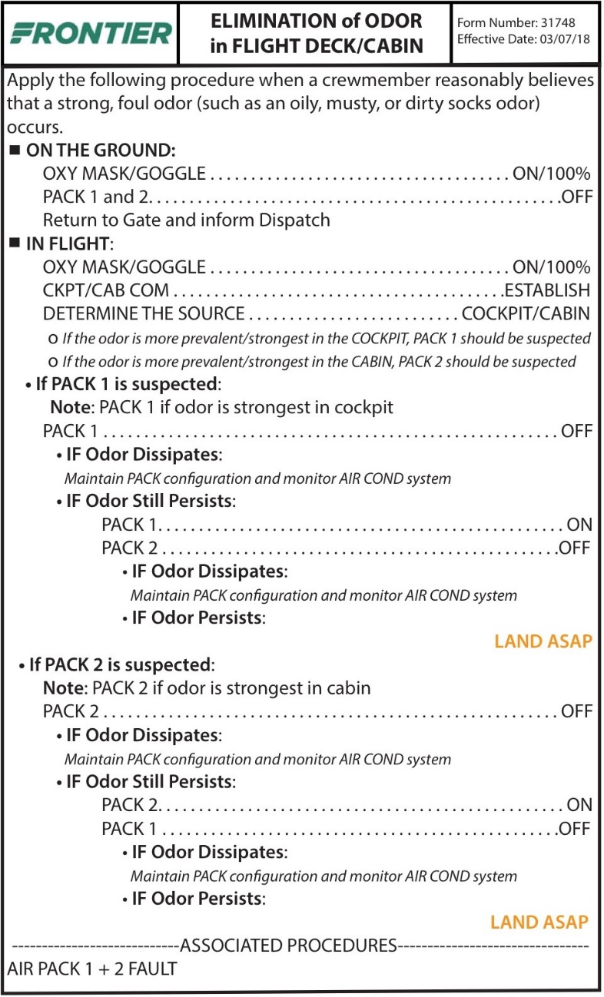
Figure 4.26 EMC Checklist ELIMINATION of ODOR in FLIGHT DECK/CABIN, Scholz 2020c

Unlike the previous checklists, this one makes use of the fact that Pack 1 primarily supplies the cockpit and the front area of the aircraft and Pack 2 supplies the rear area. First, a distinction is made between whether the incident occurs in flight or on the ground. In the event that the problem occurs in flight, the first steps are to put on the oxygen masks and establish communication with the cabin. It is then checked whether the odor occurs mainly in the front or rear area of the aircraft. Depending on this, either Pack 1 or Pack 2 is switched off. If the odor persists, the initially suspected Pack is switched back on and the other Pack is switched of. In case that the problem cannot be solved this way, landing as soon as possible is recommended.

Although this procedure can accelerate troubleshooting, it can only be applied to a few aircraft models. As shown in Figures 4.27 and 4.28, the cockpit of the Boeing models B757 and B777 is supplied directly with fresh air from the left pack, i.e. Pack 1.

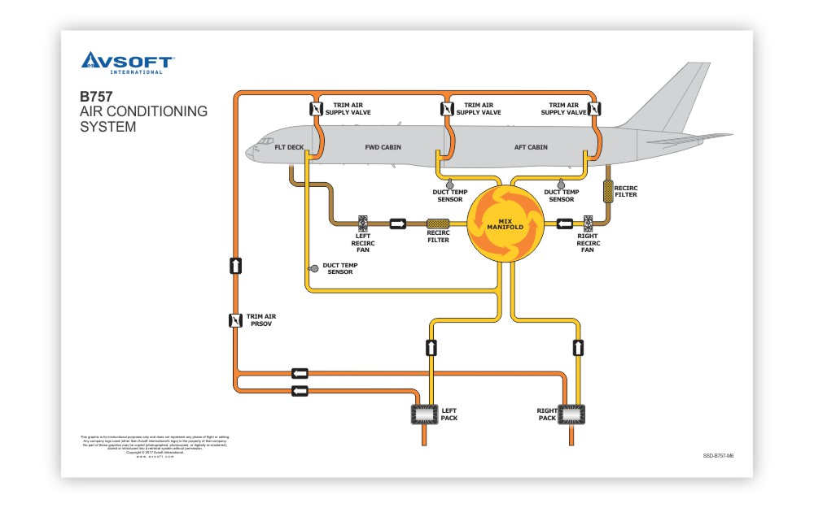
Figure 4.27 Boeing 757 Air Conditioning System, Avsoft 2018a

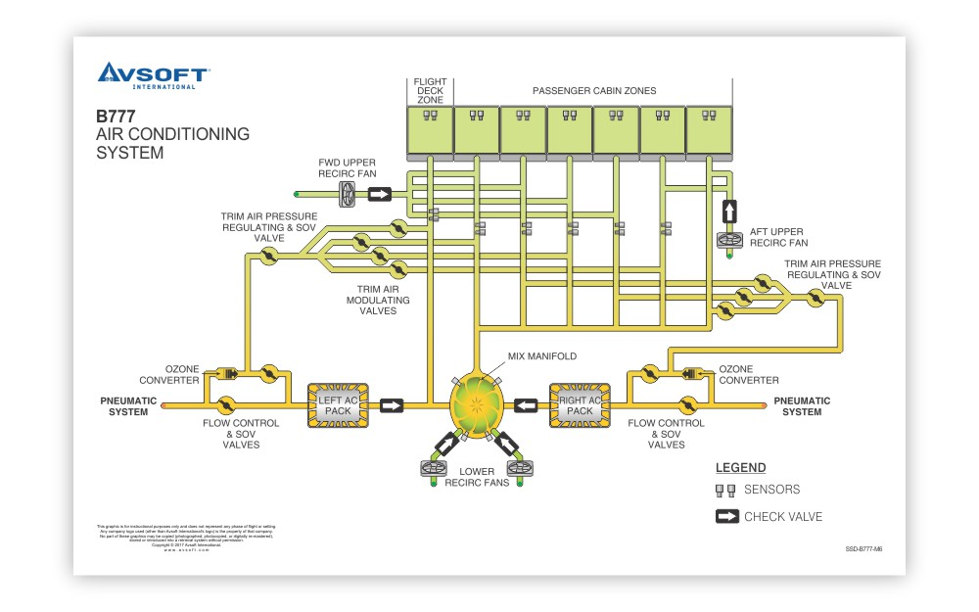
Figure 4.28 Boeing 777 Air Conditioning System, Avsoft 2018b
In other aircraft, such as the Airbus models discussed above, the cockpit is not fed with fresh air from a specific pack. Instead, like the cabin, the cockpit draws its fresh air from the mixing chamber. For this reason, the fresh air both in the cockpit and in the cabin is very likely to be equally contaminated if contamination comes from a pack or the bleed air supply of an engine.

The attempt is similar to the EMC checklist for smoke or fumes in the cabin. Although the attempt to localize the area in the aircraft appears to safe time in the trouble shooting process, there are several factors unobtained. In contrast to the OEM checklists, the APU is not explicitly switched off first. Accordingly, if the APU is not switched off the cross-bleed valve is not closed automatically. The result is that both packs are equally supplied with bleed air from all engines. If there is now a contamination, for example from engine oil in the bleed air, both packs are equally supplied with the contaminated bleed air, which is why switching the individual packs on and off has no effect. The APU might be assumed to be turned off, but to ensure an efficient troubleshooting, it should be named explicitly.

American Airlines also provides an EMC Checklist for odors, toxic substances, and volatile liquid for the Boeing 737, which is attached as Appendix A. This checklist covers various causes and sources of fire, smoke, and odors. If you focus on a CACE caused by bleed air contamination, the flow chart shown in Figure 4.29 results.

Figure 4.29 EMC Checklist odors/toxic substances/volatile liquid, American Airlines, Boeing B737, based on Appendix A

Like the Frontier Checklist, this one takes advantage of the differentiation between forward and rear cabin contamination of the cabin air. Additionally, unlike the EMC Checklist provided by Frontier, this checklist also covers the contamination of the bleed air supply of an individual engine before entry into the Packs. That is achieved since here the APU bleed air supply is initially stopped and the isolation valve is closed, with the effect that each Pack is only supplied by exactly one engine.

4.5 Applicability and Potential Problems

Although the EMC Checklists for smoke, fire and fumes theoretically cover a CACE due to bleed air contamination, in terms of finding the source it is uncertain whether the procedure is efficient enough to adequately respond to such an incident. The most important aspect is the time it takes to determine and eliminate the source. Under normal conditions when using both packs, the air exchange rate is around 20 to 30 changes per flight hour, i.e. one “complete change” every 2 to 3 minutes (see Lakies 2019a, p.14). Although in theory a complete change of cabin air is assumed every three minutes, this is not a literally accurate description. The air exchange rate represents the volume of fresh air from the environment flowing into the cabin with the unit cabin volume per hour. Since the fresh air is only mixed with the air already in the cabin instead of directly replacing it, the time it takes for a complete exchange of the cabin air exceeds three minutes by far. In Schuchard 2017, the resulting thinning effect is described as a "forced thinning effect" and would ensure that if the source is eliminated, the contamination levels fall below a measurable level within minutes. Due to the complex geometry in the cabin, this is not the case in reality. Seats and cabin monuments act as sink and cause the thinning effect to slow down. This case is referred to in Schuchard 2017 as the "delayed thinning effect". In his memo from June 27th, 2020 Scholz (2020b) explains:

The (theoretical) air change rate is the air flow rate divided by the volume of the room. With full mixing (i.e. ventilation efficiency of 1), the concentration is reduced to 36.8% after one air change. (Scholz 2020b, p.1)

Scholz (2020b) bases this on the fundamental ventilation equation

$S+Q_{e}C_{out}-Q_{e}C=V\frac{dC}{dt}$ , (4.1)

S: source strength in kg/s
$Q_{e}$: effective air flow rate for ventilation in m³/s
C: concentration of CO2 or any other substance in kg/m³ in the room
$C_{out}$: concentration of CO2 or any other substance in kg/m³ outside of the room
V: volume of the room

and develops the following equation for the percentual change of a contaminant concentration over time for $C_{0}=S/V$:

$\frac{C(t)}{C_{0}}=e^{-1/T∙t}=e^{-ηλt}=e^{-η\frac{t}{t_{n1}}}$ , (4.2)

with $t_{n1}$ being the time for “one theoretical air exchange”(Scholz 2020b, p2), the air exchange rate λ and the ventilation efficiency η. Considering a ventilation efficiency of $η=1$, results in the percentual change over theoretical air exchanges shown in Table 4.1 and Figure 4.30.
Table 4.1 Relative remaining concentration for a ventilation efficiency of η = 1 over
relative time, Scholz 2020b
$$x=\frac{t}{t_{n1}}$$ | 0.1 | 1/3 | 1/2 | 1 | 2 | 3 | 4 | 5
$$C(t)/C_{0}$$ | 90.5% | 71.7% | 60.7% | 36.8% | 13.5% | 5.0% | 1.8% | 0.67%

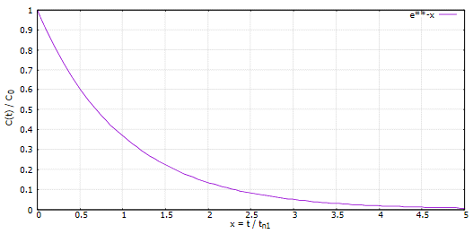
Figure 4.30 Relative remaining concentration for a ventilation efficiency of η = 1 over
relative time, Scholz 2020b

Considering the decay time, which is defined by the EU Guidelines to Good Manufacturing Practice (EU GGMP 2008), as the time it takes for the concentration to decrease to 1%, and can be calculated from

$t=-\frac{t_{n1}}{η}ln\left(C\left(t\right)/C_{0}\right)=-\frac{t_{n1}}{η}ln(0.01)=4.605\frac{t_{n1}}{η}$ , (4.3)

as well as assuming a ventilation efficiency of $η=46.05\%$, Scholz (2020b) concludes:

The air in a room will never be "fully renewed", but a remaining concentration of 1% may be accepted to call this "fully renewed" (in accordance with ISO 14644-3). As a rule of thumb "fully renewed" is achieved during a time about ten times the time for one (theoretical) air change.
(Scholz 2020, p.5)

A further aspect which needs to be considered is the filtering. In his bachelor thesis, Marcel Lakies developed an Excel tool with which the temporal progress of a contamination can be calculated. Lakies (2019a) sets up the following equations 4.4 to 4.8 in which he considers the air exchange rate, as well as the proportion of recirculated air and the influence of possible filters in the air conditioning system:

$c_{cab}\left(t\right)=C∙e^{-at}+\frac{b_{1}+b_{2}∙\left(t-\frac{1}{a}\right)}{a}$ , (4.4)

where $a$, $b_{1}$, $b_{2}$ and $C$ are defined as:

$a=λ∙\left(1+τ-Θ∙α_{d,rec}∙α_{f,rec}∙α_{d,in}∙α_{f,in}\right)$ (4.5)

$b_{1}=\frac{1}{V_{cab}}∙S_{i,con}+S_{s,con} ε α_{f,in}+\left(1-Θ\right)∙\left(S_{oa,con}+S_{cp,con}\right)∙α_{d,ca} α_{d,in} α_{f,in}$ (4.6)

$b_{2}=\frac{1}{V_{cab}}∙S_{i,lin}+S_{s,lin} ε α_{f,in}+\left(1-Θ\right)∙\left(S_{oa,lin}+S_{cp,lin}\right) α_{d,ca} α_{d,in} α_{f,in}$ (4.7)

$C=c_{0}-\frac{1}{a}∙\left(b_{1}-\frac{b_{2}}{a}\right)$ (4.8)

According to Lakies (2019a), C is the constant of integration, not a concentration and therefore negligible for the influence on the change of contaminant levels over time. Nevertheless, the influence of C cannot be neglected in this consideration since it still shows the dependence of the concentration on the share of the recirculated air. The α values represent the various filters used in the air conditioning system, while θ describes the proportion of the recirculated air and λ the frequency of total air exchanges. The different source strengths S are assumed to be constant or linear over time. $V_{cab}$ is the volume of the cabin and ε the weakening coefficient. If, according to the EMC Checklists of the Airbus aircraft, the recirculation is stopped the portion of recirculated air θ changes to zero. As a result, the value of equations a, b₁ and b₂ increase which again causes the contaminant concentration over time to decrease faster.

In order to give a better understanding of the information gained through Lakies' work and the significance for the problem at hand, an example calculation is carried out below using the Excel tool provided by Lakies (2019a). The adapted Excel table can be found in Lakies 2019b.

Like Lakies already exemplary did in his Excel tool, a cabin volume of 470 m³ is assumed, which, according to Lakies (2019a), is equivalent to the volume of an Airbus A340-600. Since the focus of the consideration in connection with this Excel tool is on the effect of the recirculation share, the boundary conditions regarding applied filters and the air exchange rate are also not changed. The values given by Lakies are therefore applied. The portion of recirculated air θ is set to zero and the weakening coefficient is set to one, in accordance with Lakies (2019a) since the event is considered to “[take] place in the duct which delivers conditioned air to the mixing unit”(Lakies 2019a, p.38), which means that the value for ε needs to be set to 1-θ. In his exemplary calculation Lakies assumes TCP as contaminant and an internal source strength $S_{i,con}$ of $1.66∙{10}^{-10} kg$ per second. This value is based on an average TCP concentration of 100 ng / m³ in the cabin, which Lakies bases on findings in Schuchard 2017, De Boer 2015 and De Ree 2014. “[Also] the source strength associated with the air conditioning process [which] is assumed to be constant with a value of $S_{cp,con}=1∙{10}^{-10} kg/s$ [is adopted from Lakies]. In both cases no linear part exists, hence $S_{i,lin}=S_{cp,lin}=0$”(Lakies 2019a, p. 60). Since the outside air is assumed to be clean, the values for $S_{oa,con}$ and $S_{oa,lin}$ are zero. In his exemplary calculation Lakies chooses a random release pattern for the source strength of the contamination event, which can be seen in the following Table 4.2:

Table 4.2 Variable TCP source strengths, release pattern used by Lakies (2019a)
Time interval |  | $S_{s,con}$ | $S_{s,lin}$
s | min | kg/s | kg/s²
0 | 0 | 0 | 0
120 | 2 | 0 | $4.054∙{10}^{-8}$
130 | 2.16 | $4.054∙{10}^{-7}$ | 0
140 | 2.33 | $4.054∙{10}^{-7}$ | $1.01∙{10}^{-8}$
150 | 2.5 | $6.081∙{10}^{-7}$ | 0
170 | 2.83 | $6.081∙{10}^{-7}$ | $-6.081∙{10}^{-8}$
180 | 3 | 0 | 0

In Section 7.2.2 of his elaboration, Lakies addresses the effects of a variation in the source strength on the TCP concentration in the cabin over time. The values of the various scenarios S0, S1A and S1B can be found in the Excel table for secondary events attached to Lakies (2019a) elaboration. As can be seen in Figures 4.31 and 4.32, a change in the source strength primarily causes a change in the concentration amplitude. The time it takes to clean up the cabin air changes just slightly.

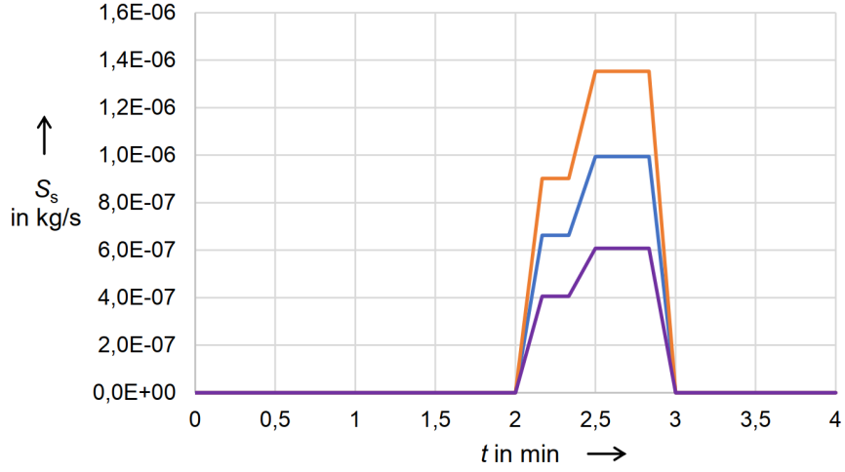
Figure 4.31 TCP source strengths related to secondary event at S0, S1A and S1B, Lakies 2019a
$S_{s}$ TCP source strength released in duct system
t Time
Scenario S0 with $S_{s,ca}$
Variation S1A with $S_{s,rec}$
Variation S1B with $S_{s,in}$

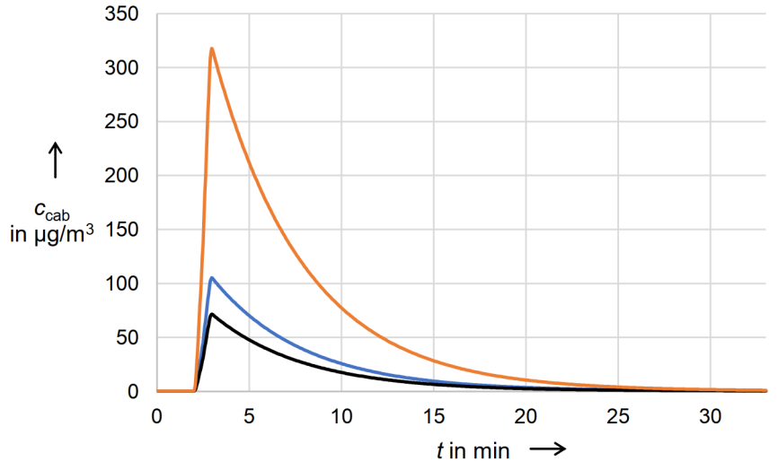
Figure 4.31 TCP concentration in the cabin at scenario S0 and variations S1A and S1B, Lakies 2019a
$c_{cab}$ TCP concentration in the aircraft cabin
t Time
Scenario S0
Variation S1A
Variation S1B

The pattern Lakies chose was randomly chosen which can make it harder to understand the key information indicated a short duration of the contamination event and a changing source strength over time. Considering an ongoing contamination source and a duration for the troubleshooting process, a simplified contamination pattern is chosen in Table 4.3.

Table 4.3 Variable source strengths, simplified release pattern
Time interval |  | $S_{s,con}$ | $S_{s,lin}$
s | min | kg/s | kg/s²
0 | 0 | 0 | 0
600 | 10 | $5.0∙{10}^{-7}$ | 0
1200 | 20 | $5.0∙{10}^{-7}$ | 0
1201 | 20 | 0 | 0

The resulting concentration graph is presented in Figure 4.33.

Figure 4.33 Concentration in the cabin
$c_{cab}$ Concentration in the aircraft cabin
t Time
Concentration (recirculation: $θ=0.5$)
Release pattern $S_{s,con}$ = 500 ng/s from 10 min. to 20 min.

The results shown in Figure 4.33 show that even though the duration it takes for a complete clean-up of the cabin air is about 20 minutes, the most significant reduction of the concentration takes place in 5 minutes.

The delay in the thinning process caused by the complex geometry in the cabin cannot be compensated by switching of the aircraft systems. Furthermore, the oil vapors entering the cabin in the event of a CACE could stick on the surfaces in the air conditioning ducts or the ECS itself and thereby cause an ongoing smoke development in the cabin even if the source has already been determined. These findings show that even if the original source is isolated/eliminated, the smoke or fume in the cabin does not necessarily disappear in the usual two to three minutes it takes for an air exchange. In the worst case this delay in the thinning process could cause the pilot to falsely eliminate the source of the smoke development and thereby to turn the faulty bleed air supply back on. This risk can be minimized by lengthening the waiting time for assessing the change in the situation when switching a component on or off.

Another problem with CACEs due to fluid vapors in the bleed air in combination with the thinning effect arises from the circumstances already mentioned in Section 3.1. The human nose is only able to smell changes in fume concentrations and the perceived intensity is highly subjective for the human nose. As a result, the pilot could falsely get the impression that the reduced perceived intensity is caused by the successful elimination of the source. In order to respond reliably in adequate time, objective sensor data is necessary.

One point that needs to be taken into account when it comes to reducing cabin air contamination is that the recirculation share has no influence on the initial contamination level entering the cabin in the event of bleed air contamination. The amount of air pushed into the mixing chamber is constant and not dependent on whether recirculated air is added or not. The recirculation leads to a higher flowrate into the cabin from the mixing chamber and a higher outflow out of the cabin, but just like the flowrate from the Packs into the mixing chamber, the outflow over board is not affected by the recirculation of the cabin air. If that is taken into account, as Scholz (2020b) has already done for the decay curve, the upswing curve can be derived in a simplified form.

The upswing curve basically corresponds to a step response. Thereby, in order to derive a simplified upswing curve, the same approach is used as that of Scholz (2020b). First the general ventilation equation (4.1) is considered. Like Scholz (2020b) for the decay curve $C_{out}$, i.e. the concentration outside the aircraft, is assumed to be 0 at this point. This allows equation 4.1 to be rewritten as

$S+Q_{e}C=V\frac{dC}{dt}$ (4.9)

The definition for the air flow rate for the ventilation $Q$ is defined as in Scholz (2020b):

$Q=λ∙V$ , (4.10)

as well as the ventilation efficiency η:

$η=\frac{Q_{e}}{Q}↔Q_{e}=η Q$ . (4.11)

Taking into account equations 4.10 and 4.11, Equation 4.9 can then be rewritten to

$S+η λ V C=V\frac{dC}{dt}$ , or (4.12)

$S(t)=V∙\dot{C}(t) - η λ V∙C(t)$ . (4.13)

Transferring equation 4.13 to the Laplace domain, the following equation results:

$S(s)=V(s+η λ)∙C(s)$ (4.14)

The transfer function $G(s)$ results from the output function $U_{out}$ divided by the input function $U_{out}$, i.e. the concentration $C(s)$ divided by the source strength $S(s)$:

$\frac{C(s)}{S(s)}=\frac{1}{V(s+η λ)}=\frac{\frac{1}{V}}{\frac{1}{η λ} s+1}$ (4.15)

Transforming the transfer function back into the time domain gives the equation

$C(t)=\frac{S(t)}{V}∙\left(1-e^{-t η λ}\right)$ . (4.16)

If the ventilation efficiency is assumed as $=1$, as well as the maximum contamination level $C_{t1}=S/V$, the following Table 4.4 and the graph in Figure 4.34 can be concluded.

Table 4.4 Relative concentration development for a ventilation efficiency of η = 1 over
relative time
$$x=\frac{t}{t_{n1}}$$ | 0.1 | 1/3 | 1/2 | 1 | 2 | 3 | 4 | 5
$$C(t)/C_{t1}$$ | 9.52% | 28.35% | 39.35% | 63.21% | 86.47% | 95.00% | 98.17% | 99.33%

Figure 4.34 Relative concentration development for a ventilation efficiency of η = 1 over
relative time

The derived equation 4.16 can be used in combination with the equation 4.2 developed by Scholz (2020b) for a simplified description of a contaminant concentration curve. This simplification can only be used if the contaminants are not caught or impaired by filters in the recirculation or the duct system.

Using Scholz's (2020b) simplified approach, as can be seen in Figure 4.30, the duration for cleaning the cabin air, with the elimination of the source of contamination, of 5 air changes results. Based on the legal ventilation strength per pax (Scholz 2020d) of

$Q = 0.25 \frac{kg}{min}=18\frac{m^{3}}{h}$ , (4.17)

as well as a maximum number of passengers of 297 pax (Lufthansa 2021) for the Airbus A340-600, with its ventilated cabin volume of $752 m^{3}$(Scholz 2021), i.e. the combined volume of the cockpit, the cabin , and the cargo compartment the time it takes for a complete cleanup of the cabin air $t_{clean}$ can be calculated as follows:

$n=\frac{Q}{V}=\frac{18\frac{m^{3}}{h}∙297}{752m^{3}}=7.1\frac{1}{h}$ (4.18)

$t_{n1}=\frac{1}{n}=\frac{1}{7.1} h=0.14 h=8.45 min$ (4.19)

$t_{clean}=5∙8.45 min=42.25 min$ (4.20)

Taking this into account, the need for a sensory monitoring system for the air conditioning system becomes even clearer. A corresponding sensor system could detect a drop in the contamination level much faster than a human would be able to.

5 Descending to FL100, Minimum Obstacle Clearance, MEA

In case that smoke development represents the greatest danger, steps must be taken to remove smoke and fumes, as already mentioned in Chapter 4. Exemplary the corresponding checklist for the Airbus A320 is shown in Figures 5.1 and 5.2.

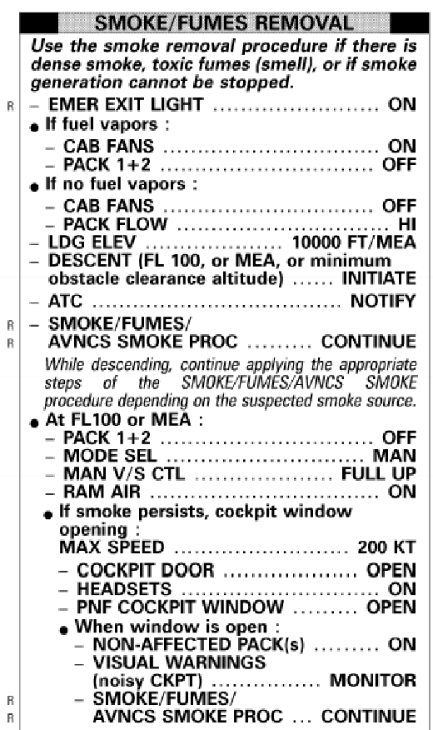  Figure 5.1 Smoke/fumes removal,  Airbus A320,  Smart Cockpit 2020a | 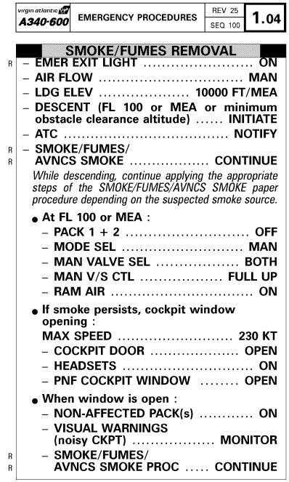  Figure 5.2 Smoke/fumes removal,  Airbus A340,  Smart Cockpit 2020b
First the emergency exit lights are switched on. If there are fluid vapors in the cabin, the cabin fans are switched on and Packs 1 and 2 are switched off. This way, the bleed air supply is stopped, and the cabin is only supplied with air via recirculation from the mixing chamber. If there are no fuel vapors in the cabin, the cabin fans are deactivated and the Pack flow is set to HI, i.e. the maximum flow rate. The cabin is thus still supplied with bleed air and the recirculation is stopped. The descent to FL100, minimum obstacle clearance altitude, or MEA is then initiated, and air traffic control is to be informed. If smoke or fumes from the avionics compartment is suspected, the corresponding steps of the SMOKE / FUMES AVNCS SMOKE procedure must continue to be carried out during the descent. Arrived at FL100, minimum obstacle clearance altitude or MEA, the bleed air supply is first stopped by switching off the two packs. Then the MODE SEL switch is switched to manual, the MAN V/S CTL switch to FULL UP and finally by setting the RAM AIR switch to on the cabin is flooded with ram air. In case that even then the smoke persists, cockpit window can be opened at a maximum speed of 200kt, whilst therefore the Headsets must be set on. When the cockpit window is open, the non-affected packs can be switched on again. It is then necessary to monitor visual warnings and, if smoke from the avionics compartment is suspected, to continue to follow the procedure for SMOKE/FUMES/AVNCS SMOKE.

Considering the given checklists for smoke and fumes removal, the question arises, when a descend to 10000 ft, MEA, or minimum obstacle clearance is beneficial and allowed. To answer this question, it is first necessary to provide an overview of the legal and safety-relevant aviation guidelines for the cruising altitude. This is followed by an overview of the technical and aerodynamic relationships between the aircraft systems, the flight performance, and the cruising altitude. Finally, the corresponding results are evaluated to give an objective and problem-related statement as to what extend a decrease is beneficial in the event of a CACE.

5.1 Legal and Safety-Relevant Aviation Guidelines for the Cruising Altitude

In order to protect persons and property the ICAO international standards provide a set of general rules for the minimum heights:

“Except when necessary for take-off or landing, or except by permission from the appropriate authority, aircraft shall not be flown over the congested areas of cities, towns or settlements or over an open-air assembly of persons, unless at such a height as will permit, in the event of an emergency arising, a landing to be made without undue hazard to persons or property on the surface”
(ICAO 2005, page 24, section 3.1.2).

That means, specifically for VFR flights:

“Except when necessary for take-off or landing, or except by permission from the appropriate authority, a VFR flight shall not be flown: a) over the congested areas of cities, towns or settlements or over an open-air assembly of persons at a height less than 300 m (1000 ft) above the highest obstacle within a radius of 600 m from the aircraft; b) elsewhere than as specified in 4.6 a), at a height less than 150 m (500 ft) above the ground or water”(ICAO 2005, page 34, section 4.6).

In case of a IFR flight, the rules are:

“Except when necessary for take-off or landing, or except when specifically authorized by the appropriate authority, an IFR flight shall be flown at a level which is not below the minimum flight altitude established by the State whose territory is overflown, or, where no such minimum flight altitude has been established: a) over high terrain or in mountainous areas, at a level which is at least 600 m (2000 ft) above the highest obstacle located within 8 km of the estimated position of the aircraft; b) elsewhere than as specified in a), at a level which is at least 300 m (1000 ft) above the highest obstacle located within 8 km of the estimated position of the aircraft”
(ICAO 2005, page 36, section 5.1.2).

Except for areas with high mountains dropping to 10000 ft will most likely not violate these general rules for minimum heights, and even then, could be permitted by air traffic control.

“Nothing in these rules shall relieve the pilot-in-command of an aircraft from the responsibility of taking such action, including collision avoidance manoeuvres based on resolution advisories provided by ACAS equipment, as will best avert collision”(ICAO 2005, page 25, section 3.2).

Despite this basic rule of collision avoidance and the avoidance rule that "an aircraft that is aware that another is compelled to land shall give way to that aircraft" (ICAO 2005, page 25, section 3.2.2.5.3), it is nevertheless essential to inform the air traffic control of the intention to descent to 10000 ft or, using the Boeing EMC checklist, to 9500 ft. This is the only way to ensure that the area is cleared, and the descending is safe. When air traffic control is informed, descending to 10000 ft or even 9500 ft will violate no rule and is therefore allowed in case of emergency.

5.2 Technical and Performance Relevant Aspects

Despite the legal aspects of descending to 10000 ft or below, the question remains whether the descend is beneficial in terms of flight performance and technical aspects. In principle, if the smoke poses too great a health risk and the cause of the smoke development cannot be found, or smoke is suspected from the air conditioning system, the Packs suspected to be the source are deactivated in accordance with the EMC checklists previously examined. In order to ensure a sufficient supply of fresh air, it is necessary to lead air from the environment directly into the cabin. With both Packs deactivated and the recirculation turned off the only possibility to achieve this is via ram air. In the troposphere, air pressure decreases with altitude, while the proportion of oxygen remains constant at 21%. For most people, the body is used to the air pressure at MSL, i.e. to an oxygen partial pressure of about 213 hPa. If the partial pressure of oxygen becomes too low, the pressure difference causes the oxygen to no longer reach the bloodstream in sufficient quantities from the lungs. Up to about 8000 ft, the partial pressure of oxygen is so high that no noticeable physiological changes occur. Between 8000 ft and 12000 ft, the body can usually fully compensate for the falling oxygen partial pressure (see Crown 1973). Above 10000 ft the body is only able to compensate incompletely, a drop in performance and hypoxia can occur (See SKYbrary 2019b). In cruise condition the cabin is pressurized to maintain a cabin altitude of 8000 ft and thereby the necessary partial oxygen pressure. When switching the air supply for the cabin to ram air the cabin pressure adapts to the pressure outside the aircraft. Since, in order to maintain the health condition of the passengers, the cabin altitude needs to maintain under 10000 ft, the altitude must also be changed to 10000 ft or below. As a result of these basic requirements for the fresh air supply, a descend to 10000 ft is necessary precisely when the air supply is no longer guaranteed by the two packs and recirculation, or the amount of smoke in the cabin reaches a critical level and cannot be eliminated by the extraction valves alone. If one of these cases occurs, there is no suitable alternative to descending to 10000 ft, as adequate air supply is not optional but mandatory.

One of the safety-relevant aspects when descending to FL100 is the resulting change in range. When the flight altitude changes, numerous other parameters such as air temperature and density change. As a result, the range of the aircraft also changes. This discrepancy needs to be examined to determine whether the range is still sufficient for safely reaching an airport. In order to calculate the range or specific fuel consumption of an aircraft, Breguet's range formula is usually used, with $R$ being the range, $E$ the lift-to-drag ratio, $V$ the cruise speed, $m$ the mass and $c$ the specific fuel consumption.

$R = E∙\frac{V}{c∙g}∙ln\left(\frac{m_{1}}{m_{2}}\right)$ (5.1)

In his lecture, Scholz (2017) presents a mathematical approach for calculating the range loss when descending from cruising altitude to 10000 ft based on this range formula. He does not start from specific numerical examples or a certain cruising altitude, but rather sets the range at 10000 ft in relation to the range at a general cruising altitude. To ensure this, the assumption is made that the lift-to-drag ratio $E$, as well as the gravitational acceleration $g$ and the mass ratio ${m_{1}}/{m_{2}}$ remain constant. This results in the relation equation:

$\frac{R_{10K}}{R_{CR}}=\frac{V_{10K}}{V_{CR}}∙\frac{c_{CR}}{c_{10K}}$ (5.2)

Considering the equation for the specific fuel consumption:

$c=c_{a} V+c_{b}$ (5.3)

with

$c_{a}=3.38∙{10}^{-8}\frac{kg}{N m}$ (5.4)

and

$c_{b}=1.04∙{10}^{-5} \sqrt{\frac{T_{0}}{T(h)}}\frac{kg}{N s}$ , (5.5)

as well as

$V=M a$ , (5.6)

with the Mach number $M$, and the speed of sound $a$, equation 5.2 can be written as:

$\frac{R_{10K}}{R_{CR}}=\frac{V_{10K}}{V_{CR}}∙\frac{{sfc}_{a} M_{CR} a_{CR}+c_{b}(h_{CR)}}{c_{a} M_{10K} a_{10K}+c_{b}(h_{10K)}}$ (5.7)

Since the lift $L$ is considered to be constant, as well as the planform wing area $S_{W}$ and the lift coefficient $c_{L}$, the equation

$L=m g=\frac{1}{2} ρ V^{2}∙c_{L}∙S_{W}$ , (5.8)

can be written as the relation equation

$ρ_{CR}∙V_{CR}^{2}=ρ_{10K}∙V_{10K}^{2}↔V_{10K}=\sqrt{\frac{ρ_{CR}}{ρ_{10K}}}∙V_{CR}↔\frac{V_{10K}}{V_{CR}}=\sqrt{\frac{ρ_{CR}}{ρ_{10K}}}$ . (5.9)

Combining equation 5.6 and 5.9, as well as the equation for the speed of sound

$a_{CR}=a_{0}∙\sqrt{\frac{T_{CR}}{T_{0}}}$ , (5.10)

the relation equation for the Mach number can be written as

$\frac{M_{10K}}{M_{CR}}=\sqrt{\frac{ρ_{CR}}{ρ_{10K}}}∙\frac{a_{0}}{a_{10K}}∙\sqrt{\frac{T_{CR}}{T_{0}}}$ (5.11)

Already known are the density and speed of sound at 10000ft

$ρ_{10K}=0.90464 \frac{kg}{m^{3}}$ and (5.12)
$a_{0}=328.39 \frac{m}{s}$ , (5.13)

as well as the temperature and speed of sound at mean sea level

$T_{0}=288.15 K$ and (5.14)
$a_{0}=340.29 \frac{m}{s}$ . (5.15)

The ratios of the range (5.7), speed (5.9) and Mach number (5.11) can then be represented graphically as a function of the flight altitude (see Scholz 2017, p.63). The diagram created by Scholz (2017) is shown in the following Figure 5.3. The range ratio was calculated with a Mach number at cruising altitude of $M_{CR}=0.75$.
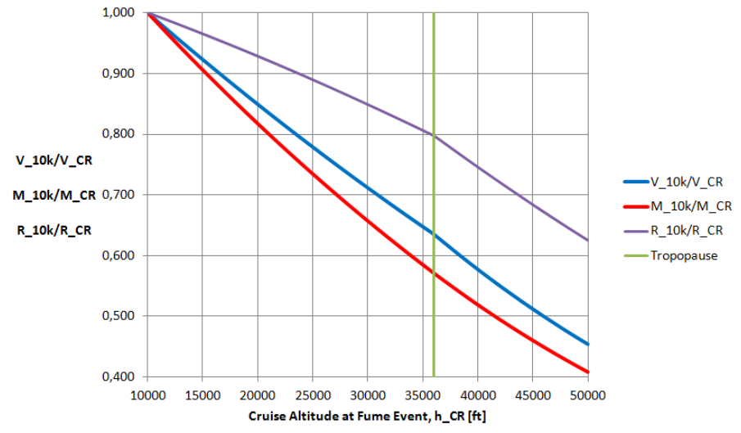
Figure 5.3 Ratio of Cruise Speed, Mach Number and Range, Scholz 2017

Since the reduction in resistance by lowering the Mach number to 10000 ft is not taken into account, the equation does not provide exact values, but the deviation is sufficiently small for a rough estimate of the range reduction. The equations and the diagram by Scholz (2017) show a reduction in range of around 20% despite the reduced speed / Mach number.

Besides the mathematical approach, there is also another way to analyze the range change depending on the flight altitude. The following Tables 5.1 to 5.3 show tables in which the maximum cruise thrust limits under ISA conditions are listed depending on weight and flight level.

Table 5.1 Max. Cruise Thrust Limits, Airbus A330, Scholz 2020c
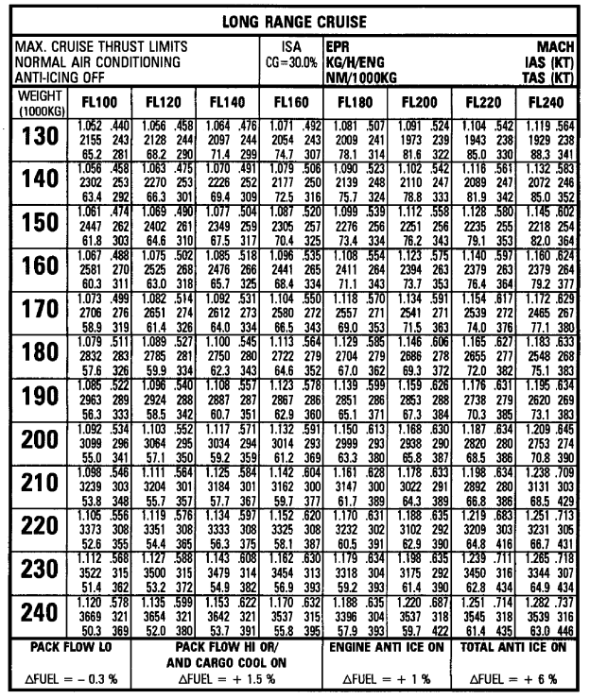

Table 5.2 Max. Cruise Thrust Limits, Airbus A340, Scholz 2020c
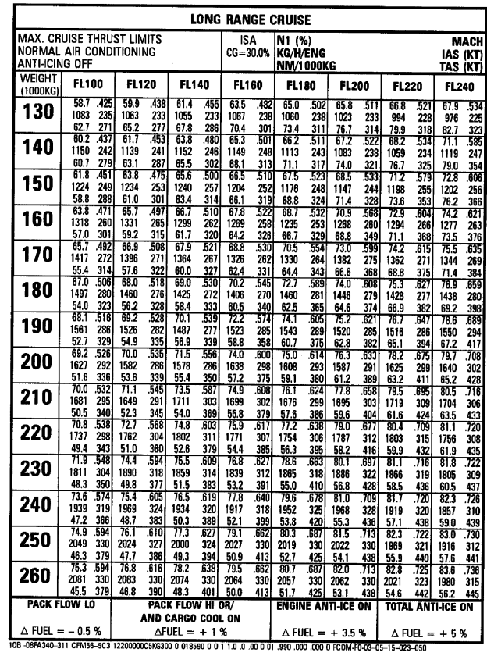

Table 5.3 Max. Cruise Thrust Limits, Airbus A350, Scholz 2020c
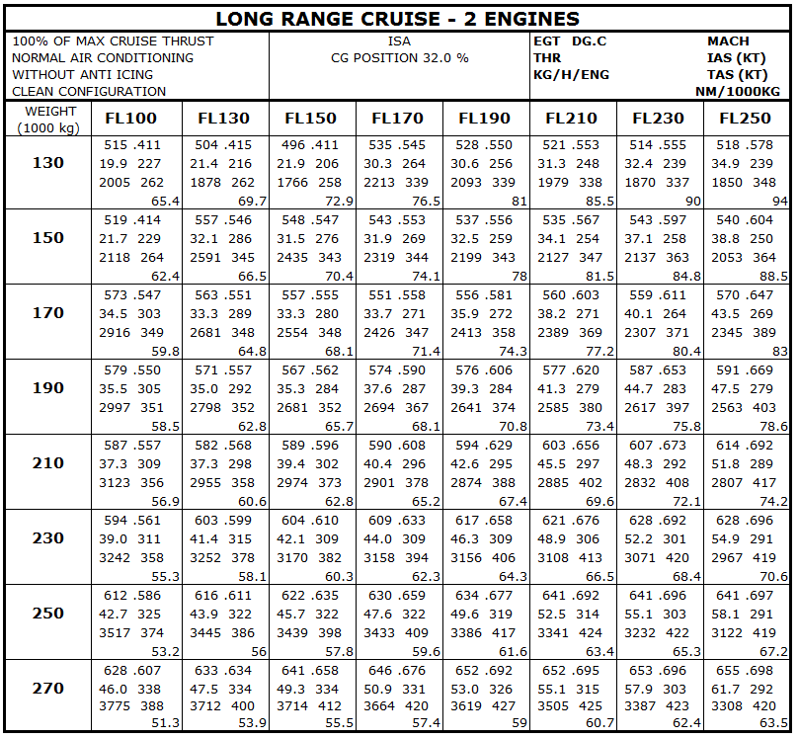

The tables show both the true air speed and the fuel consumption at max. cruise thrust limit. Both these values and the possible miles per ton of fuel also listed in the tables show a considerable difference in the range depending on the flight altitude. In the following Tables 5.4 to 5.6 the possible miles per ton of fuel are extracted from Tables 5.1 to 5.3 and listed together with the respective percentage deviation from the value of the next higher flight level, with the weight remaining the same.

Table 5.4 NM per ton fuel, Airbus A330, based on Table 5.1
MAX. CRUISE THRUST LIMITS  NORMAL AIR CONDITIONING  ANTI-ICING OFF |  |  | ISA  CG=30.0% |  |  | NM/1000kg  DEVIATION TO NEXT FL (%)
Weight  (1000kg) | FL100 | FL120 | FL140 | FL160 | FL180 | FL200 | FL220 | FL240
130 | 65.2 | 68.2 | 71.4 | 74.4 | 78.1 | 81.6 | 85 | 88.3
 | 4 | 4 | 4 | 5 | 4 | 4 | 4 | 0
140 | 63.4 | 66.3 | 69.4 | 72.5 | 75.7 | 78.8 | 81.9 | 85
 | 4 | 4 | 4 | 4 | 4 | 4 | 4 | 0
150 | 61.8 | 64.6 | 67.5 | 70.4 | 73.4 | 76.2 | 79.1 | 82
 | 4 | 4 | 4 | 4 | 4 | 4 | 4 | 0
160 | 60.3 | 63 | 65.7 | 68.4 | 71.1 | 73.7 | 76.4 | 79.2
 | 4 | 4 | 4 | 4 | 4 | 4 | 4 | 0
170 | 58.9 | 61.4 | 64 | 66.5 | 69 | 71.5 | 74 | 77.1
 | 4 | 4 | 4 | 4 | 3 | 3 | 4 | 0
180 | 57.6 | 59.9 | 62.3 | 64.6 | 67 | 69.3 | 72 | 75.1
 | 4 | 4 | 4 | 4 | 3 | 4 | 4 | 0
190 | 56.3 | 58.5 | 60.7 | 62.9 | 65.1 | 67.3 | 70.3 | 73.1
 | 4 | 4 | 3 | 3 | 3 | 4 | 4 | 0
200 | 55 | 57.1 | 59.2 | 61.2 | 63.3 | 65.8 | 68.5 | 70.8
 | 4 | 4 | 3 | 3 | 4 | 4 | 3 | 0
210 | 53.8 | 55.7 | 57.7 | 59.7 | 61.7 | 64.3 | 66.8 | 68.5
 | 3 | 3 | 3 | 3 | 4 | 4 | 2 | 0
220 | 52.6 | 54.4 | 56.3 | 58.1 | 60.5 | 62.9 | 64.8 | 66.7
 | 3 | 3 | 3 | 4 | 4 | 3 | 3 | 0
230 | 51.4 | 53.2 | 54.9 | 56.9 | 59.2 | 61.4 | 62.8 | 64.9
 | 3 | 3 | 4 | 4 | 4 | 2 | 3 | 0
240 | 50.3 | 52 | 53.7 | 55.8 | 57.9 | 59.7 | 61.4 | 63
 | 3 | 3 | 4 | 4 | 3 | 3 | 3 | 0

Table 5.5 NM per ton fuel, Airbus A340, based on Table 5.2
MAX. CRUISE THRUST LIMITS  NORMAL AIR CONDITIONING  ANTI-ICING OFF |  |  | ISA  CG=30.0% |  |  | NM/1000kg  DEVIATION TO NEXT FL (%)
Weight  (1000kg) | FL100 | FL120 | FL140 | FL160 | FL180 | FL200 | FL220 | FL240
130 | 62.7 | 65.2 | 67.8 | 70.4 | 73.4 | 76.7 | 79.9 | 82.7
 | 4 | 4 | 4 | 4 | 4 | 4 | 3 | 0
140 | 60.7 | 63.1 | 65.5 | 68.1 | 71.1 | 74 | 76.7 | 79
 | 4 | 4 | 4 | 4 | 4 | 4 | 3 | 0
150 | 58.8 | 61 | 63.4 | 66.1 | 68.8 | 71.4 | 73.6 | 76.2
 | 4 | 4 | 4 | 4 | 4 | 3 | 3 | 0
160 | 57 | 59.2 | 61.7 | 64.2 | 66.7 | 68.8 | 71.1 | 73.5
 | 4 | 4 | 4 | 4 | 3 | 3 | 3 | 0
170 | 55.4 | 57.6 | 60 | 62.4 | 64.4 | 66.6 | 68.8 | 71.4
 | 4 | 4 | 4 | 3 | 3 | 3 | 4 | 0
180 | 54 | 56.2 | 58.4 | 60.5 | 62.5 | 64.6 | 66.9 | 69.2
 | 4 | 4 | 3 | 3 | 3 | 3 | 3 | 0
190 | 52.7 | 54.9 | 56.9 | 58.8 | 60.7 | 62.8 | 65.1 | 67.2
 | 4 | 4 | 3 | 3 | 3 | 4 | 3 | 0
200 | 51.6 | 53.6 | 55.4 | 57.2 | 59.1 | 61.2 | 63.2 | 65.2
 | 4 | 3 | 3 | 3 | 3 | 3 | 3 | 0
210 | 50.5 | 52.3 | 54 | 55.8 | 57.6 | 59.6 | 61.6 | 63.5
 | 3 | 3 | 3 | 3 | 3 | 3 | 3 | 0
220 | 49.4 | 51 | 52.6 | 54.4 | 56.3 | 58.2 | 59.9 | 61.9
 | 3 | 3 | 3 | 3 | 3 | 3 | 3 | 0
230 | 48.3 | 49.8 | 51.5 | 53.2 | 55 | 56.8 | 58.5 | 60.5
 | 3 | 3 | 3 | 3 | 3 | 3 | 3 | 0
240 | 47.2 | 48.7 | 50.3 | 52.1 | 53.8 | 55.3 | 57.1 | 59
 | 3 | 3 | 3 | 3 | 3 | 3 | 3 | 0
250 | 46.3 | 47.7 | 49.3 | 50.9 | 52.7 | 54.1 | 55.9 | 57.6
 | 3 | 3 | 3 | 3 | 3 | 3 | 3 | 0
260 | 45.5 | 46.8 | 48.3 | 50 | 51.7 | 53.1 | 54.6 | 56.2
 | 3 | 3 | 3 | 3 | 3 | 3 | 3 | 0

Table 5.6 NM per ton fuel, Airbus A350, based on Table 5.3
MAX. CRUISE THRUST LIMITS  NORMAL AIR CONDITIONING  ANTI-ICING OFF |  |  | ISA  CG=30.0% |  |  | NM/1000kg  DEVIATION TO NEXT FL (%)
Weight  (1000kg) | FL100 | FL130 | FL150 | FL170 | FL190 | FL210 | FL230 | FL250
130 | 65.4 | 69.7 | 72.9 | 76.5 | 81 | 85.5 | 90 | 94
 | 6 | 4 | 5 | 6 | 5 | 5 | 4 | 0
150 | 62.4 | 66.5 | 70.4 | 74.1 | 78 | 81.5 | 84.8 | 88.5
 | 6 | 6 | 5 | 5 | 4 | 4 | 4 | 0
170 | 59.8 | 64.8 | 68.1 | 71.4 | 74.3 | 77.2 | 80.4 | 83
 | 8 | 5 | 5 | 4 | 4 | 4 | 3 | 0
190 | 58.5 | 62.8 | 65.7 | 68.1 | 70.8 | 73.4 | 75.8 | 78.6
 | 7 | 4 | 4 | 4 | 4 | 3 | 4 | 0
210 | 56.9 | 60.6 | 62.8 | 65.2 | 67.4 | 69.6 | 72.1 | 74.2
 | 6 | 4 | 4 | 3 | 3 | 3 | 3 | 0
230 | 55.3 | 58.1 | 60.3 | 62.3 | 64.3 | 66.5 | 68.4 | 70.6
 | 5 | 4 | 3 | 3 | 3 | 3 | 3 | 0
250 | 53.2 | 56 | 57.8 | 59.6 | 61.6 | 63.4 | 65.3 | 67.2
 | 5 | 3 | 3 | 3 | 3 | 3 | 3 | 0
270 | 51.3 | 53.9 | 55.5 | 57.4 | 59 | 60.7 | 62.4 | 63.5
 | 5 | 3 | 3 | 3 | 3 | 3 | 2 | 0

The evaluation of the miles per ton of fuel shows an average quasi-linear decrease per 2000 ft of altitude loss of approximately 4%, or 2% per 1000 ft for an aircraft mass between130 t and 210 t and a loss of approximately 3% per 2000 ft of altitude loss, or 1.5% per 1000 ft for an aircraft mass of more than 210 t. If, for example, the aircraft descends from FL390 to FL100 with a mass of 130 t, this means a loss of range of around

$\frac{FL390-FL100}{1000 ft}∙2\%=48\%$ . (5.16)

Even if the range under "max. Cruise" condition is reduced by 48% when descending to 10000 ft, it should be noted that flights in commercial aviation usually operate under different conditions. Flights in commercial air travel are designed for maximum economic efficiency. According to the saying "time is money", the aim is to achieve an economically optimal balance between duration and consumption. This means that a higher consumption and a correspondingly larger amount of fuel is planned as standard. In order to be able to make a reasonable assumption about the change in range, it is necessary to compare the existing consumption values from the tables with those under normal commercial conditions. To ensure this, the payload range diagram provided by Airbus (2020) is analyzed using the example of the Airbus A340 in Figure 5.4.

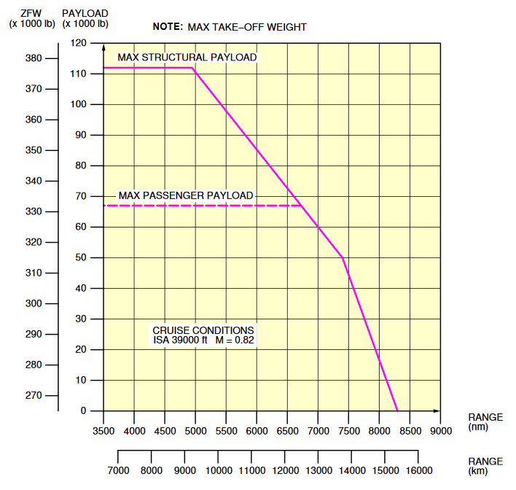
Figure 5.4 Payload Range Diagram, A340-300, Airbus 2020

In order to obtain a value for the range per ton of fuel consumed from the payload range diagram, the range between "maximum zero fuel weight" and "maximum fuel tank capacity" must be considered in accordance with Figure 5.5, because the curve shown in this area represents the change in range depending on the amount of fuel.

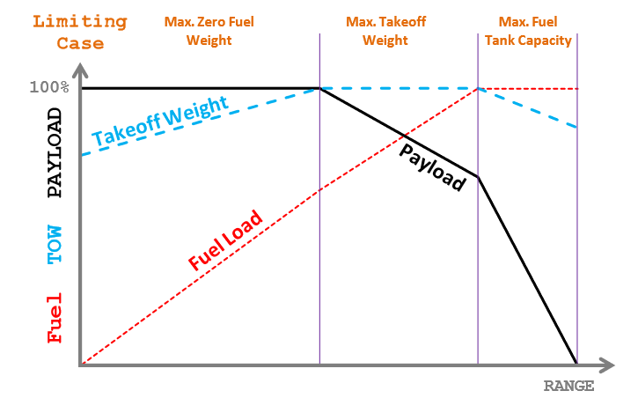
Figure 5.5 Payload Range Diagram, Lukaczyk 2016

Figure 5.4 shows that the range is reduced from 7400 NM to 4950 NM with a payload change from 112000 pounds (lb) to 50000 lb, which is equivalent to a fuel mass reduction of 62000 (lb). That means a range of 39.5 NM per 1000 lb fuel, i.e. 87.1 NM per ton fuel, with

$1 kg=2.20462 lb$ . (5.17)

In order to compare the values from the payload range diagram with Table 5.2, it is still necessary to determine the mass under consideration. For this purpose, the data for the Airbus A340-300 are the maximum take-off mass ($m_{MTO}$)

$m_{MTO}=271 t$ , (5.18)

and the maximum landing mass ($m_{ML}$)

$m_{ML}=192 t$ . (5.19)

These values give the average flight mass ($m_{CR}$) of

$m_{CR}=192 t+\frac{271 t - 192 t}{2}=231,5 t$ (5.20)

Assuming a cruising altitude of around 39000 ft and extrapolating the values of the range per ton of fuel consumed from the A340's performance table (Table 5.2) for a mass of 230 t, the result is the following specific air range (SAR) per ton of fuel consumed:

$\frac{60.5 \frac{NM}{t}-48.3 \frac{NM}{t}}{14}∙29+48.3 \frac{NM}{t}=73.6\frac{NM}{t}$ (5.21)

This extrapolated value results in a specific air range difference to the SAR value concluded from the payload range diagram of

$87.1 \frac{NM}{t}-73.6 \frac{NM}{t}=13.5 \frac{NM}{t}$ , (5.22)

which means a range reduction from the payload range diagram to the table value of

$\frac{13.5 \frac{NM}{t}}{87.1 \frac{NM}{t}}=0.155=15.5\%$ . (5.23)

If the loss of range according to Table 5.2 when descending to 10000 ft, i.e.

$\frac{73.6\frac{NM}{t}-48.3 \frac{NM}{t}}{73.6\frac{NM}{t}}=0.3438=34.38\%$ , (5.24)

is combined with the loss of range by adjusting the cruising speed, etc., i.e. the configuration change from the one considered in the payload range diagram as normal operation to the one considered in the Tables 5.1 to 5.6, the change of range is about

$\frac{87.1 - 48.3}{87.1}=0.445=44.5\%$ , (5.25)

which is by far more than the mathematical approach provided by Scholz (2017). The high difference can result from various factors not considered in the empiric approach when combining the payload range diagram with the tables. For example, the change of range over the height might not be completely linear. Furthermore, the calculated reduced Mach number at 10000 ft in Scholz (2017) is

$\frac{M_{10K}}{M_{CR}}(h=39000 ft)∙M_{CR}=0.53∙0.82=0.435$ , (5.26)

while the Mach number at 10000 ft in Table 5.2 for a mass of 230 t is considered to be 0.548, i.e. a difference in the Mach number between the mathematical approach by Scholz (2017) and the payload range diagram in combination with Table 5.2 of

$∆M=0.548-0.435=0.113$ (5.27)
The greater reduced Mach number in the mathematical approach probably has a great share on the difference of the SAR per ton fuel consumed.

Another aspect, which compensates for the loss of range or makes it negligible, results from the requirements for fuel planning based on the schedule for a "rapid decompression of the cabin". When a flight is planned, the required fuel is calculated as precisely as possible to avoid unnecessary additional weight. Nevertheless, there are some legal fuel reserves taking the event of a rapid decompression of the aircraft cabin into account. In that case an emergency descent to 10000 ft is necessary in order to provide the passengers oxygen supply, i.e. the necessary partial oxygen pressure. Most flights over land don’t require extra fuel in order to guarantee a safe landing on the nearest airport, despite the increased fuel consumption, since in most cases there is a variety of possible alternate destination airports in a suitable range. Yet there are flights without any alternate airports, like the flight from LA International Airport (LAX) to Honolulu International Airport (HNL) whose route can be seen in the following Figure 5.6.

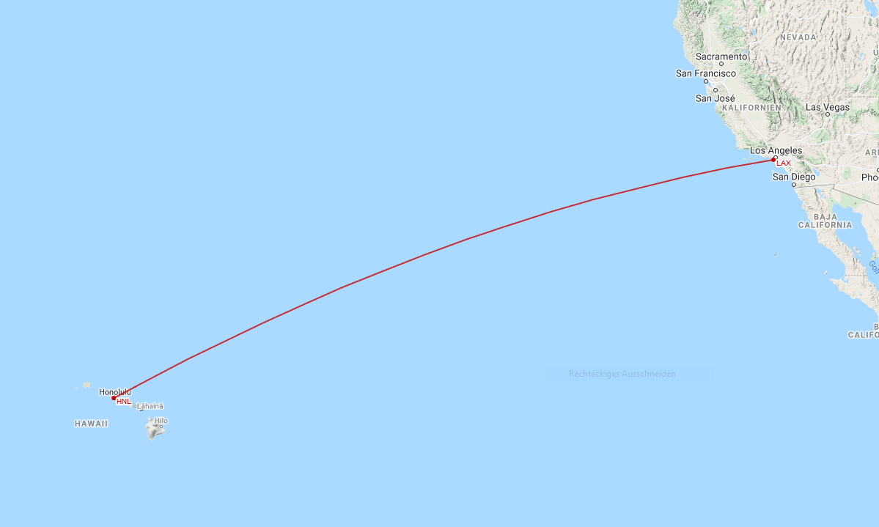
Figure 5.6 Flight Route LAX – HNL, GCM 2021

According to the pilot Juan Brown (2019), who also got an airframe and powerplant mechanic license, the route from the united states’ west coast to Hawaii represents “one of the longest single routes without a suitable alternate airport” (Browne 2019), and therefore a suitable example for flights where the fuel planning, considering the emergency descent situation, must be accomplished without the possibility to deviate from the start or destination airport, i.e. enough fuel to safely reach either the start or destination airport from any point on the flight rout at an altitude of 10000 ft. In order to do so, the “equal time point” (ETP) is taken as critical point (CP). The ETP is not the point of equal distance, but the point on the flight route where the flight duration towards the start and destination airport is equal, taking the winds into account. The online repository SKYbrary (2017) defines the CP / ETP as follows:

“The Critical Point (CP), or Equal Time Point (ETP), is when an aircraft is the same flying time from 2 potential en-route diversions.” (SKYbrary 2017)

This point is considered to be the point of no return and can be calculated as shown in the following Figure 5.7.

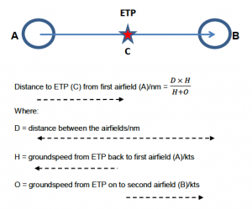
Figure 5.7 Algebraic method for calculating Critical Point/Equal Tim Point, SKYbrary 2017

For every flight on that route the fuel is calculated for this scenario, that the aircraft descends to 10000 ft at that ETP and can still land safely at the airport. Since at any other point on the route the remaining flight duration is smaller, these fuel calculations ensure a safe landing at either the start or destination airport, when descending to 10000 ft at any time on the flight. The relevant guidelines for fuel planning for a flight can be found in Section 4.3.6 of ICAO (2010) Annex 6. The “Fuel requirements” in section 4.3.6 state that “An aeroplane shall carry a sufficient amount of usable fuel to complete the planned flight safely and to allow for deviations from the planned operation” (ICAO 2010, p.59). As section 4.3.6.3 states, “The pre-flight calculation of usable fuel required shall include”(ICAO 2010, p.60):

f) additional fuel, which shall be the supplementary amount of fuel required if the minimum fuel calculated in accordance with 4.3.6.3 b), c), d) and e) is not sufficient to:
1) allow the aeroplane to descend as necessary and proceed to an alternate aerodrome in the event of engine failure or loss of pressurization, whichever requires the greater amount of fuel based on the assumption that such a failure occurs at the most critical point along the route;
i) fly for 15 minutes at holding speed at 450 m (1 500 ft) above aerodrome elevation in standard conditions; and
ii) make an approach and landing;
(ICAO 2010, p.61)

Since the descend to 10000 ft is mandatory in the event of a rapid loss of pressure and this emergency situation is taken into account in the regulations of the ICAO (2010) for fuel planning, the descend to 10000 ft in the case of a CACE is also taken into account in the fuel planning and accordingly despite increased fuel consumption possible.

In spite of the fact that a descent to 10000 ft can in principle be carried out, this is not always done in the event of smoke development in the cabin. This is primarily because as you descend to 10000 ft, the speed must be reduced. If a fire on board is assumed, or at least this cannot be ruled out, a landing as quickly as possible is desired; however, the landing would be delayed by descending. Although the approach of wanting to land as soon as possible is understandable, in the event that a fire can be ruled out by logical conclusions, or is at least unlikely, the descent to 10000 ft should be carried out to minimize serious damage to the health of the crew and passengers. One example for a situation where a descent was not initiated is the US Airways Flight 432 from September 17, 2010 whose flight route is shown in the following Figure 5.8.

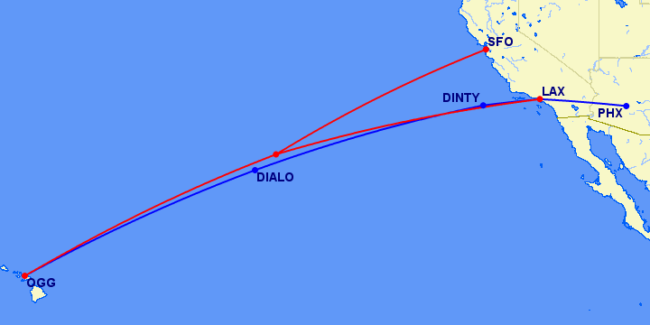
Figure 5.8 US Airways Flight 432 Diversion Flight Route, GCM 2010

“On Friday 17 September, US Airways flight 432 from Phoenix to Kahulua (Maui), operated in a Boeing 757-2G7 (N908AW, SN 24233 / LN 244, which once wore a special "Arizona Cardinals" livery), had been enroute a little over 3.5 hours when the crew reported smoke in the cockpit and elected to make a precautionary diversion to San Francisco.” (GCM 2010)

On October 11, 2010 a video of the flight was published on YouTube (2010). This video was apparently posted by a passenger who wrote in the description:

“Our plane was about two hours out over the Pacific Ocean headed for Maui when a thick smoke started to fill the cabin of our plane. There was a burning smell, but flight staff crew couldn't figure out where the smoke was coming from. Since we weren't to the half way[sic] mark we had to turn the plane around and fly back two hours and land in San Francisco. For two hours we had to fly with the smoke and the fire alarms going off in the cabin.” (YouTube 2010)

Instead of staying at the regular altitude, the altitude could have been reduced to 10000 ft and the smoke removed. After a few minutes, the conclusion could have been made that a fire is unlikely since a fire would probably have already become visible. In that case, a flight over 2 hours with permanent smoke exposure could have been prevented.

6 Schedule to Determine the Reason for a CACE

Based on the existing EMC checklists of the OEMs and airlines from Section 4, as well as the knowledge of the functionality and structure of the individual aircraft systems, a basic flow chart can be elaborated which can be used for the troubleshooting process in a CACE. In terms of scope and efficiency, this schedule is fundamentally dependent on whether or not sensor monitoring of the bleed air system is implemented.

6.1 Sensory Monitoring in Accordance with Section 3.5.2

In the event that sensor monitoring is implemented in accordance with Section 3.5.2, a long troubleshooting process is usually not necessary since the sensor system can automatically indicate the location of the faulty measurement in the event of a detection. For example, if the sensor on the bleed air supply of Engine 1 is triggered, it is automatically clear that this bleed air supply must be switched off. The problem can thus be directly localized and eliminated.

6.2 Sensory Monitoring in Cabin and Cockpit / No Sensory Monitoring

The fewer sensors are used, the longer and less precise the troubleshooting process becomes. If no sensors are used at all, there is the aforementioned problem of subjective odor perception. As a result, in a troubleshooting process that is based on systematic switching of the system components, on the one hand you have to wait longer to ensure that the odor subsides, and on the other hand there is a higher risk of a misdiagnosis if one starts to get used to the odor. Both in the event that sensory monitoring is implemented in the cabin and the cockpit as well as in the event that no sensors are used at all, the schedule for the systematic switching of the system components is the same.

The EMC checklist for elimination of odors in the cabin provided by the airline Frontier was evaluated in Chapter 4.4. The basic approach of paying attention to which area of the aircraft is primarily affected makes sense for a quick determination. In some Boeing aircraft, the front cabin area and the cockpit are mainly supplied with fresh air via Pack 1, while the rear cabin area is primarily supplied via Pack 2. The problem with the EMC checklist from Frontier is that, although it can be determined more quickly which pack is affected, contamination in the bleed air before entering the packs cannot be assigned to a source when both packs are fed from the same source. In order to circumvent this problem i.e. to be able to determine a contamination in the bleed air supply of an individual engine, it is necessary to close the cross-bleed valve. As already described in the previous chapters, this happens automatically when the APU bleed air supply is stopped. In this case, each pack is only fed by the bleed air supply of a single engine. If then a difference in concentration between the front and rear cabin area is detected, the problem can be traced back to exactly one Pack or Engine. Although the APU is usually turned off in normal operation condition, it should be explicitly pointed out, in order to prevent possible misinterpretations.

When the recirculation of the cabin air is stopped, and the cross-bleed valve is closed the development of contamination in the cabin and the cockpit must be checked for any changes. In accordance with Section 4.5, depending on whether sensory monitoring is implemented, a wait of up to 9 minutes is required to prevent incorrect assessments and to take the delayed thinning effect into account. If sensory monitoring is implemented, as Figure 4.28 already shows, the waiting time needed to record a significant drop in the contaminant concentration if the source has been successfully identified and isolated can be greatly reduced. If no sensor data is available that can confirm a possible decrease in the contaminant concentration, the time for checking for a change in the concentration must be extended accordingly. Based on the findings of this thesis, in addition to the thinning effect, the weakening of the odor perception of the human nose must be taken into account. A waiting time of at least 5 minutes should therefore be considered.

If a change in the contaminant concentration can be recognized in either the front or rear area of the aircraft, the corresponding Pack and bleed air supply for the area where the concentration remains high must then be turned off. Afterwards, when a decrease in the concentration in both areas of the aircraft is confirmed, the APU bleed air supply can be reactivated, which also causes the cross-bleed valve to open again. As a result, all areas of the aircraft are supplied sufficiently by the remaining Pack and bleed air supply, as well as the APU bleed air supply. The malfunctioning Pack and bleed air supply must remain deactivated for the remaining flight.

In case that a decrease in the contaminant concentration cannot be recognized, neither in the front nor the rear area of the aircraft, the only option remaining is the descent to 10000 ft or bellow. In that case, as explained in Section 5.2, it must be checked whether it is still possible to safely reach the destination airport or an alternative airport despite the reduced range. If possible, the descent can be proceeded. As long as a safe arrival cannot be guaranteed due to the reduced range, the current flight altitude must be maintained.

6.3 Applicable Checklist for CACEs

For a better overview and to provide an applicable checklist, the schedules elaborated in Sections 6.1 and 6.2 are shown below in the style of the EMC checklists analyzed previously, including some of their steps which are not mentioned under 6.1 and 6.2 mainly taken from the EMC Checklist for smoke in cabin from the Airbus A330/A340 (see Figure 4.2).

If deems necessary................................................LAND ASAP

VENT EXTRACT...........................................................OVRD
CAB FANS................................................................OFF
GALLEY..................................................................OFF
SIGNS....................................................................ON
CKPT/CABIN COM....................................................ESTABLISH

If required:
Oxygen masks.....................................................ON/100%
If identified:
FAULTY EQUIPT....................................................ISOLATE

---------------------------------------------------------------------------
If DENSE SMOKE, at any time of the procedure:
DESCENT for smoke removal.......................................INITIATE
SMOKE/TOXIC FUMES REMOVAL..........................................APPLY
ELEC EMER CONFIG................................................CONSIDER
---------------------------------------------------------------------------

If AIR COND SMOKE SUSPECTED:
APU BLEED............................................................OFF
CROSS-BLEED VALVE..................................................CLOSE
CHECK FOR SMOKE/FUME DISSIPATION...................................APPLY

If SMOKE/FUME in AFT CABIN OR BOTH CABIN and CKPT PERSISTS:
PACK 2............................................................OFF
WAIT up to 9 MINUTES.................................................
If SMOKE/FUME PERSISTS:
PACK 2..........................................................ON
APU BLEED.....................................................AUTO
PROCEDURE “If SMOKE/FUME in FWD CABIN/CKPT PERSISTS”.........APPLY
If SMOKE/FUME DISSIPATES:
VENT EXTRACT..................................................AUTO
CAB FANS......................................................AUTO
Maintain PACK and BLEED AIR configuration and monitor AIR COND
system

If SMOKE/FUME in FWD CABIN/CKPT PERSISTS:
PACK 1............................................................OFF
WAIT up to 9 MINUTES.................................................
If SMOKE/FUME PERSISTS:
PACK 1 and 2..................................................AUTO
APU BLEED.....................................................AUTO
PROCEDURE for DENSE SMOKE....................................APPLY
If SMOKE/FUME DISSIPATES:
VENT EXTRACT..................................................AUTO
CAB FANS......................................................AUTO
Maintain PACK and BLEED AIR configuration and monitor AIR COND
system
If the sensory monitoring is implemented as suggested in Section 3.3.2, the faulty equipment can instantly be identified. Thereby the EMC Checklist for CACEs can be narrowed down to the following:

If deems necessary................................................LAND ASAP

VENT EXTRACT...........................................................OVRD
CAB FANS................................................................OFF
GALLEY..................................................................OFF
SIGNS....................................................................ON
CKPT/CABIN COM....................................................ESTABLISH

If required:
Oxygen masks.....................................................ON/100%
If identified:
FAULTY EQUIPT....................................................ISOLATE

---------------------------------------------------------------------------
If DENSE SMOKE, at any time of the procedure:
DESCENT for smoke removal.......................................INITIATE
SMOKE/TOXIC FUMES REMOVAL..........................................APPLY
ELEC EMER CONFIG................................................CONSIDER
---------------------------------------------------------------------------

7 Discussion

As the results of the research in Section 2 show, although efforts are already being made to use filters to prevent or minimize the occurrence and effects of CACEs, the results of the research also show that sensory monitoring of the cabin air and its supply components has not yet been implemented (see Section 3). Although sensor-based monitoring is not yet used in series production in civil aviation, research is being conducted and appropriate sensor systems developed. The company PALL Aerospace with its Pure Cabin Technology is already well advanced in its development and is already conducting field tests (see Mlcak 2019). Currently the cabin air quality sensor developed by PALL Aerospace is placed in front of the ECS duct outlets in the cabin, but it is already planned to place more sensors in the bleed air supply to determine the cause of a CACE as soon as possible. It is evident that different approaches to sensory monitoring are possible, the cost of which depend strongly on their respective precision and the extent of implementation. Although cost-intensive, there is no doubt that with increasing scope of sensory monitoring, the time needed to detect a CACE decreases and thus contributes significantly to the safety of passengers and crew. Furthermore, the research in the course of this work leads to the conclusion that, due to the highly subjective perceptive capacity of humans for a CACE, the introduction of sensors for monitoring the cabin air, to ensure safety, is not only helpful but highly necessary.

Not only the manufacturers but also the responsible authorities seem to have a controversial point of view. As already shown, the need for sensors to monitor the air conditioning system has been indirectly included in aviation regulations for years (see FAA 2021). Despite everything, such sensory monitoring has not yet been mandatorily implemented. For example, the German Aviation Authority Luftfahrt-Bundesamt (LBA) writes in its 2017 safety report that, depending on the concentration of certain substances, inhaling these compounds poses a health risk and that therefore a special regulatory focus lies on the monitoring of the air quality in aircraft (See LBA 2017, p.21). At the same time, in the following sections of the same safety report, the incidents and the number of cases are played down, which makes the matter less urgent (see LBA 2017, p.21-22). These contradicting statements could lead to the fallacy that the occurrence of CACEs represents a tolerable security gap due to its rarity. That would mean in return that safety is an option. – It is not!

Checklists already exist which take a CACE into account. However, the analysis of some representative checklists shows that although some of these checklists offer a good approach, they are still insufficient to guarantee a target-oriented troubleshooting, especially because of the lack of data as well as insufficient training of the flight crews for the case of a CACE, which can be concluded from the measures applied in already mentioned flights, like the US Airways Flight 432 (GCM 2010).

Apart from the basic problem of source identification, this thesis also deals with the descending measure provided in the EMC checklists, which is applied in case of excessive smoke development or in the event that the identification of the source is not possible. It is shown that a descent is necessary in case of a complete failure of the air conditioning system or in case of excessive smoke emission and the resulting health hazard. While it is clear that a descend to 10000 ft is undesirable as long as a fire has not been ruled out, given the speed at which a fire would usually spread on an airplane, after a few minutes of troubleshooting it can be assumed that a fire is rather unlikely and the descend to 10000 ft should be carried out. This way, critical health effects can be minimized.

Although the results of this elaboration clearly show the need for sensory monitoring of the air conditioning system in order to avoid and combat CACEs, this thesis also provides a revised version of an applicable EMC checklist, which pilots can use as a guideline on how to proceed with CACEs. This elaborated checklist mainly relates to the situation that there is no sensory monitoring of the air-conditioning system is implemented or only in the cabin and cockpit, but also considers the possible implementation of sensors in the air-conditioning system, to the extent that it only shortens the checklist.

8 Summary

In order to confirm the initially subjective impression of a CACE through objective data, the implementation of a sensory monitoring system of the air conditioning system is necessary. Stationary installed sensors in the duct systems and the cabin are particularly helpful here, as they can provide the pilot with clear data, based on the detected substances, such as ultra-fine particles, and their respective positioning. Sensor systems that function on the basis of spectroscopy are particularly promising. With regard to individual indicators to be measured for the detection of CACEs, research suggests formaldehyde and ultrafine particles as the most promising approaches.

This thesis shows that there are various checklists available for smoke, fire, and fumes, that already cover the situation of a CACE. Although these checklists should be modified in order to be most efficient, checklists dedicated specifically to cabin air contamination would not support better than presently available more general checklists, since the differentiation between a fire on board and CACEs due to fuel vapors are sometimes not easy to accomplish. Since the greater fear is that of a fire, the chances are high that only the checklist for fire would be followed. In this case, the new, specific checklist for CACEs could be ignored.

Based on flight crew operating manuals of the aircraft models under consideration, this thesis contains an overview of how the cause of a CACE can be determined as quickly as possible through systematic switching of aircraft systems. It shows how the individual aircraft systems interact, what waiting times are necessary and how, under certain circumstances, logical conclusions can be used to exclude individual components from consideration. Above all, it is shown that simply switching off the individual packs without observing the boundary conditions does not necessarily lead to a correct conclusion. It is further explained that the waiting time between the various switching positions must be long enough, i.e. up to 9 minutes, in order to avoid jumping to wrong conclusions.

The consideration of the legal requirements, as well as the technical possibilities, shows that a descent to 10000 ft in the case of a CACE, with severe health risk for the crew and passengers, is in any case allowed and must be considered. Since in many cases maintaining the cruise flight altitude is preferred in order to reach the nearest airport more quickly, this thesis points that a fire can be ruled out with a high degree of probability by logical conclusions after a certain period of time. When this is done there is no need to expose the crew and passengers to unnecessary health risks, in order to reach the nearest airport more quickly.

9 Recommendations

This thesis already shows how important a sensory monitoring of the air conditioning is. Even if only the case of a CACE due to engine leaks is considered here, the problem can generally be scaled up to various problems in the air supply, which only increases the urgency for sensory monitoring.

For future work it is important to keep an eye on further progress in the development of corresponding sensor systems, such as the one developed by PALL Aerospace. It is also necessary to adapt the revised version of a possible checklist for CACEs elaborated in this thesis, which is quite general here, to specific aircraft types and then to subject these to corresponding tests.

Further considerations can also be carried out with regard to other possible reasons for cabin air contamination, with particular reference to the perceptibility through the human nose. This further research can provide information about whether and to what extend humans are able to recognize threats from air contamination without the aid of sensors. By proving that hazardous events, which are not recognizable without the implementation of sensory monitoring, the pressure on the OEMs as well as on the responsible authorities, to take action, could be increased.

List of References

AAIB, 2011. Aircraft Incident Report Smoke in Cockpit, Boeing 767-300. Reykjavik, Island: Aircraft Accident Investigation Board (AAIB), May 2011.
Available from: https://docplayer.net/49688310-Aircraft-incident-report.html
Archived as: https://perma.cc/GK7K-LNL8

AIRBEAM, 2021. Airbeam and Aircasting Website. Brooklyn, NY, USA.
Available from: https://www.habitatmap.org/
Archived as: https://perma.cc/K6GL-753X

AIRBUS, 2020. 3 – Aircraft Performance. In: A340-200/-300 Aircraft Characteristics Airport and Maintenance Planning. Blagnac Cedex, France: Airbus S.A.S Technical Dara Support and Service, 2020.
Available from: https://bit.ly/3qU8WYu
Archived as: https://perma.cc/39C6-VLXE

ASHRAE, 2013. Air Quality within Comercial Aircraft, ANSI/ASHRAE Standard 161-2013. Georgia, USA: ASHRAE.
Available from: https://bit.ly/3qKtJh9
Archived as: https://perma.cc/8ZSZ-4JRW

AVSOFT, 2018a, B757 Air Conditioning System. Denver, USA: Avsoft International.
Available from: https://www.avsoft.com/wp-content/uploads/2018/02/SSD-B757-1.jpg
Archived as: https://perma.cc/EA6R-QPZX

AVSOFT, 2018b, B777 Air Conditioning System. Denver, USA: Avsoft International.
Available from: https://www.avsoft.com/wp-content/uploads/2018/02/SSD-B777-1.jpg
Archived as: https://perma.cc/ZNN7-DBFF

AWAIR, 2021. Awair Website. San Francisco, USA.
Available from: https://uk.getawair.com/
Archived as: https://perma.cc/CN49-HV5K

BURIAN, Barbara, 2021. Challenges in Emergency and Abnormal Checklist Design. Mountain View, USA: San Jose State University Foundation at the NASA Ames Research Center.
Available from: https://bit.ly/2Mlx4nO
Archived as: https://perma.cc/SC8Y-PGQY

BROWN, Juan, 2019. Hawaiian Air Flight 47 -Smoke in the Cabin [Video]. Youtube.com, 2019-08-27.
Available from: https://youtu.be/3KfAs2p27MQ

CAMBRIDGE DICTIONARY, 2021. Measure. Cambridge, UK: Cambridge University, 2021.
Available from: https://dictionary.cambridge.org/de/worterbuch/englisch/measure
Archived as: https://perma.cc/2GGD-ARFL

CHEN, Hong, 2004. Improvement of Classification Accuracy in Smell Detection Using Electronic Noses. Master Thesis. Ottawa: Carleton University.
Available from: https://bit.ly/3669DGk
Archived as: https://perma.cc/YRF2-K3PY

CORDIS, 2016. Detection of Oil in Compressed Air (DOCA). Denmark: DANSK FUNDAMENTAL METROLOGI.
Available from: https://cordis.europa.eu/project/rcn/104716/brief/de
Archived as: https://perma.cc/944N-BMCG

CROWN, T. J., KELMAN, G. R., 1973. Psychological Effects of Mild Acute Hypoxia. In: British Journal of Anaesthesia,Volume 45, Issue 4, 1973.
Available from: https://doi.org/10.1093/bja/45.4.335
Archived as: https://perma.cc/UX9R-V29T

CRUMP, D. R., HARRISON, P., WALTON, C., 2011. Aircraft Cabin Air Sampling Study; Part 1 of the Final Report. Cranfield, UK: Institute of Environment and Health.
Available from: http://dspace.lib.cranfield.ac.uk/handle/1826/5305

DAY, Gregory, 2015. Aircraft Cabin Bleed Air Contaminants: A Review. Washington, USA: Federal Aviation Administration (FAA).
Available from: https://bit.ly/2NyFsBn
Archived as: https://perma.cc/CM22-YZLX

DE BOER, Jacob; ANTELO, Angel; VAN DER VEEN, Ike; et al., 2015. Tricresyl Phosphate and the Aerotoxic Syndrome of Flight Crew Members - Current Gaps in Knowledge. In: Chemosphere, vol. 119, pp. 58-61
Available from: https://doi.org/10.1016/j.chemosphere.2014.05.015 (Open Access)

DE REE, Hans; VAN DEN BERG, Martin; BRAND, Teus; et al., 2014. Health Risk Assessment of Exposure to Tricresyl Phosphates (TCPs) in Aircraft: A Commentary. In: Neurotoxicology, vol.45, pp.209-215
Available at: https://doi.org/10.1016/j.neuro.2014.08.011

DFROBOT, 2020. Digital Universal Particle Concentration Sensor. Shanghai, China: Zhiwei Robotics Corp.
Available from: https://bit.ly/3c6zMZw
Archived as: https://perma.cc/W4PH-TK6Y

EASA, 2012. Certification Specifications and Acceptable Means of Compliance for Large Aeroplanes CS­25. Cologne, Germany: European Aviation Safety Agency (EASA),
2012-07-13.
Available from: https://bit.ly/2Y74n0F
Archived as: https://perma.cc/QJQ9-EXXN

EASA, 2020. Workshop on Future Cabin Air Quality Research: Stakeholder Presentation Material. 30th – 31st January 2020. Cologne, Germany: European Aviation Safety Agency (EASA).
Available from: https://bit.ly/3sTw5wi
Archived as: https://perma.cc/4WTF-K6D8

EGG, 2021. Egg Website. NY, USA: Wicked Device LLC.
Available from: https://airqualityegg.wickeddevice.com/egg
Archived as: https://perma.cc/MC2X-P9MT

EUROSTARS, 2016. Photo-Acoustic Sensor for Oil Detection in Compressed Air (Pasoca). Brussels, Belgium: Eureka Association.
Available from: https://www.eurostars-eureka.eu/project/id/10132
Archived as: https://perma.cc/PTF3-YE6C

FAA, 2017. FAA-H-8083-16B; Glossary. Washington, USA: Federal Aviation Administration (FAA).
Available from: https://bit.ly/3qWQMp0
Archived as: https://perma.cc/2K6Z-GKYV

FAA, 2021. §91.3 Responsibility and authority of the pilot in command. In: FAA Part 91- General Operating and Flight Rules, Subpart A. Washington, USA: Federal Aviation Administration (FAA).
Available from: https://bit.ly/3t0iT8S
Archived as: https://perma.cc/TH7B-YGWG

FEHRM, Bjorn, 2016. Bjorn’s Corner: Efficient systems. In: Leeham news and analysis, 2016-02-05.
Available from: https://bit.ly/3c5xNEH
Archived as: https://perma.cc/4R75-JPWM

FLUKE, 2020. Fluke 985 Particle Counter. Everett, USA: Fluke Corporation.
Available from: https://bit.ly/3acEHFN
Archived as: https://perma.cc/J7EY-79MW

FRINGOE, 2021. FrinGOe: A Spectrometer-On-the-Go. Enterprise One, Singapore: frinGOe.
Available from: https://fringoe.com/
Archived as: https://perma.cc/NC9Y-Z9U4

FSS, 2018. On-Board Air Quality – Final Report on the Effect of New Materials. Amsterdam, Netherlands: Future Sky Safety (FSS).
Available from: https://bit.ly/2Miyu2J
Archived as: https://perma.cc/47XE-D82Q

GCM, 2010. Featured Maps: US Airways Flight 432 Diversion (19 September 2010) [Online]. Great Circle Mapper. CA, USA: Great Circle Mapper.
Available from: http://www.gcmap.com/featured/20100919
Archived as: https://perma.cc/C6X5-ZZTE

GCM, 2021. Great Circle Mapper (GCM). CA, USA: Great Circle Mapper.
Available from: https://bit.ly/398s6Uu
Archived as: https://perma.cc/F98N-D6QY

HAINES, Gavin, 2017. Does Easyjet’s New Filtration System Suggest Toxic Cabin Air Really Is an Issue?. In: The Telegraph, 2017-09-18.
Available from: https://bit.ly/3qIHw80
Archived as: https://perma.cc/A5M2-UEZ7

ICAO, 2005. ICAO Annex 2 – Rules of the Air. Montreal, Canada: International Civil Aviation Organization (ICAO).
Available from: https://bit.ly/3t3DQzs
Archived as: https://perma.cc/VC8T-AGGB

ICAO, 2010. ICAO Annex 6, Operation of Aircraft Part I, International Commercial Air Transport – Aeroplanes. Montreal, Canada: International Civil Aviation Organization (ICAO).
Available from: https://www.theairlinepilots.com/forumarchive/quickref/icao/annex6.pdf
Archived as: https://perma.cc/54KZ-XCXA

JONES, Byron, Et al., 2012. Sensors and Prognostics to Mitigate Bleed Air Contamination Events. 2012 Progress Report. Manhattan, KS, USA: Kansas State University, 2012.
Available from: https://bit.ly/2LXoOuC
Archived as: https://perma.cc/796E-HPBM
JONES, Byron, 2019. Bleed Air Contamination Detection [Video & Text]. In: International Aircraft Cabin Air Conference (Imperial College London South Kensington, 2019-09-17 – 2019-09-18). Kansas, USA: Kansas State University.
Available from: https://vimeo.com/ondemand/aca2019/
Available from: http://doi.org/10.5281/zenodo.4464548

LAKIES, Marcel, 2019a. Dynamic Cabin Air Contamination Calculation Theory. Project. Hamburg University of Applied Sciences, Aircraft Design and Systems Group (AERO).
Available from: https://nbn-resolving.org/urn:nbn:de:gbv:18302-aero2019-03-01.015

LAKIES, Marcel, 2019b. Example Calculations Secondary CACE [Excel Table] In: Dynamic Cabin Air Contamination Calculation Theory. Project. Hamburg University of Applied Sciences, Aircraft Design and Systems Group (AERO).
Available from: https://doi.org/10.7910/DVN/O4HCUP

LBA, 2017. Ereignisse im Zusammenhang mit der Qualität der Kabinenluft – Fume/smell. In: Sicherheitsbericht 2017. Braunschweig, Germany: Luftfahrt-Bundesamt (LBA).
Available from: https://bit.ly/3chV9Ht
Archived as: https://perma.cc/D2VM-NWGR

LUFTHANSA, 2021. Airbus A340-600. Frankfurt, Germany: Deutsche Lufthansa AG
Available from: https://www.lufthansa.com/de/de/346
Archived as: https://perma.cc/9FNN-KDHW

LUKACZYK, Trent, Et al., 2016. SUAVE: An Open-Source Environment for Multi-Fidelity Conceptual Vehicle Design. Stanford, CA, USA: Stanford University, 2016.
Available from: https://doi.org/10.2514/6.2015-3087
Open Access at: https://bit.ly/3a9L0tq

MCDONNEL DOUGLAS, 1993. MD-11 Flight Crew Operating Manual. Berkeley, Missouri, USA: McDonnel Douglas Corporation, 1993-06-01

MLCAK, Rick, 2019. Monitoring Cabin Air Quality on Commercial Aircraft [Video & Text]. In: International Aircraft Cabin Air Conference (Imperial College London South Kensington, 2019-09-17 – 2019-09-18). New York, USA: Pall Corporation.
Available from: https://vimeo.com/ondemand/aca2019/
Available from: https://doi.org/10.5281/zenodo.4464582

PALL, 2011. Odour/VOC Removal Filters – Frequently Asked Questions.
Available from: http://www.pall.de/pdfs/Aerospace-Defense-Marine/AEOVOCEN.pdf
Archive at: https://perma.cc/7G2L-ZE87

SCHOLZ, Dieter, 2017. Aircraft Cabin Air and Engine Oil – A Systems Engineering View. Hamburg, Germany: Aircraft Design and Systems Group (AERO), 2017-04-27.
Available from: https://bit.ly/3cdxBmT
Archived as: https://perma.cc/DE36-LGTB

SCHOLZ, Dieter, 2018. Technical Solutions to the Problem of Contaminated Cabin Air. In: German Aerospace Congress (Friedrichshafen, Germany, 2018-09-04 – 2018-09-06). Cologne, Germany: Deutsche Gesellschaft für Luft- und Raumfahrt (DGLR).
Available from: https://bit.ly/36dlq5G
Archived as: https://perma.cc/RKM4-DNUU

SCHOLZ, Dieter, 2019a. Contaminated Aircraft Cabin Air –An Aeronautical Engineering Perspective. In: AVSA Meeting (Paris Charles de Gaulle Airport, 2019-05-27). Hamburg, Germany: Hamburg University for Applied Science
Available from: https://bit.ly/3acF5UL
Archived as: https://perma.cc/7738-UTKV

SCHOLZ, Dieter, 2019b. Cabin Air Contamination – A Summary of Engineering Arguments. In: International Aircraft Cabin Air Conference (Imperial College London South Kensington, 2019-09-17 – 2019-09-18). Hamburg, Germany: Hamburg University for Applied Science
Available from: https://doi.org/10.5281/zenodo.4450242
Archived as: https://perma.cc/7GAW-8ZPK

SCHOLZ, Dieter, 2020a. Lufthansa Rescue: It's Not Just about CO2 --- Specific Demands on Lufthansa Also on the Subject of "Contaminated Cabin Air"!. Hamburg, Germany: University of Applied Science, 2020-05-13.
Available from: https://bit.ly/3oropxE
Archived as: https://perma.cc/5MW2-QJHX

SCHOLZ, Dieter, 2020b. Aircraft Cabin Ventilation Theory. Hamburg, Germany: University of Applied Science, 2020-06-27.
Available from: https://purl.org/AERO/M2020-06-27
Archived as: https://perma.cc/KXZ8-BXZU

SCHOLZ, Dieter, 2020c. Re: AW: AW: Bachelorarbeit aktueller Stand --- Wieder eine Überarbeitung [E-Mail]. From: info@profscholz.de, To: lukas.stichternath@haw-hamburg.de, 2021-01-31.

SCHOLZ, Dieter, 2020d. Belüftung der Kabine in Passagierflugzeugen (2020) [Video]. Hamburg, Germany: University of Applied Science, 2020-07-21.
Available from: https://youtu.be/QYP255V03BY
SCHOLZ, Dieter, 2021. Mehr Checklisten! [E-Mail]. From: info@profscholz.de, To: lukas.stichternath@haw-hamburg.de, 2020-10-08.

SCHUCHARD, Sven, 2017. CAQ – Preliminary Cabin Air Quality Measurement Campaign, 2017. Cologne, Germany: European Aviation Safety Agency (EASA).
Available from: https://bit.ly/2KHrCLR
Archived as: http://perma.cc/Z6S7-QXE5

SGX, 2020a. SGX-4CO Industrial Carbon Monoxide Sensor. Corcelles-Cormondrèche, Switzerland: SGX Sensortech.
Available from: https://bit.ly/3ofK0ZH
Archived as: https://perma.cc/5XTP-85D2

SGX, 2020b. SGX-4DT Industrial Dual Toxic Sensor (CO and H₂S). Corcelles-Cormondrèche, Switzerland: SGX Sensortech.
Available from: https://bit.ly/3a1ntL8
Archived as: https://perma.cc/XH2T-SL6K

SKYBRARY, 2017. Critical Point (CP). SKYbrary.aero, last edited 2017-10-23.
Available from: https://www.skybrary.aero/index.php/Critical_Point_(CP)
Archived as: https://perma.cc/C7JK-42AS

SKYBRARY, 2019a. Aircraft Bleed Air Systems. SKYbrary.aero, last edited
2019-02-01.
Available from: https://www.skybrary.aero/index.php/Aircraft_Bleed_Air_Systems
Archived as: https://perma.cc/VTQ5-YWWY

SKYBRARY, 2019b. Hypoxia. SKYbrary.aero, last edited
2019-09-24.
Available from: https://www.skybrary.aero/index.php/Hypoxia
Archived as: https://perma.cc/533U-6Y5L

SMART COCKPIT, 2020a. A320 Smoke Procedure. Smartcockpit.com.
Available from: https://bit.ly/2Y9CODT
Archived as: https://perma.cc/R89W-4DUN

SMART COCKPIT, 2020b. A330/A340 Smoke Procedure. Smartcockpit.com.
Available from: https://bit.ly/2KH1JM9
Archived as: https://perma.cc/P5QG-ZCA7

SMART COCKPIT, 2021a. A320 Air Cond / Press / Vent. Smartcockpit.com.
Available from: https://bit.ly/39Vq6y5
Archived as: https://perma.cc/2M94-ZUNB
SMART COCKPIT, 2021b. A319/A320/A321 Electrical. Smartcockpit.com.
Available from: https://bit.ly/365nZGZ
Archived as: https://perma.cc/2ZHR-HS7B

SMART COCKPIT, 2021c. A340 Air Cond / Press / Vent. Smartcockpit.com.
Available from: https://bit.ly/3o9ecWE
Archived as: https://perma.cc/AY8N-QAW5

SMART COCKPIT, 2021d. A319/A320/A321 Pneumatics. Smartcockpit.com.
Available from: https://bit.ly/3pbX9Ep
Archived as: https://perma.cc/SR64-4BHU
SMART COCKPIT, 2021e. A340 Pneumatics. Smartcockpit.com.
Available from: https://bit.ly/3a1lFlk
Archived as: https://perma.cc/HW5D-WMMB

SMART COCKPIT, 2021f. A330 Pneumatics. Smartcockpit.com.
Available from: https://bit.ly/2Nw1CUI
Archived as: https://perma.cc/86UH-Q9U7

STRANGER, Marianne, KOPPEN, Gudrun, 2020. Human Biomonitoring & Exposures Similarities with Other Indoor Environments. In: EASA 2020. Cologne, Germany: European Aviation Safety Agency (EASA).
Available from: https://bit.ly/3pfL6WI
Archived as: https://perma.cc/4WTF-K6D8

TESTO, 2020a. Testo 315-3 ohne Bluetooth - CO/CO2-Messgerät für Umgebungsmessungen. Lenzkirch, Germany: Testo SE & Co. KGaA.
Available from: https://bit.ly/2Y5t1P8
Archived as: https://bit.ly/2Y6n4S7

TESTO, 2020b. Universal-Klimamessgerät. Lenzkirch, German: Testo SE & Co. KGaA.
Available from: https://bit.ly/3iDeyn4
Archived as: https://perma.cc/YHZ5-P4GQ

TROTEC, 2020. HCHO / TVOC measuring device BQ16. Heinsberg, Germany: Trotec GmbH.
Available from: https://bit.ly/3665bYi
Archived as: https://perma.cc/PL7H-RZFU

UHOO, 2021. uHoo website. Milford, USA: uHoo.
Available from: https://getuhoo.com/
Archived as: https://perma.cc/5X4R-2QW9

URADMONITOR, 2021. uRADMonitor featured by Bosch [Online]. Timisoara, Romania: uRADMonitor.
Available from: https://bit.ly/2Mkn4Lz
Archived as: https://perma.cc/2UTD-5T9H

VOTH, Viola, 2018. Analyse der Entstehungsmechanismen von Ölnebel in Flugzeugkabinen. Bachelor Thesis. Braunschweig, Germany: Technische Universität Braunschweig.
Available from: https://bit.ly/2MmeJY8
Archived as: https://perma.cc/2WW2-HMW3

WIKIPEDIA, 2021a. Aircraft Pilot. Wikipedia.org, 2021
Available from: https://en.wikipedia.org/wiki/Aircraft_pilot
Archived as: https://perma.cc/2C62-SNM8

WIKIPEDIA, 2021b. Airbus A340. Wikipedia.org, 2021
Available from: https://de.wikipedia.org/wiki/Airbus_A340
Archived as: https://perma.cc/VYU9-6PHL

YOUTUBE, 2010. US Airways Flight 432 Phoenix to Maui [Video]. YouTube.com, Uploaded 2010-10-11 by user “acbourgeois1”.
Available from: https://youtu.be/AZqeA32Em2s

All documents viewed on 2021-01-30.

http://CabinAir.ProfScholz.de
https://AircraftCabinAir.com

